新 书 推 荐

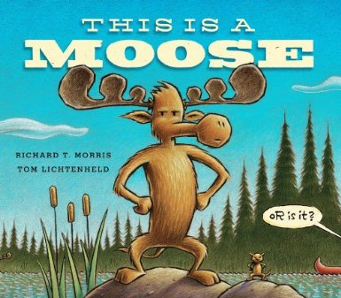
中文书名： 《这是一只麋鹿》
英文书名：This is A Moose
作 者：Richard T. Morris
出 版 社：Little Brown
代理公司：ANA
出版日期：2014年5月
代理地区：中国大陆、台湾
审读资料：电子稿/样书
页 数：40页
类 型：儿童绘本

内容简介：

A hilarious picture book about a family of moose on a movie set who refuse to be typecast, from #1 New York Times bestselling artist Tom Lichtenheld!

Light! Camera! Moose!
Moose? Yes, moose! When a movie director tries to capture the life of a moose on film, he's in for a big surprise. It turns out the moose has a dream bigger than just being a moose - and his friends are going to make that dream come true.
In this hilarious romp, Richard T. Morris and bestselling illlustrator Tom Lichtenheld remind us to dream big and, when we do, to aim for the moon.

作者简介：

In researching this book Richard T. Morris lived for two years ago among a herd of wild moose in the Canadian Rocky Mountains, where he survived on roots and- cut! Sorry. He made this whole story up. Richard is actually the author of Bye-Bye Baby! (Walker/Bloomsbury, 2009). He is also a regular contributor Ellen Potter and Anne Mazer's Spilling Ink creative writing blog. He lives in New Jersey with his family.

媒体评价：

"Morris gives "This is a Moose" an unexpected and lively structure. Lichtenheld is a master of texture: His fir trees look spiky; the duck's beret has the soft thickness of felt; and the blue sky, with delicate variations in color, has the opacity of northern morning as the fog begins to lift."
----The New York Times

内文图画：

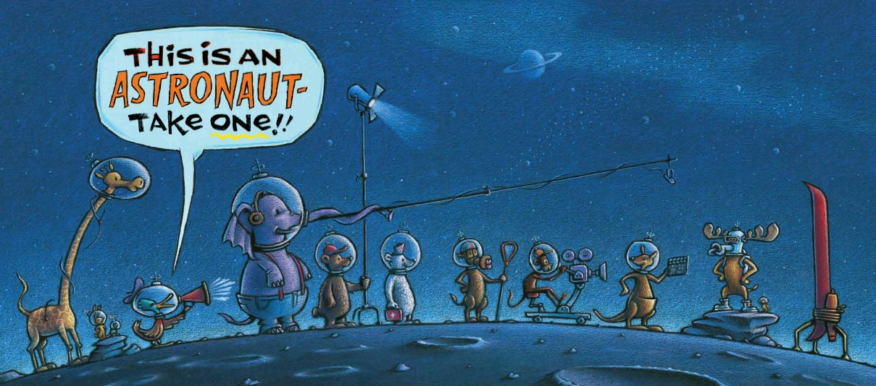

谢谢您的阅读！
请将回馈信息发至：黄家坤 （Jackie Huang）
安德鲁﹒纳伯格联合国际有限公司北京代表处
北京市海淀区中关村大街甲59号中国人民大学文化大厦1705室, 邮编：100872
电话：010-82504106
传真：010-82504200
Email: JHuang@nurnberg.com.cn
网址：www.nurnberg.com.cn
微博：http://weibo.com/nurnberg
豆瓣小站：http://site.douban.com/110577/
微信订阅号：安德鲁书讯

