新 书 推 荐

作者简介：
Andy Seed is an author and poet, living in North Yorkshire. He writes memoirs, funny poems and humorous non-fiction books as well as all sorts of things for teachers. Andy's most popular book for adults is All Teachers Great and Small and his most popular book for children is the poetry collection Razzle Dazzle.

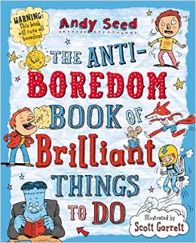
中文书名：
英文书名：The Anti-Boredom Book of Brilliant
Things to Do
作 者：Andy Seed
出 版 社：Bloomsbury
代理公司：ANA
出版日期：2014年7月
代理地区：中国大陆、台湾
审读资料：电子稿/样书
页 数：160页
类 型：7-9岁知识读物

内容简介：

Warning: this book will cure all boredom! Pick which pet is worse: a vampire bat, a dead worm or Godzilla; decide what you would do if you were Prime Minister; discover some yucky things that people eat around the world...and much more! This witty and wacky book is bursting with laugh-out-loud facts, games, quizzes and things to do for hours of fun. Say goodbye to long journey blues!

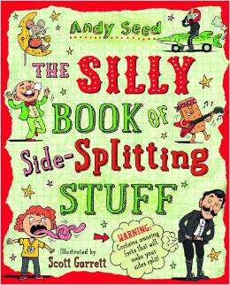
中文书名：
英文书名：The Silly Book of Side-Splitting Stuff
作 者：Andy Seed
出 版 社：Bloomsbury Childrens
代理公司：ANA
出版日期：2014年5月
代理地区：中国大陆、台湾
审读资料：电子稿/样书
页 数：160页
类 型：7-9岁知识读物

内容简介：

This laugh-out-loud book is bursting with lists, facts, jokes and funny true stories all about silly people, silly animals, silly inventions, silly names and much more. Discover The Great Stink, the man who ate a bike, a girl really called Lorna Mower and a sofa that can do 101mph. Find out about famous pranks, crazy festivals, nutty cats, gross foods, epic sports fails, ludicrously silly words and really rubbish predictions. There are even lots of great silly things to do. Unmissable!

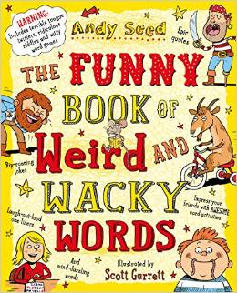
中文书名：
英文书名：The Funny Book of Weird and Wacky Words
作 者：Andy Seed
出 版 社：Bloomsbury
代理公司：ANA
出版日期：2014年6月
代理地区：中国大陆、台湾
审读资料：电子稿/样书
页 数：160页
类 型：7-9岁知识读物

内容简介：

Do you know what 'park your jam on the frog' means? Fancy some ognib? What rhymes with 'circus'? .plus many more amazing things you never knew about words. Have hours of fun wixing up your murds with this hilarious book, packed full of rhymes, puns, games, jokes, gibberish and more.

谢谢您的阅读！
请将回馈信息发至：李馥辰(Cindy Li)
安德鲁﹒纳伯格联合国际有限公司北京代表处
北京市海淀区中关村大街甲59号中国人民大学文化大厦1705室, 邮编：100872
电 话：010-82509406
传 真：010-82504200
Email：Cindy@nurnberg.com.cn
网址：www.nurnberg.com.cn
微博：http://weibo.com/nurnberg
豆瓣小站：http://site.douban.com/110577/
微信订阅号：安德鲁书讯

