新 书 推 荐

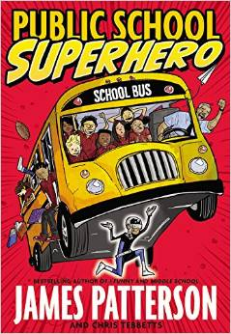
中文书名：《校园小超人》
英文书名：Public School Superhero
作 者：James Patterson , Chris Tebbetts
Cory Thomas
出 版 社：Little, Brown
代理公司：ANA
出版日期：2015年3月
代理地区：中国大陆、台湾
审读资料：电子稿/样书
页 数：304页
类 型：7-12 岁少年文学

内容简介：

Kenny Wright is a kid with a secret identity. In his mind, he's Stainlezz Steel, super-powered defender of the weak. In reality, he's a chess club devotee known as a "Grandma's Boy," a label that makes him an easy target for bullies. Kenny wants to bring a little more Steel to the real world, but the question is: can he recognize his own true strength before peer pressure forces him to make the worst choice of his life?

Featuring more than 150 pieces of line art and comic-style sequences, James Patterson's newest illustrated novel is a genuinely funny yet poignant look at middle school in a challenging urban setting, where a kid's life can depend on the everyday decisions he makes.

作者简介：


James Patterson is the internationally bestselling author of House of Robots and the I Funny, Middle School, Treasure Hunters books, as well as the Confessions, Maximum Ride, Witch & Wizard, Daniel X, and Alex Cross series. His books have sold more than 300 million copies worldwide, making him one of the bestselling authors of all time. He lives in Florida.

Chris Tebbetts has collaborated with James Patterson on three books in the Middle School series and is also the author of The Viking, a fantasy-adventure series for young readers. He lives in Vermont.

Cory Thomas is an illustrator and cartoonist based in Atlanta, GA. His syndicated comic strip, Watch Your Head, appears in newspapers across the country.

谢谢您的阅读！
请将回馈信息发至：李馥辰(Cindy Li)
安德鲁﹒纳伯格联合国际有限公司北京代表处
北京市海淀区中关村大街甲59号中国人民大学文化大厦1705室, 邮编：100872
电 话：010-82509406
传 真：010-82504200
Email：Cindy@nurnberg.com.cn
网址：www.nurnberg.com.cn
微博：http://weibo.com/nurnberg
豆瓣小站：http://site.douban.com/110577/
微信订阅号：安德鲁书讯

