新 书 推 荐

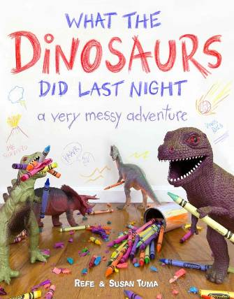
中文书名：《恐龙们昨晚都干了什么》
英文书名：What the Dinosaurs Did Last Night
作 者：Refe Tuma and Susan Tuma
出 版 社：Little Brown
代理公司：ANA
出版日期：2015年10月
代理地区：中国大陆、台湾
审读资料：电子稿/样书
页 数：待定
类 型：儿童绘本

内容简介：

Since Toy Story (and maybe since the very first toys!) children and their parents have wondered what it would be like if toys came to life. Refe and Susan Tuma take this wonder several steps further in WHAT THE DINOSAURS DID LAST NIGHT.

Every November, writer and social media master Refe Tuma and his wife Susan work into the night to bring their four children scenes from the secret lives of their toys - specifically the nighttime antics of their plastic dinosaurs. The dinosaurs wreck bathrooms, destroy vases, rock out, encounter terrifying hot irons, even do the dishes with hilarious, magical results. Each scene is photographed in meticulous detail, letting viewers joyfully suspend belief and think to themselves - just LOOK what the dinosaurs did last night!

作者简介：

Refe and Susan Tuma live in Kansas City with their four children and a herd of plastic dinosaurs. The Tumas began cataloguing their dinosaurs' antics in 2012, igniting the imaginations of hundreds of thousands of children--young and old--across the world.

内文插图：

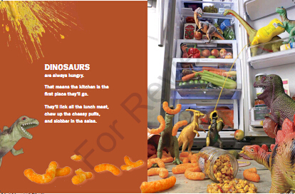
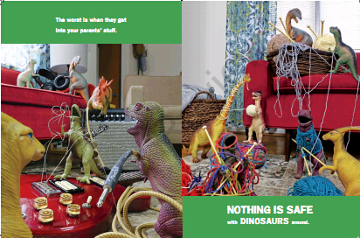

谢谢您的阅读！
请将回馈信息发至：李馥辰(Cindy Li)
安德鲁﹒纳伯格联合国际有限公司北京代表处
北京市海淀区中关村大街甲59号中国人民大学文化大厦1705室, 邮编：100872
电 话：010-82509406
传 真：010-82504200
Email：Cindy@nurnberg.com.cn
网址：www.nurnberg.com.cn
微博：http://weibo.com/nurnberg
豆瓣小站：http://site.douban.com/110577/
微信订阅号：安德鲁书讯

