美国儿童绘本作者 杰瑞德·查普曼
（Jared Chapman）作品推荐

作者简介：

Jared Chapman is a cartoonist and an illustrator. He has worked for Walt Disney Television Animation, Nick Jr., Hallmark, and The Hollywood Reporter, among others. His debut picture book was Pirate, Viking & Scientist, and he lives in Mount Pleasant, Texas.

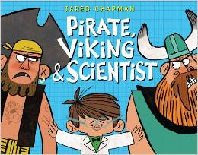
中文书名：《海盗，维京人和科学家》
英文书名：PIRATE, VIKING & SCIENTIST
作 者：Jared Chapman
出 版 社：Little Brown
代理公司：ANA
出版日期：2014年11月
代理地区：中国大陆、台湾
审读资料：电子稿/样书
页 数：48页
类 型：儿童绘本

内容简介：

Pirate is friends with Scientist. Scientist is friends with Viking. Pirate and Viking are NOT friends. What will Scientist do? Use his brain, of course! Can Scientist conduct a clever experiment that will bring the battling brutes together once and for all? Find out in this tale of a classic friendship conundrum imagined through the eyes of a determined little boy who won't rest until he proves that you really can have more than one best friend. A bonus scientific word list introduces kids to basic concepts about the scientific method, from hypotheses to experiments and results!

内文图画：
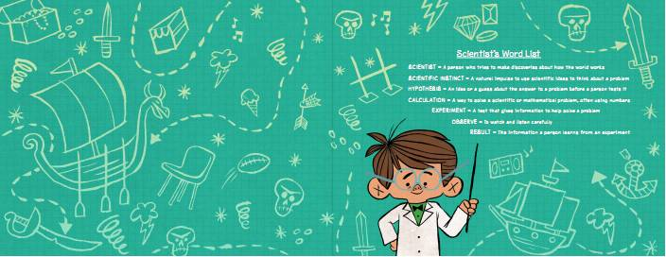
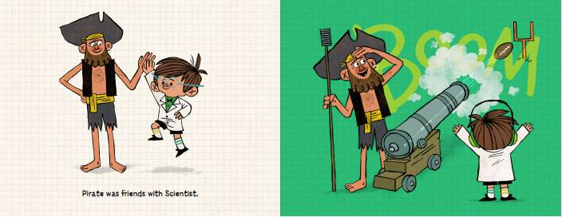

媒体评价：

Praise for Pirate, Viking & Scientist:
"A clear triumph for the scientific method....as funny as it is sneakily informative."
----Kirkus Reviews

"The accessible text, silly premise, and simple yet accurate incorporation of scientific principles make this a unique gem.... A great read-aloud to foster discussions around the scientific process and important lessons about friendship."
----School Library Journal

"With boisterous drawings...and a preface providing key terms in the scientific method, it's great inspiration for classroom science units or at-home Venn-diagramming."
----Publishers Weekly

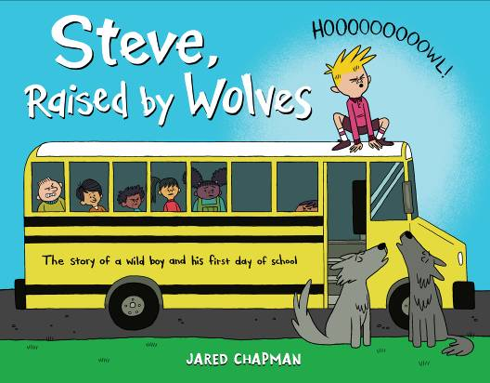
中文书名：《狼人史蒂夫》
英文书名：STEVE, RAISED BY WOLVES
作 者：Jared Chapman
出 版 社：Little Brown
代理公司：ANA
出版日期：2015年1月
代理地区：中国大陆、台湾
审读资料：电子稿/样书
页 数：40页
类 型：3-6岁儿童绘本

内容简介：

"Be yourself!" Steve's mom tells him on the first day of school, and he knows just what to do. After all, wolves are great at HOWLING in class, SHREDDING homework, and POUNCING on new friends! But Steve's classmates are not happy. Why can't he behave like everyone else? When the classroom pet goes missing, it's up to Steve to save the day--by showing everyone what wolves do best.

内文图画：

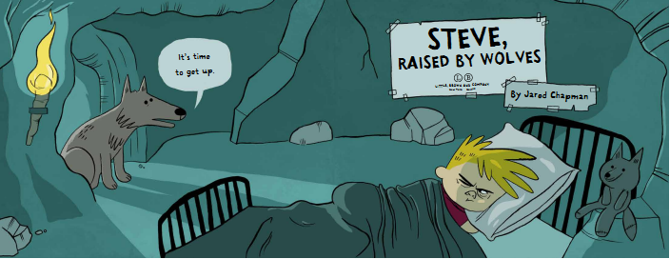
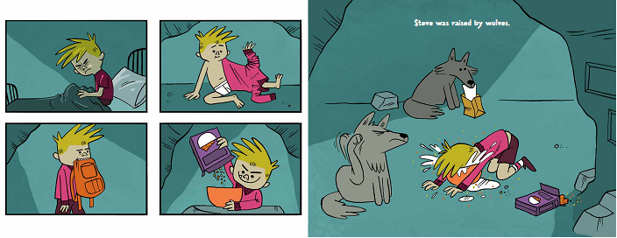
谢谢您的阅读！
请将回馈信息发至：李馥辰(Cindy Li)
安德鲁﹒纳伯格联合国际有限公司北京代表处
北京市海淀区中关村大街甲59号中国人民大学文化大厦1705室, 邮编：100872
电 话：010-82509406
传 真：010-82504200
Email：Cindy@nurnberg.com.cn
网址：www.nurnberg.com.cn
微博：http://weibo.com/nurnberg
豆瓣小站：http://site.douban.com/110577/
微信订阅号：安德鲁书讯

