新 书 推 荐

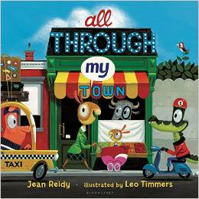
英文书名：All Through My Town
作 者：Jean Reidy and Leo Timmers
出 版 社：Bloomsbury
代理公司：ANA
出版日期：2013年3月
代理地区：中国大陆、台湾
审读资料：电子稿/样书
页 数：32页
类 型：3-6岁儿童绘本

内容简介：

Rising, waking
Bread is baking
School bus honks its horn

Who are the people in your neighborhood? Perfect for the pre-K set, this adorable rhyming text takes a walking tour of your community. The fresh modern art of Leo Timmers features hidden details and a perennial theme reminiscent of Richard Scarry. Little ones will beg to re-read again as they discover the characters who repeat throughout the art in this sweet and vibrant story.

作者简介：


Jean Reidy has been told that a naughty little kid lives within her - and she takes that as a high compliment. She loves crunchy peanut butter and her pink striped pajama pants. She writes from her home in Colorado.

内文图画：


谢谢您的阅读！
请将回馈信息发至：李馥辰(Cindy Li)
安德鲁﹒纳伯格联合国际有限公司北京代表处
北京市海淀区中关村大街甲59号中国人民大学文化大厦1705室, 邮编：100872
电 话：010-82509406
传 真：010-82504200
Email：Cindy@nurnberg.com.cn
网址：www.nurnberg.com.cn
微博：http://weibo.com/nurnberg
豆瓣小站：http://site.douban.com/110577/
微信订阅号：安德鲁书讯

