新 书 推 荐
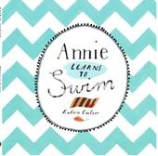
英文书名：Annie Learns to Swim
作 者：Katrin Coetzer
出 版 社：Bumble Books
代理公司：S.B.Rights Agency/ANA
出版日期：2015年3月
代理地区：中国大陆、台湾
审读资料：电子稿/样书
页 数：28页
类 型：儿童绘本

内容简介：

Annie’s mum wants her to learn how to swim; she buys her a new swimming costume. But Annie doesn’t like water-it’s wet and splashy and deep…
Until Miss Klara, the swimming teacher, pairs Annie with Lisa, who swims just like a sea otter!

作者简介：

Katrin Coetzer is an illustrator based in Cape Town, South Africa. She works editorially for various international publications and has extended her visual art practice to include four exhibitions of her paintings and drawings in Europe last year.
Her work has been selected for the Bologna Illustrators Exhibition on two occasions and she has illustrated two picture books for children in South Africa.

内文图画：

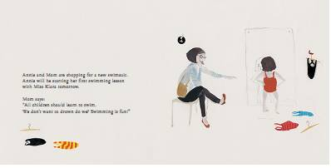
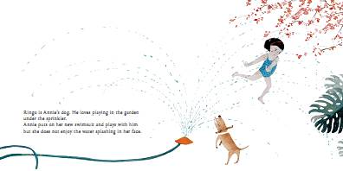

附件中的是绘本电子稿请审读

谢谢您的阅读！
请将回馈信息发至：宁非 (Katalin Ning)
安德鲁﹒纳伯格联合国际有限公司北京代表处
北京市海淀区中关村大街甲59号中国人民大学文化大厦1705室, 邮编：100872
电 话：010-82509406
传 真：010-82504200
Email：Katalin@nurnberg.com.cn
网 站：Http://www.nurnberg.com.cn
新浪微博：http://weibo.com/nurnberg
豆瓣小站：http://site.douban.com/110577/
微信订阅号：安德鲁书讯


