新 书 推 荐

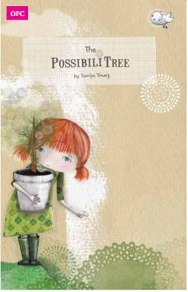
英文书名：The PossibiliTree
作 者：Tamlyn Young
出 版 社：Bumble Books
代理公司：S.B.Rights Agency /ANA
出版日期：2015年6月
代理地区：中国大陆、台湾
审读资料：电子稿/样书
页 数：32页
类 型：儿童绘本

核心卖点：

A story book about the importance of stories
A strong message of hope and friendship
Stunning book from Bumble Books shortlisted for the 3rd BOP (Bologna Best Children Books Publisher of the Year)

内容简介：

Grown-ups think they are more clever than kids but I don’t think that’s always true. I think grown-ups forget how to do a lot of important things… like how to play and how to see the magic in everyday kinds of things.

This story is for anyone who wants to carry on growing. grown-ups included! Join Anna Twig in search of something very important!

作者简介：

TAMLYN YOUNG was born in Durban,South Africa and now lives in Limerick, Ireland. She holds an honours degree in Fine Art and a Master’s degree in Visual Art: (Illustration) from Stellenbosch University. Tamlyn uses layers of mixed media and digital collage to create her images. Her creative process begins with drawing and developing these ideas into a visual story. The PossibiliTree is Tamlyn’s first children’s book.

内文图画：

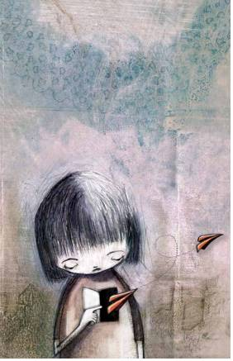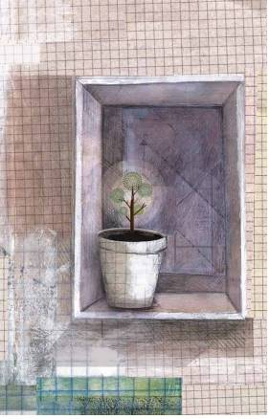

谢谢您的阅读！
请将回馈信息发至：宁非 (Katalin Ning)
安德鲁﹒纳伯格联合国际有限公司北京代表处
北京市海淀区中关村大街甲59号中国人民大学文化大厦1705室, 邮编：100872
电 话：010-82509406
传 真：010-82504200
Email：Katalin@nurnberg.com.cn
网 站：Http://www.nurnberg.com.cn
新浪微博：http://weibo.com/nurnberg
豆瓣小站：http://site.douban.com/110577/
微信订阅号：安德鲁书讯


