Leif Frond series

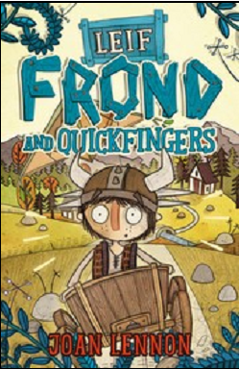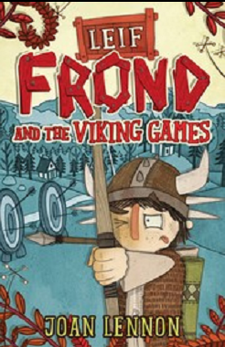

作者简介：

Joan Lennon lives in the Kingdom of Fife, on the River Tay. The Kingdom is said to be shaped like a dog's head. If this is so, her flat is somewhere on the tip of the ear, which explains a lot. She has a husband, four tall sons and one short cat, and plans to go on writing forever.

英文书名：Leif Frond and Quickfingers
作 者：Joan Lennon
出 版 社：BLOOMSBURY
代理公司：ANA
出版日期：2014年8月
代理地区：中国大陆、台湾
审读资料：电子稿/样书
页 数：96页
类 型：7-12岁少年文学

核心卖点：

An exciting and hilarious Viking adventure
Published with companion title Leif Frond and the Viking Games
Part of the A&C Black Funny Month
Author of the brilliant thought-provoking sci-fi story, Planet Hell

内容简介：

A wandering pedlar vanishes, along with half the village’s belongings. Can Leif track down the pedlar and prove himself to be the hero he knows he is?

A wandering pedlar turns up in Leif’s village, much to the delight of the Vikings of Frondfell. Only Leif suspects there’s something not quite right about the small, wrinkly old man.
As belongings start to go missing in the village and the pedlar is suddenly nowhere to be found, Leif’s suspicions are confirmed.
Can Leif track down the disappearing pedlar, survive insane flying inventions, and prove himself to be a hero once and for all?

媒体评价：

"Great fun, these are easy reads which will appeal to boys and girls."
----www.parentsintouch.co.uk, Sarah Brew

英文书名：Leif Frond and the Viking Games
作 者：Joan Lennon
出 版 社：BLOOMSBURY
代理公司：ANA
出版日期：2014年8月
代理地区：中国大陆、台湾
审读资料：电子稿/样书
页 数：80页
类 型：7-12岁少年文学

核心卖点：

An exciting and hilarious Viking adventure
Published with companion title Leif Frond and the Viking Games
Part of the A&C Black Funny Month
Author of the brilliant thought-provoking sci-fi story, Planet Hell

内容简介：

“The name’s Frond, Leif Frond.” And the mission for Leif is to become a champion at the Viking Games. If only he was a bit more like a hero…
Leif wants to be a hero, but as the youngest and smallest member of his huge Viking family, he’s never had the chance to shine. Can he finally become a champion at the Midsummer Games?
All he has to do is compete with some fully grown Viking heroes at sports including archery (no problem, with his very special bow from Queue the Artificer) and wrestling (big problem, the other contenders are all twice his size). Oh, and keep the Widow Brownhilde away from his father before he does something stupid like marrying her. And stop his meddlesome granny from cheating. And avoid his gigantic troll-like sister and her list of chores....

媒体评价：

"Great fun, these are easy reads which will appeal to boys and girls."
----www.parentsintouch.co.uk, Sarah Brew

谢谢您的阅读！
请将回馈信息发至：李馥辰(Cindy Li)
安德鲁﹒纳伯格联合国际有限公司北京代表处
北京市海淀区中关村大街甲59号中国人民大学文化大厦1705室, 邮编：100872
电 话：010-82509406
传 真：010-82504200
Email：Cindy@nurnberg.com.cn
网 站：Http://www.nurnberg.com.cn
新浪微博：http://weibo.com/nurnberg
豆瓣小站：http://site.douban.com/110577/


