Dragon Child series

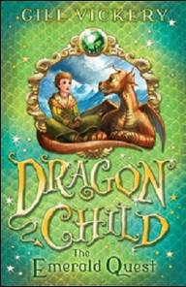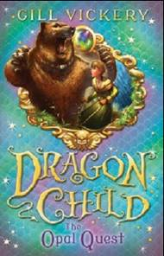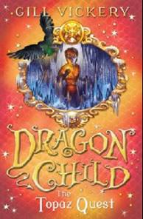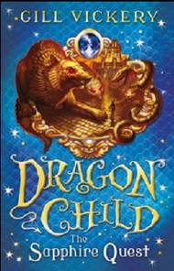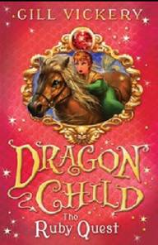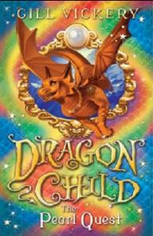

作者简介：

Gill Vickery has loved writing and painting since she was very small. She has been a teacher, and also a children's librarian, which she says is the best job in the world, because you get paid to read children's books!

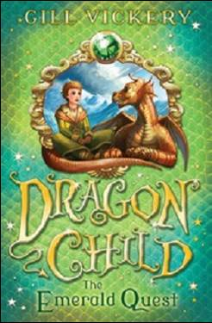
英文书名：The Emerald Quest
作 者：Gill Vickery
出 版 社：Bloomsbury
代理公司：ANA
出版日期：2012年11月
代理地区：中国大陆、台湾
审读资料：电子稿/样书
页 数：80页
类 型：7-12岁少年文学

核心卖点：

Thrilling new adventure series for fantasy lovers.
Great stories for girls looking for action, excitement and adventure with a strong female lead.
Book 2, The Opal Quest, is published in March 2013

内容简介：

A girl raised by dragons must retrieve their stolen Jewels of Power in order to prove herself a true DragonChild. First in the series

When the six sister-witches stole the DragonQueen's jewels of power, they banished the dragons from their home in the land of Tulay. Before the dragons left, they took with them a human child as hostage. Tia has been raised by the dragons and considers them her family. She is appalled to learn that her own human mother is one of the sister-witches who are now the despotic rulers of Tulay. Tia decides she will prove herself to be a true DragonChild by retrieving the jewels, with the aid of her DragonBrother Finn.

In this first exciting adventure, Tia goes after the jewel that gives its possessor the power to control beasts. The second story, The Opal Quest, is published in March 2013.

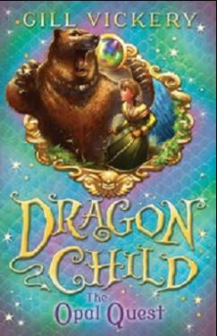
英文书名：The Opal Quest
作 者：Gill Vickery
出 版 社：Bloomsbury
代理公司：ANA
出版日期：2013年3月
代理地区：中国大陆、台湾
审读资料：电子稿/样书
页 数：80页
类 型：7-12岁少年文学

核心卖点：

Thrilling new adventure series for fantasy lovers.
Great stories for girls looking for action, excitement and adventure with a strong female lead.

内容简介：

A girl raised by dragons must retrieve their stolen Jewels of Power in order to prove herself a true DragonChild. Second in the series.

When the DragonQueen's Jewels of Power were stolen by the six sister-witches, the dragons were banished from the land of Tulay. They took with them a human child as hostage. Tia has been raised by the dragons and considers them her family. But when she learns that her mother is one of the sister witches, she must prove herself to be a true DragonChild by retrieving the jewels, with the aid of her DragonBrother.
In this second exciting adventure, Tia goes after the jewel that gives its possessor the power to shift shape.

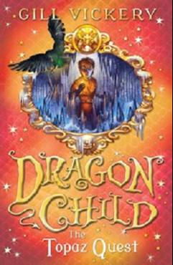
英文书名：The Topaz Quest
作 者：Gill Vickery
出 版 社：Bloomsbury
代理公司：ANA
出版日期：2013年7月
代理地区：中国大陆、台湾
审读资料：电子稿/样书
页 数：80页
类 型：7-12岁少年文学

核心卖点：

Third in the exciting series
Great adventure stories, with a gutsy and sympathetic heroine
Each book is a standalone adventure wihin a linked series building to an exciting climax

内容简介：

The third DragonChild adventure. Tia goes after the weather-altering magical topaz, but now the High Witches are after her… Thrilling magical adventure for 7-9s with a strong heroine.

The third DragonChild adventure. Tia is determined to retrieve the DragonQueen's six stolen Jewels of Power from the High Witches. She has already got the emerald that lets her speak to animals and the opal that lets her change shape. Now she goes after the weather-altering magical topaz. But the High Witches have realised that they are under attack, and the High Witch Luona, in her icebound fastness, will not let the topaz go without a fight. Can Tia and her DragonBrother Finn continue their quest now the powerful witches are on the alert? Thrilling magical adventure for 7-9s.

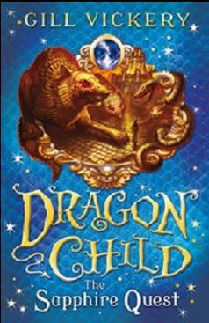
英文书名：The Sapphire Quest
作 者：Gill Vickery
出 版 社：Bloomsbury
代理公司：ANA
出版日期：2013年11月
代理地区：中国大陆、台湾
审读资料：电子稿/样书
页 数：80页
类 型：7-12岁少年文学

核心卖点：

Fourth in the exciting series
Great adventure stories, with a gutsy and sympathetic heroine
"There are some genuinely scary and throat-parching moments along the way and Tia doesn't get her way easily but she is a very engaging new role model for any girl tired of soppy princesses." -Mary Hoffmann, Book Maven blog.

内容简介：

The fourth DragonChild adventure. Tia goes after the magical sapphire that can teleport its user, but her quest is becoming ever more dangerous…
The fourth DragonChild adventure. Tia is determined to retrieve the DragonQueen's six stolen Jewels of Power from the High Witches. She has the emerald that lets her speak to animals, the opal that lets her change shape and the topaz that controls the weather. Now she goes after the magical sapphire that allows teleportation. But that means facing the terrifying High Witch Skadi and her strange land filled with statues that watch...and move...and attack. Can Tia and her DragonBrother Finn retrieve the fourth jewel?

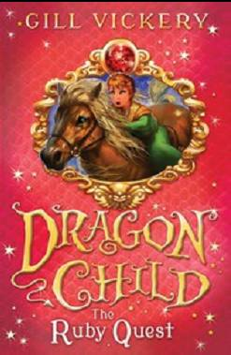
英文书名：The Ruby Quest
作 者：Gill Vickery
出 版 社：Bloomsbury
代理公司：ANA
出版日期：2014年3月
代理地区：中国大陆、台湾
审读资料：电子稿/样书
页 数：80页
类 型：7-12岁少年文学

核心卖点：

Fifth in the exciting series
Great adventure stories, with a gutsy and sympathetic heroine
"There are some genuinely scary and throat-parching moments along the way and Tia doesn't get her way easily but she is a very engaging new role model for any girl tired of soppy princesses." -Mary Hoffmann, Book Maven blog.

内容简介：

The fifth DragonChild adventure. Tia must steal the ruby with the power to stop time, but her greedy aunt, the evil High Witch Hyldi, doesn’t intend to let it go…

The fifth DragonChild adventure. Tia is determined to retrieve the DragonQueen's six stolen Jewels of Power from the High Witches. She has four of the magical jewels; now she is going after the ruby that can stop time. But that means facing the vicious High Witch Hyldi, in her corrupt, greedy town. Tia is alone, without her DragonBrother Finn, and people depending on her. Can she use all her wits and her growing witch-powers to retrieve the fifth jewel?

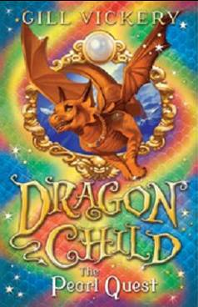
英文书名：The Pearl Quest
作 者：Gill Vickery
出 版 社：Bloomsbury
代理公司：ANA
出版日期：2014年7月
代理地区：中国大陆、台湾
审读资料：电子稿/样书
页 数：80页
类 型：7-12岁少年文学

核心卖点：

The sixth book, bringing this exciting series to a close.
Great adventure stories, with a gutsy and sympathetic heroine
"There are some genuinely scary and throat-parching moments along the way and Tia doesn't get her way easily but she is a very engaging new role model for any girl tired of soppy princesses." - Mary Hoffmann, Book Maven blog.
"The final book in Vickery’s delightful Dragonchild series is just as compelling as the first. […] It’s perfect for children drawn to epic fantasy, but pitched at a rather easier reading level than most fantasy, making it a great stepping stone to longer books..." Emma Barnes,
www.awfullybigblogadventure.blogspot.co.uk

内容简介：

The sixth DragonChild adventure. Tia goes after the magical pearl with the power to heal, which is held by the last High Witch-her mother…

The sixth DragonChild adventure. Tia is on a quest to retrieve the DragonQueen's six stolen Jewels of Power from the High Witches. She has all the jewels but the healing pearl - which is held by the last High Witch, her mother, Ondine. Ondine has no idea that Tia is her daughter. She's determined not to lose the pearl to a thief who has brought down her five sisters. But Tia is equally determined to finish her quest, without her evil mother learning the truth...

谢谢您的阅读！
请将回馈信息发至：李馥辰(Cindy Li)
安德鲁﹒纳伯格联合国际有限公司北京代表处
北京市海淀区中关村大街甲59号中国人民大学文化大厦1705室, 邮编：100872
电 话：010-82509406
传 真：010-82504200
Email：Cindy@nurnberg.com.cn
网 站：Http://www.nurnberg.com.cn
新浪微博：http://weibo.com/nurnberg
豆瓣小站：http://site.douban.com/110577/


