新 书 推 荐

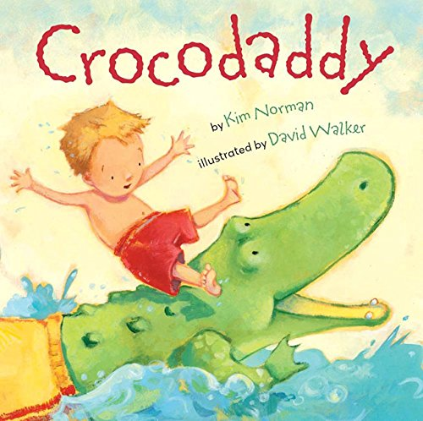
英文书名：Crocodaddy
作 者：Kim Norman（文）David Walker（图）
出 版 社：Sterling Children's Books
代理公司：ANA
出版日期：2015年5月
代理地区：中国大陆、台湾
审读资料：电子稿/样书
页 数：32页
类 型：儿童绘本

内容简介：

Celebrate the imagination—and the love between father and son—with this paperback edition of Kim Norman's fun, rhyming, and totally original tale. On a hot summer's day, a young boy playfully sets out on a “crocodaddy hunt” in the lake. Following the creature's shadow, dark and wet, he's soon taking a wild ride on the grinning croc's back. And when they leave the water, something wonderful happens: Crocodaddy transforms into . . . just DADDY. Bright, energetic illustrations (complete with wily crocodile in Dad's swim trunks) fully capture the story's humor and warmth.

作者简介：


Kim Norman is a graphic designer, singer, actress, and writer of books for young readers. Crocodaddy is based on fond memories of splashing in Maine's Lake Kezar with her father and watching her two sons (now grown) as they chased their own "Crocodaddy" in the backyard pool. Kim is the author of several other picture books, including Ten on the Sled; If It's Snowy and You Know It, Clap Your Paws; and Puddle Pug (all Sterling). She and her husband live in Smithfield, VA. Visit Kim online at kimnormanbooks.com.

David Walker has created art for everything from fabrics and scrapbook supplies to greeting cards and children's books. Among the many books he has illustrated are Nighty-Night, Sleep Tight by Jennifer Berne, and Time for a Hug and Time for a Bath, both by Phillis Gershator (all Sterling). David lives in Chapel Hill, NA, in “a tangle of dogs, cats, and kids.” Visit David online at davidwalkerstudios.com.

媒体评价：

“A little boy and his father frolic in a pond on a lazy summer day. The child is "captain of the Crocodaddy hunt." He rides the creature, lures it with a sandwich, and splashes and giggles, but he doesn't succeed in taming the wild beast until he tickles its knees. The final spread shows the father restored to his human form, while the boy, "a little chip off the lazy old Croc," pretends to be the crocodile. Walker's vibrant colors and expressive characters bounce along with the percussive rhyming text, lending visual power to what could have been a one-note premise. This celebration of imaginative play holds appeal for children.”
----Kathleen Kelly MacMillan, Carroll County Public Library, MD

内文图画：

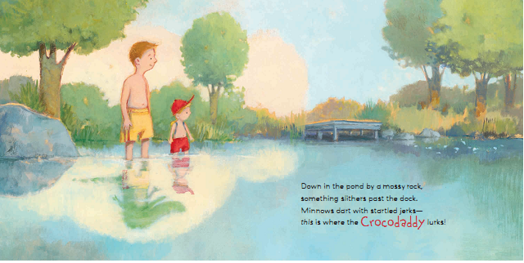

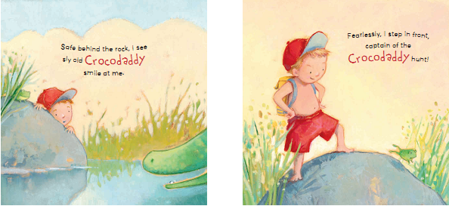

谢谢您的阅读！
请将回馈信息发至：李馥辰(Cindy Li)
安德鲁﹒纳伯格联合国际有限公司北京代表处
北京市海淀区中关村大街甲59号中国人民大学文化大厦1705室, 邮编：100872
电 话：010-82509406
传 真：010-82504200
Email：Cindy@nurnberg.com.cn
网 站：Http://www.nurnberg.com.cn
新浪微博：http://weibo.com/nurnberg
豆瓣小站：http://site.douban.com/110577/


