新 书 推 荐

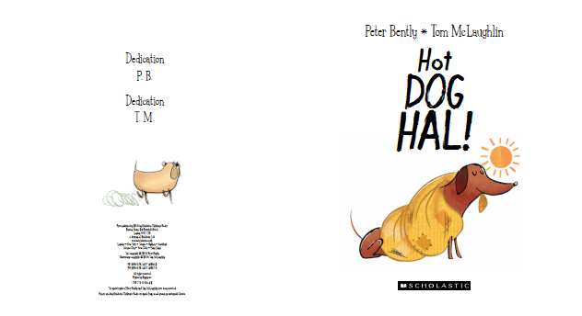
英文书名：Hot Dog Hal
作 者：Peter Bently（文）Tom McLaughlin（图）
出 版 社：Scholastic UK
代理公司：ANA
出版日期：2016年2月
代理地区：中国大陆、台湾
审读资料：电子稿/样书
页 数：32页
类 型：儿童绘本

核心卖点：

From Roald Dahl Funny Prize winner Peter Bently comes a hilarious picture book about a sausage dog and his beloved blanket
Meet a misfit band of loveable canine characters
With a funny rhyming text that is perfect for reading aloud
Humorous illustrations by CAPTAIN BUCKLEBOOTS ON THE NAUGHTY
STEP illustrator Tom McLaughlin

内容简介：

A hilarious new picture book by Roald Dahl Funny Prize winner Peter Bently and bestselling illustrator Tom McLaughlin.
Sausage dog, Hal, loves his trusty old blanket and goes nowhere without it, even though his friends all say that it makes him look like a sausage covered in mustard. From the beach to the zoo, wherever Hal goes his blanket goes with him. Little do Hal's friends know just how useful it might turn out to be when a thunderstorm strikes and Hal manages to rescue his canine chums using that scruffy old blanket!

作者简介：

Peter Bently won the Roald Dahl Funny Prize 2011 for CATS AHOY and is also the author of LARK IN THE ARK and THE GREAT DOG BOTTOM SWAP. Peter lives in Devon.
peterbently.com
@PeterBently

Tom McLaughlin is the illustrator of CAPTAIN BUCKLEBOOTS ON THE NAUGHTY STEP and FATHER CHRISTMAS ON THE NAUGHTY STEP as well as THE DIABOLICAL MR TIDDLES. Tom lives in Devon.
@_TomMcLaughlin

内文图画：

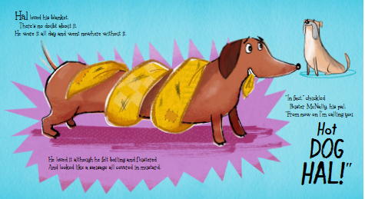

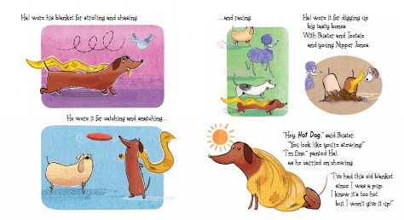

谢谢您的阅读！
请将回馈信息发至：李馥辰(Cindy Li)
安德鲁﹒纳伯格联合国际有限公司北京代表处
北京市海淀区中关村大街甲59号中国人民大学文化大厦1705室, 邮编：100872
电 话：010-82509406
传 真：010-82504200
Email：Cindy@nurnberg.com.cn
网 站：Http://www.nurnberg.com.cn
新浪微博：http://weibo.com/nurnberg
豆瓣小站：http://site.douban.com/110577/


