新 书 推 荐

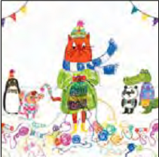
中文书名：《斯坦利的奇妙毛线》
英文书名：Stanley’s Wonderful Woolies
作 者：Emily MacKenzie
出 版 社：Bloomsbury Children’s Books
代理公司：ANA
出版日期：2016年1月
代理地区：中国大陆、台湾
审读资料：电子稿/样书
页 数：32页
类 型：儿童绘本

卖点提炼：

- Another fabulously funny story from the creator of Wanted! Ralfy Rabbit, Book Burglar
- Quirky, interesting artwork with immediate appeal - great for fans of Neal Layton
- Working mainly with ink, digital collage and screen printing, Emily MacKenzie’s illustrative work draws from childhood memories, an inquisitive nature and a vivid imagination. As well as drawing, Emily loves knitting and generally gets very excited about anything bright and colourful
- Emily MacKenzie’s first picture book for Bloomsbury Wanted! Ralfy Rabbit, Book
- Burglar has now been translated into five languages

内容简介：

Meet Stanley, a cat slightly-less-ordinary, with a passion for . . . knitting! He knocks up pom-poms at breakfast time, whips up bobble hats at bath time. He even knits in his sleep! But when Stanley gets carried away with his dream of winning The Woolly Wonders Competition, he has to decide what's more important - his knitting or his friends?

作者简介：

Emily Mackenzie is a freelance illustrator and graphic designer based in Edinburgh who graduated from Edinburgh College of Art. Working mainly with ink, digital collage and screen printing, Emily's illustrative work draws from childhood memories, an inquisitive nature and a vivid imagination. As well as drawing, Emily loves knitting and generally gets very excited about anything bright and colourful! This is Emily's first picture book. She lives in Edinburgh.

内文图画：

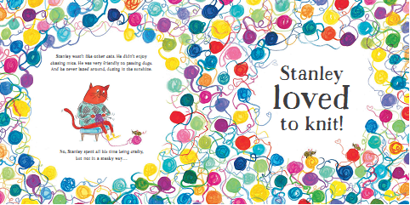
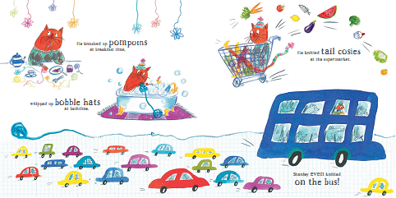

谢谢您的阅读！
请将回馈信息发至：宁非 (Katalin Ning)
安德鲁﹒纳伯格联合国际有限公司北京代表处
北京市海淀区中关村大街甲59号中国人民大学文化大厦1705室, 邮编：100872
电 话：010-82509406
传 真：010-82504200
Email：Katalin@nurnberg.com.cn
网 站：Http://www.nurnberg.com.cn
新浪微博：http://weibo.com/nurnberg
豆瓣小站：http://site.douban.com/110577/
微信订阅号：安德鲁书讯


