新 书 推 荐

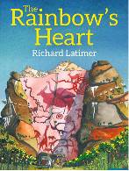
中文书名：《彩虹之心》
英文书名：The Rainbow’s Heart
作 者：Richard Latimer
出 版 社：Bumble Books
代理公司：S.B.Rights Agency /ANA
出版日期：年月
代理地区：中国大陆、台湾
审读资料：电子稿/样书
页 数：20页
类 型：儿童绘本

卖点提炼：

A true adventure and journey through unique landscapes
A strong message about assisting others when in need
A celebration of nature - its importance, beauty and fragility when in the hands of people with bad intentions.
Stunning artwork with unique perspectives, characters and interpretations.

内容简介：

When cousins Dusty Rhodes and Bob Wyre are asked to help save a mysterious colony of bees, they must follow a honeyguide across Africa – all the way to the Rainbow’s Heart.

作者简介：

Richard Latimer is an artist and writer living in South Africa who practiced architecture for a number of years. If he is not creating a wooden African-centric globe in his studio, you might find him crafting an instalment of my latest book, making wood cuts or detailing the wings of a bee in pen and ink.
He has published one picture book, The Rainbow’s Heart, and his sculptures adorn the frontage of local government buildings.

内文图画：

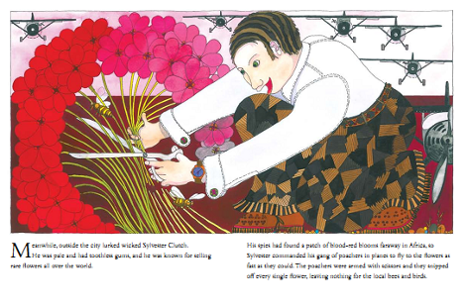

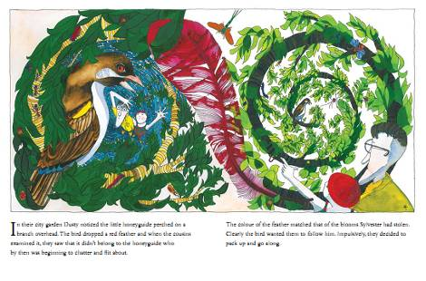

谢谢您的阅读！
请将回馈信息发至：李馥辰(Cindy Li)
安德鲁﹒纳伯格联合国际有限公司北京代表处
北京市海淀区中关村大街甲59号中国人民大学文化大厦1705室, 邮编：100872
电 话：010-82509406
传 真：010-82504200
Email：Cindy@nurnberg.com.cn
网 站：Http://www.nurnberg.com.cn
新浪微博：http://weibo.com/nurnberg
豆瓣小站：http://site.douban.com/110577/


