新 书 推 荐

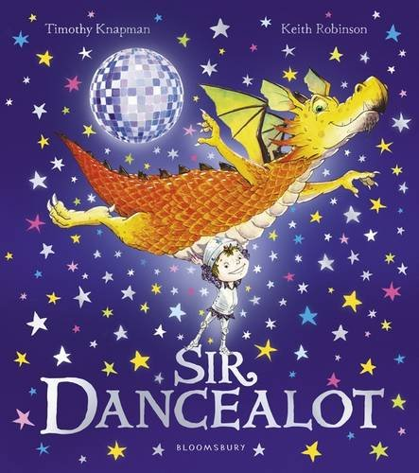
英文书名：Sir Dancealot
作 者：Timothy Knapman（文）Keith Robinson（图）
出 版 社：Bloomsbury
代理公司：ANA
出版日期：2016年4月
代理地区：中国大陆、台湾
审读资料：电子稿/样书
页 数：32页
类 型：儿童绘本

内容简介：

From jiving away trolls to boogying aside bogglesnots and bopping off beasties, there's not a fearsome foe Sir Dancealot can't defeat! But when a fire-breathing dragon arrives at the castle gates demanding a dance-off, everyone is worried. Could this be one step too far for our hero of the dance floor? A hilarious story of sequinned clothes, dragon foes and twinkly toes.

作者简介：

Timothy Knapman has written plays, opera libretti, song lyrics and children's books. Timothy's books, including the successful Mungo series (Puffin), have been translated into 12 languages.

Keith Robinson joined the BBC as part of the team who created the Corporation's very first website. He later founded an award-winning media production. In 2001, Keith decided to move into freelance illustration. Keith lives near Lyme Regis.

内文图画：

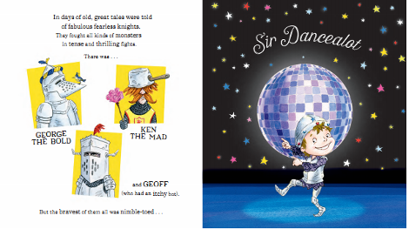
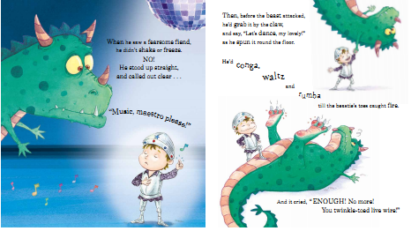
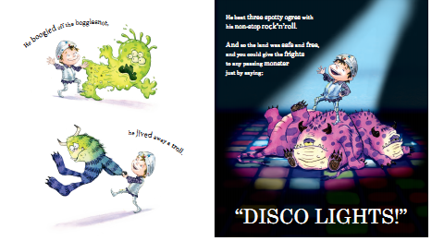
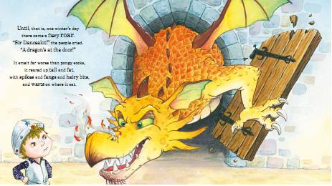

谢谢您的阅读！
请将回馈信息发至：宁非 (Katalin Ning)
安德鲁﹒纳伯格联合国际有限公司北京代表处
北京市海淀区中关村大街甲59号中国人民大学文化大厦1705室, 邮编：100872
电 话：010-82509406
传 真：010-82504200
Email：Katalin@nurnberg.com.cn
网 站：Http://www.nurnberg.com.cn
新浪微博：http://weibo.com/nurnberg
豆瓣小站：http://site.douban.com/110577/
微信订阅号：安德鲁书讯


