新 书 推 荐

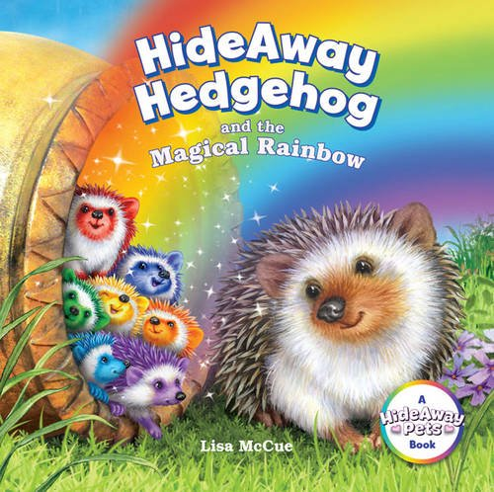
英文书名：Hide Away Hedgehog and the Magical Rainbow
作 者：Lisa McCue
出 版 社：Sterling Publishing
代理公司：ANA
出版日期：2015年10月
代理地区：中国大陆、台湾
审读资料：电子稿/样书
页 数：26页
类 型：儿童绘本

内容简介：

What's a hedgehog to do on a sunny day except take a walk? Mama hedgehog just can't resist-even though her litter of hoglets is nearly due. As she wanders further and further from home, rain and thunder roll in. Desperate, Mama finds shelter in an old pot. But it turns out this is no ordinary pot ...Soon it's glowing-and Mama hedgehog gets a wonderful, colourful surprise! A magical tale from bestselling author and artist Lisa McCue.

作者简介：

Lisa McCue has illustrated more than 150 books, including the reworking of the beloved Corduroy series and Sterling's own Quiet Bunny series. The Society of Illustrators has frequently included her work in its exhibitions.

内文图画：

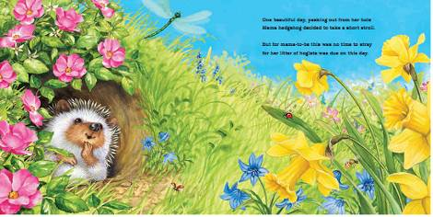
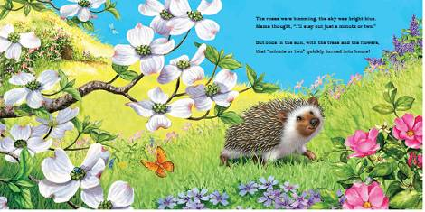
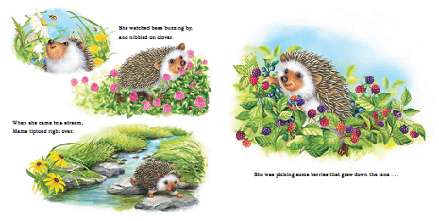
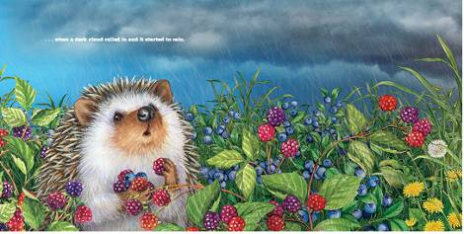

谢谢您的阅读！
请将回馈信息发至：宁非 (Katalin Ning)
安德鲁﹒纳伯格联合国际有限公司北京代表处
北京市海淀区中关村大街甲59号中国人民大学文化大厦1705室, 邮编：100872
电 话：010-82509406
传 真：010-82504200
Email：Katalin@nurnberg.com.cn
网 站：Http://www.nurnberg.com.cn
新浪微博：http://weibo.com/nurnberg
豆瓣小站：http://site.douban.com/110577/
微信订阅号：安德鲁书讯


