新 书 推 荐

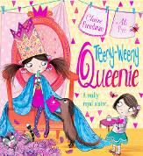
英文书名：TEENY-WEENY QUEENIE
作 者：Claire Freedman（文）Ali Pye（图）
出 版 社：Scholastic UK
代理公司：ANA
出版日期：2016年4月
代理地区：中国大陆、台湾
审读资料：电子稿/样书
页 数：32页
类 型：3-6岁儿童绘本

卖点提炼：

- Laugh-out-loud text from Claire Freedman, author of ALIENS LOVE UNDERPANTS
- This cheeky picture book will appeal to all little girls with royal ambitions
- Narrated in Queenie's regal tones, this right royal tale will have readers in stitches
- Explores sibling relationships in a light-hearted and entertaining manner, whilst carrying a positive message about sisterly love
- Warm, funny artwork by ELLIE MAY illustrator, Ali Pye

内容简介：

A right royal picture book treat from Claire Freedman, author of ALIEN'S LOVE UNDERPANTS.
Queenie has one BIG ambition. When she grows up she is going to be Queen. Because growing up can take "forever" she is already practicing doing queenly things. One day, Queenie summons her Dear Loyal Subjects to a royal tea party. Queenie reluctantly invites her shy little sister, Ella, but during the party forgets to include her in the games.
Suddenly, Queenie doesn't feel so queenly, she feels horrible and mean. In this laugh-out-loud, feel-good tale, Queenie discovers that if there is one thing more important than being a good queen, it is being a great sister!

作者简介：

Claire Freedman is the author of the bestselling ALIENS LOVE UNDERPANTS (500,000 copies sold) and many more successful picture books, including SUPERKID (9781407124063) and
GEORGE'S DRAGON AT THE FIRE STATION (9781407137896). Claire lives in Essex.
clairefreedman.co.uk @clairefreedman
Ali Pye is the illustrator of SOMETHING DELICIOUS and THE DEEP DARK WOOD, as well as the ELLIE MAY series. Ali lives in Twickenham. alipye.com
内文图画：

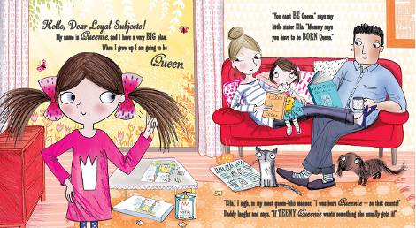

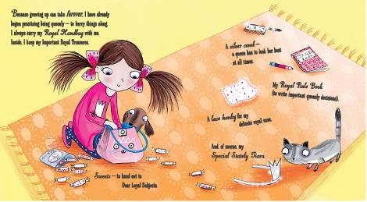

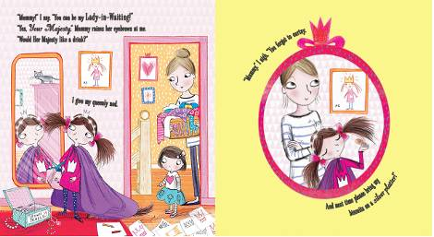

谢谢您的阅读！
请将回馈信息发至：宁非 (Katalin Ning)
安德鲁﹒纳伯格联合国际有限公司北京代表处
北京市海淀区中关村大街甲59号中国人民大学文化大厦1705室, 邮编：100872
电 话：010-82509406
传 真：010-82504200
Email：Katalin@nurnberg.com.cn
网 站：Http://www.nurnberg.com.cn
新浪微博：http://weibo.com/nurnberg
豆瓣小站：http://site.douban.com/110577/
微信订阅号：安德鲁书讯


