新 书 推 荐

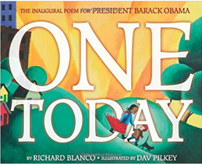
英文书名：One Today
作 者：Richard Blanco and Dav Pilkey
出 版 社：Little Brown
代理公司：ANA
出版日期：2015年11月
代理地区：中国大陆、台湾
审读资料：电子稿/样书
页 数：40页
类 型：3-6岁儿童绘本

内容简介：

President Barak Obama invited Richard Blanco to write a poem to share at his second presidential inauguration.

That poem is One Today, a lush and lyrical, patriotic commemoration of America from dawn to dusk and from coast to coast.

作者简介：

Richard Blanco is an award-winning American poet, storyteller, teacher, public speaker, and memoirist. He lives with his partner in Maine.

Dav Pilkey has created many beloved books, including those in the Captain Underpants series and Caldecott Honor award-winning The Paperboy. He lives with his wife in the Pacific Northwest.

媒体评价：

"I'm honored that Richard Blanco will join me and Vice President Biden at our second Inaugural. His contributions to the fields of poetry and the arts have already paved the path forward for future generations of writers. Richard's writing will be wonderfully fitting for an Inaugural that will celebrate the strength of the American people and our nation's great diversity."
----President Barack Obama

内文图画：

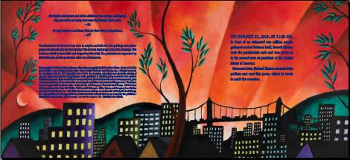
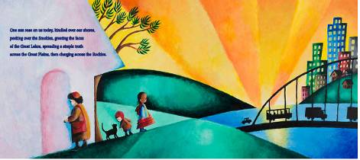
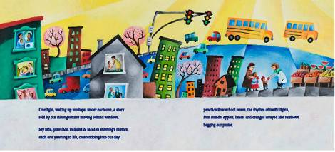

谢谢您的阅读！
请将回馈信息发至：宁非 (Katalin Ning)
安德鲁﹒纳伯格联合国际有限公司北京代表处
北京市海淀区中关村大街甲59号中国人民大学文化大厦1705室, 邮编：100872
电 话：010-82509406
传 真：010-82504200
Email：Katalin@nurnberg.com.cn
网 站：Http://www.nurnberg.com.cn
新浪微博：http://weibo.com/nurnberg
豆瓣小站：http://site.douban.com/110577/
微信订阅号：安德鲁书讯


