新 书 推 荐

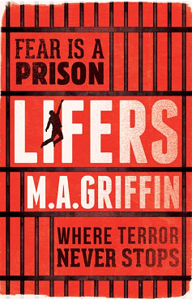
中文书名: 《终生监禁》
英文书名：LIFERS
作 者：Martin Griffin
出 版 社：CHICKEN HOUSE
代理公司：ANA
出版日期：2016年4月
代理地区：中国大陆、台湾
审读资料：电子稿/样书
页 数：待定
类 型：14岁以上青春文学

卖点提炼：

- An atmospheric noir thriller set in a future Manchester, incorporating shocking and believable science-fiction elements.
- Packed full of high-octane adventure and tension, perfect for fans of The Maze Runner who crave a grittier real-world setting; shades of fellow Manchester-based author Melvin Burgess.
- Written under the name Fletcher Moss, Martin’s first novel The Poison Boy won the 2012 Times/Chicken House Children’s Fiction Competition and was shortlisted for the Brandford Boase Award.

内容简介：

Preston explores dark Manchester in the hunt for a missing friend. Deep in the bowels of a secret institute, he discovers a sinister machine. The world inside is a cavernous dimension filled with problematic teens. Friendships are forged, promises broken and lives lost in a reckless battle for freedom, revenge – and revolution.

作者简介：


Martin Griffin studied English Literature at Manchester University. His first novel, The Poison Boy, was written under the name Fletcher Moss and won the 2012 Times/Chicken House Children’s Fiction Competition. He lives in Manchester.

谢谢您的阅读！
请将回馈信息发至：李馥辰(Cindy Li)
安德鲁﹒纳伯格联合国际有限公司北京代表处
北京市海淀区中关村大街甲59号中国人民大学文化大厦1705室, 邮编：100872
电 话：010-82509406
传 真：010-82504200
Email：Cindy@nurnberg.com.cn
网 站：Http://www.nurnberg.com.cn
新浪微博：http://weibo.com/nurnberg
豆瓣小站：http://site.douban.com/110577/


