新 书 推 荐

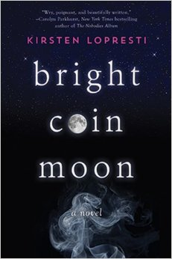
英文书名：BRIGHT COIN MOON
作 者：Kirsten Lopresti
出 版 社：Sky Pony
代理公司：BIAGI RIGHTS /ANA
出版日期：年月
代理地区：中国大陆、台湾
审读资料：电子稿/样书
页 数：272页
类 型：9-12 岁少年文学

内容简介：

Set against the colorful backdrop of immoral psychics and dishonest scam artists, Bright Coin Moon tells a story of longing and loyalty and the emotional burden of sacrifice.

Seventeen-year-old Lindsey Allen is an A-student who has her heart set on becoming an astronomer. But first she must break away from her mother, an eccentric failed beauty queen who has set up a phony psychic reading shop in their Oregon garage.

Lindsey is biding time until she graduates high school, reading tarot cards for the neighbors in her mother’s shop and recording the phases of the moon in her Moon Sign notebook. Her life changes when her mother, Debbie, decides they should move to California to become Hollywood psychics to the stars. As they pull out of the driveway, Lindsey looks up at the silver morning moon. It’s a bright coin moon, which means only one thing: what you leave behind today will rise up tomorrow.

When mother and daughter arrive in Los Angeles with new identities, they move into a leaky, run-down building and spend their nights stalking restaurants and movie premieres to catch that one celebrity they hope will be their ticket. When it seems they will never make it in LA, Lindsey is assigned a new mentor through her school. Joan is a lonely, wealthy widow who can’t get past the death of her husband, Saul. Debbie is convinced they’ve hit the jackpot, and plans for a future séance commence.

As Lindsey grows closer to Joan, guilt over the scam consumes her, and she must make the ultimate decision. But can she really betray her mother?

作者简介：

Kirsten Lopresti is the author of the young adult novel Bright Coin Moon. She holds a BA from Virginia Tech and an MFA from George Mason University. She has published short stories in several literary magazines, including The Laurel Review, New Delta Review, So To Speak, Italian Americana, and Licking River Review. She currently resides in Herndon, Virginia.

谢谢您的阅读！
请将回馈信息发至：李馥辰(Cindy Li)
安德鲁﹒纳伯格联合国际有限公司北京代表处
北京市海淀区中关村大街甲59号中国人民大学文化大厦1705室, 邮编：100872
电 话：010-82509406
传 真：010-82504200
Email：Cindy@nurnberg.com.cn
网 站：Http://www.nurnberg.com.cn
新浪微博：http://weibo.com/nurnberg
豆瓣小站：http://site.douban.com/110577/


