新 书 推 荐

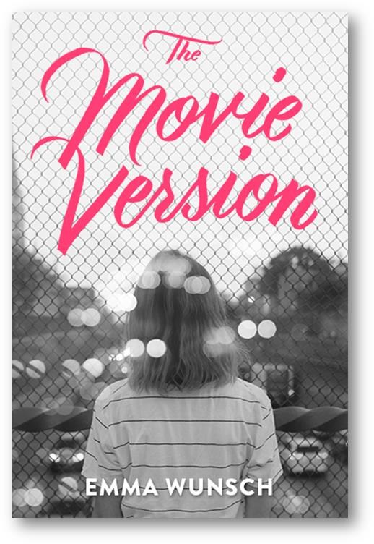
英文书名：THE MOVIE VERSION
作 者：Emma Wunsch
出 版 社：Amulet Books
代理公司：ANA
出版日期：2016年10月
代理地区：中国大陆、台湾
审读资料：电子稿/样书
页 数：368页
类 型：14岁以上少年文学

THE MOVIE VERSION is a gorgeous YA debut about a film-obsessed teen who must choose between playing sidekick to her charismatic brother or being her own leading lady. It is a smart, heartbreaking, and authentic debut YA for fans of Jandy Nelson and Jennifer Niven.

内容简介：

The only thing Amelia Anderson loves more than movies is her older brother Toby. Toby is everything the timid, understated Amelia isn’t. Toby forms a rock group in two weeks and takes the most popular girl in school to prom. Amelia, on the other hand, is afraid to drive. But Amelia doesn’t mind. She’s happy to be a planet orbiting Toby’s sun. Not to mention she’s got her first serious boyfriend. Life is good. But that was Before. When a devastating event abruptly steals Before Toby from Amelia’s life, she must figure out what comes After. Ready or not, After Amelia has to step into her own spotlight, get out of her head, and get off of Netflix. It’s time to get behind the camera--and behind the wheel.

作者简介：

Emma Wunsch has written movie reviews for The Washington Free Press, worked in a used bookstore, taught college-level writing, and published short fiction and journalism in a variety of publications including The Best of Bellevue Literary Review.

谢谢您的阅读！
请将回馈信息发至：李馥辰(Cindy Li)
安德鲁﹒纳伯格联合国际有限公司北京代表处
北京市海淀区中关村大街甲59号中国人民大学文化大厦1705室, 邮编：100872
电 话：010-82509406
传 真：010-82504200
Email：Cindy@nurnberg.com.cn
网 站：Http://www.nurnberg.com.cn
新浪微博：http://weibo.com/nurnberg
豆瓣小站：http://site.douban.com/110577/


