《龙骑士》系列
Dragon Knights series
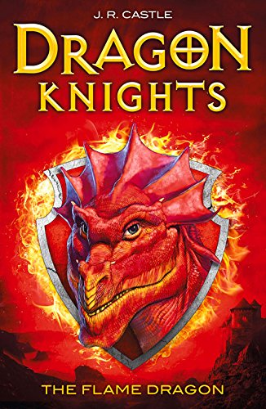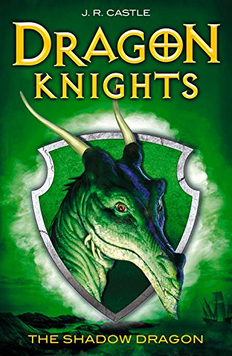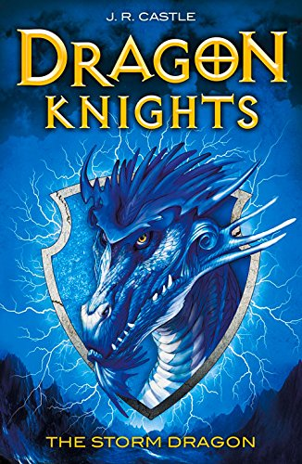

作者简介：

J. R. Castle is a pseudonym for a group of writers from the highly successful HOTHOUSE FICTION.

英文书名：The Flame Dragon
作 者：J. R. Castle
出 版 社：Piccadilly Press
代理公司：Hot Key Books / ANA
出版日期：2015年7月
代理地区：中国大陆、台湾
审读资料：电子稿/样书
页 数：224页
类 型：少年文学

内容简介：

Twelve years ago, on the Islands of Alariss, General Vayn gained power in a military coup after the emperor and empress had 'a tragic accident'. The Dragon Knights, an elite force loyal to the emperor, with the ability to transform into dragons, were defeated by Vayn's dark magic during a fierce battle. Vayn used his powers to bind the Dragon Knights in their human forms and banished them to the outer islands. Now the realm is in ruins and Vayn's Black Guard rampage through it, taking whatever they want.

When Vayn's nephew, Quinn, discovers that he's the Crown Prince, the true heir, rescued and brought up by his former palace nursemaid, he swears to stand up to his uncle and claim what is rightfully his. Ignus the Flame Dragon has been trapped in human form as a blacksmith in the Floating Mountains. With the help of Thea, a feisty girl with magic skills and an uncertain past, Quinn must break the spell and return Ignus to his true Dragon Knight destiny.

The first in an exciting new dragon-fantasy series for 9-12 year olds.

英文书名：The Shadow Dragon
作 者：J. R. Castle
出 版 社：Piccadilly Press
代理公司：Hot Key Books / ANA
出版日期：2015年7月
代理地区：中国大陆、台湾
审读资料：电子稿/样书
页 数：192页
类 型：少年文学

内容简介：

Evil General Vayn gained power twelve years ago on the Islands of Alariss, defeating the Dragon Knights, an elite force with the ability to transform into dragons, using dark magic to bind them in their human forms. Now the realm is a ruin and Vayn's Black Guard rampage the land, taking whatever they want.

Twelve-year-old Quinn, Vayn's nephew and the true heir has sworn to claim the realm that is rightfully his. With the help of Thea, a feisty girl with magic skills and an uncertain past, and Ignus the Flame Dragon, he travels to the remote and misty Keriss Island to seek his destiny. The Black Guard and their allies are on their heels when they meet Ulric, another Dragon Knight. Can they trust the shapeshifter to aid them in their quest? And will Quinn gain control of his own emerging dragon powers before it's too late?

The second in an exciting new dragon-fantasy series for 9-12 year olds!

英文书名：The Storm Dragon
作 者：J. R. Castle
出 版 社：Piccadilly Press
代理公司：Hot Key Books / ANA
出版日期：2016年1月
代理地区：中国大陆、台湾
审读资料：电子稿/样书
页 数：192页
类 型：少年文学

内容简介：

Outgrown BEAST QUEST? Enter the world of the Dragon Knights! Quinn, Thea and the Fire and Storm Dragons journey to the next island of Alariss to find Nord, the Wind Dragon. Since the rise of evil Uncle Vayn, Nord has lived a reclusive life in his family's ancestral home in the Auric Citadel. Nord laments not only the loss of his dragon powers, but also the disappearance of his betrothed, Catherine. As the wealthy residents prepare to celebrate the Blood Moon festival a mysterious illness is gripping Nord's subjects. Nord is finally awakened to the evil that is taking place and trusting Quinn he allows himself to be released to assume his dragon form ...

谢谢您的阅读！
请将回馈信息发至：李馥辰(Cindy Li)
安德鲁﹒纳伯格联合国际有限公司北京代表处
北京市海淀区中关村大街甲59号中国人民大学文化大厦1705室, 邮编：100872
电 话：010-82509406
传 真：010-82504200
Email：Cindy@nurnberg.com.cn
网 站：Http://www.nurnberg.com.cn
新浪微博：http://weibo.com/nurnberg
豆瓣小站：http://site.douban.com/110577/


