新 书 推 荐
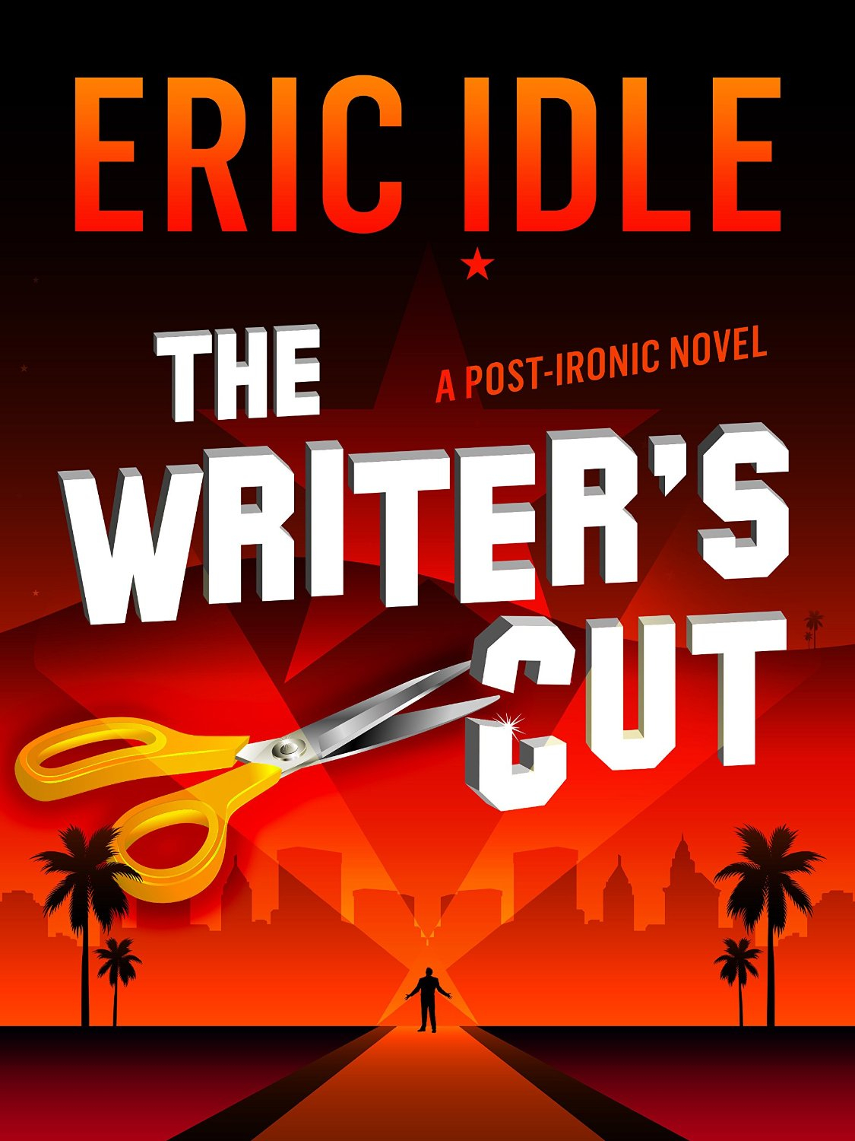
中文书名：《作者的取舍》
英文书名：THE WRITER'S CUT
作 者：Eric Idle
出 版 社：Canelo
代理公司：ANA/Maggie
页 数：116页
出版时间：2015年10月
代理地区：中国大陆、台湾
审读资料：电子稿
类 型：小说

内容简介：
A manic satirical ride through the booze and sex-fuelled world of Tinseltown from one of the world's most-loved comedians - Monty Python legend Eric Idle.
Set during the glorious days of the Bush Empire before they finally invaded and killed irony, The Writer’s Cut follows Stanley Hay, a joke writer. He has a girlfriend, a writing partner and a career going nowhere in particular. Wisecracking, ambitious and horny, Stanley decides that he is going to change that by writing a novel. This is where things start to spiral out of control.
Caught up in the excitement Stanley falsely confesses that the novel will be a kiss-and-tell (a kiss and sell?) featuring Hollywood’s most famous and glamorous actresses. Before long expectations are going through the roof, Stanley is a celebrity in his own right and he's living the LA highlife.
There's only one little problem...

作者简介：
ERIC IDLE is a comedian, actor, author, singer, playwright, and songwriter. Co-creator of ‘Monty Python’ on TV, stage and films, including ‘The Holy Grail’, which later he adapted for the stage as ‘Spamalot’. Creator of ‘The Rutles’, he starred as Ko-Ko in the English National Opera version of ‘The Mikado’, has appeared in ‘The Pirates of Penzance’ and wrote and performed the comic oratorio ‘Not The Messiah, He’s a Very Naughty Boy’. His musical play ‘What About Dick?’ co-stars Eddie Izzard, Russell Brand, Billy Connolly and Tracey Ullman. Eric has written two novels, Hello Sailor and The Road to Mars, and appeared in several movies, including ‘Nuns On the Run’, ‘Shrek The Third’, and ‘The Adventures of Baron Munchhausen’. Last year he wrote and directed the final Monty Python reunion show ‘One Down Five To Go’ at London’s O2.

媒体评价：
“I laughed, I cried, and then I read the book.” ------------Steve Martin

“Filled with intelligent observations about comedy and comedians, and enough one-liners to keep a funnyman in gigs past Pluto.” -------------The New York Times

“Dazzling … the language, the jokes, the problems and foibles of his characters are purely of our time.”----------------Los Angeles Times

谢谢您的阅读！
请将反馈信息发至：丁佳钰（Maggie Ding ）
安德鲁﹒纳伯格联合国际有限公司北京代表处
北京市海淀区中关村大街甲59号中国人民大学文化大厦1705室
邮编：100872
电话：010-82449325
传真：010-82504200
Email: Maggie@nurnberg.com.cn
网址：www.nurnberg.com.cn
新浪微博：http://weibo.com/nurnberg
豆瓣小站：http://site.douban.com/110577/

