新 书 推 荐
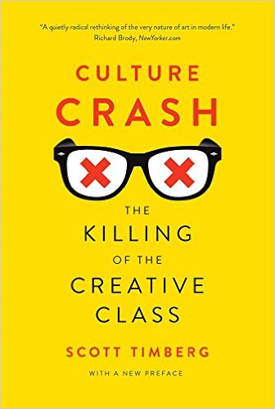
中文书名：《被冲击的创意产业》
英文书名：Culture Crash: The Killing of the Creative Class
作 者：Scott Timberg
出 版 社：Yale University Press
代理公司：ANA/Maggie
页 数：336页
出版时间：2016年1月
代理地区：中国大陆、台湾
审读资料：样书
类 型：Non-fiction

内容简介：
Change is no stranger to us in the twenty-first century. We must constantly adjust to an evolving world, to transformation and innovation. But for many thousands of creative artists, a torrent of recent changes has made it all but impossible to earn a living. A persistent economic recession, social shifts, and technological change have combined to put our artists—from graphic designers to indie-rock musicians, from architects to booksellers—out of work. This important book looks deeply and broadly into the roots of the crisis of the creative class in America and tells us why it matters.

Scott Timberg considers the human cost as well as the unintended consequences of shuttered record stores, decimated newspapers, music piracy, and a general attitude of indifference. He identifies social tensions and contradictions—most concerning the artist’s place in society—that have plunged the creative class into a fight for survival. Timberg shows how America’s now-collapsing middlebrow culture—a culture once derided by intellectuals like Dwight Macdonald—appears, from today’s vantage point, to have been at least a Silver Age. Timberg’s reporting is essential reading for anyone who works in the world of culture, knows someone who does, or cares about the work creative artists produce.

作者简介：
Scott Timberg writes on music and culture and contributes to Salon and the New York Times. He runs ArtsJournal’s Culture Crash blog and lives in Los Angeles.

媒体评价：
“Timberg—himself a culture journalist who was a victim of one of the Los Angeles Times’s seemingly endless series of layoffs—makes a good case that, as Bob Dylan once put it, ‘something there’s been lost.’”—Ben Yagoda, New York Times Book Review
(Ben Yagoda New York Times Book Review)
"A quietly radical rethinking of the very nature of art in modern life."—Richard Brody, NewYorker.com
(Richard Brody NewYorker.com)
"If you believe that the life of your mind is inseparable from the health of your life, that serious art and artists are an essential component to human nourishment, then you have an obligation, to yourself and your children and us all, to read Timberg's book."—William Giraldi, The New Republic
(William Giraldi New Republic 2015-03-26)

谢谢您的阅读！
请将反馈信息发至：丁佳钰（Maggie Ding ）
安德鲁﹒纳伯格联合国际有限公司北京代表处
北京市海淀区中关村大街甲59号中国人民大学文化大厦1705室
邮编：100872
电话：010-82449325
传真：010-82504200
Email: Maggie@nurnberg.com.cn
网址：www.nurnberg.com.cn
新浪微博：http://weibo.com/nurnberg
豆瓣小站：http://site.douban.com/110577/

