新 书 推 荐
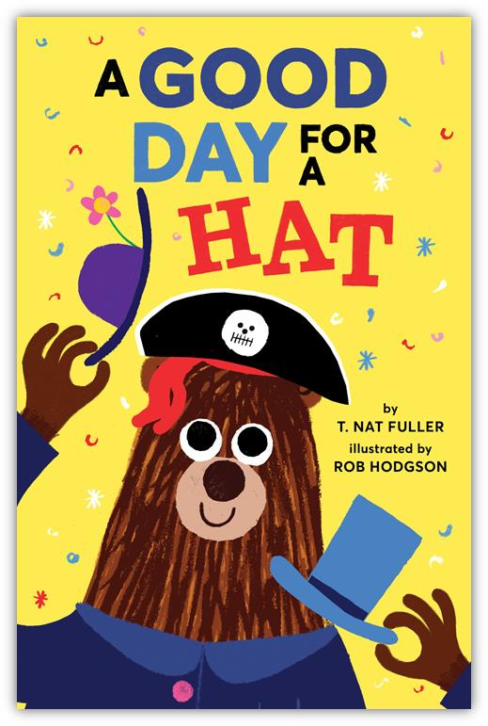
英文书名：A Good Day For A Hat
作 者：T. Nat Fuller (文）Rob Hodgson (图)
出 版 社：Abrams Appleseed
代理公司：ANA
出版日期：2017年3月
代理地区：中国大陆、台湾
审读资料：电子稿/样书
页 数：32页
类 型：3-5岁儿童绘本

卖点提炼：

- TAPS INTO A CHILD'S IMAGINATION: Young children love playing dress-up, and a hat is one of the most accessible articles of clothing to imaginative play.
- REPETITION AND ANTICIPATION: The structure of this book is very predictable. It won't be long before a child realizes that every time Mr. Brown steps outside (and every time the page is turned), something silly will happen. Recognizing patterns in this way is a step toward building problem-solving skills. Additionally, repeated text helps a child recognize words and "read" along with her parent, key steps to pre-literacy.
- CHARMING ILLUSTRATION: Rob Hodgson's accessible, silly, almost childlike art is the perfect complement to this playful text. The details he adds to his backgrounds and characters are sure to tickle children and parents alike.

内容简介：

Mr. Brown loves hats and can’t leave the house without wearing just the right one. But every time he opens the door to leave, the situation changes, and Mr. Brown feels the need to change his hat to fit. Careful readers will notice that there's a magic rabbit on every page, the likely cause of Mr. Brown's crazy day.

At last, Mr. Brown is running late and can’t make any further wardrobe changes. He decides to wear every hat he owns and is finally on his way. When he finally arrives at his destination, we find that it’s Mr. Brown’s birthday, and his friends have just the right hat for that.

In A GOOD DAY FOR A HAT, anything is possible when the door opens and a child turns the page.

作者简介：

T. Nat Fuller is very fond of hats and is on a constant quest to find just the right one. A Good Day for a Hat was inspired by real-life events sure to be recognized by anyone living in Chicago.
Rob Hodgson is an award-winning illustrator living in Bristol, England.

内文图画：

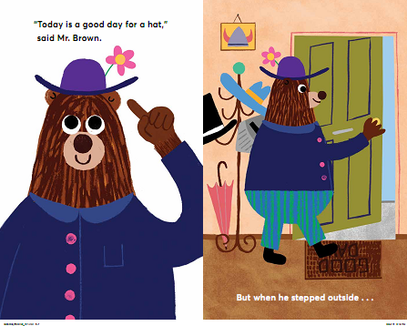
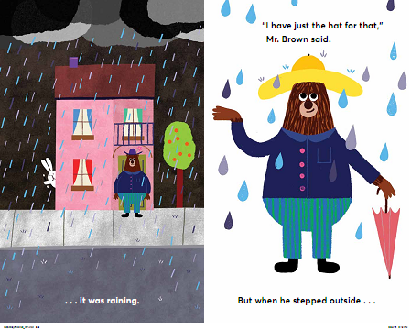

谢谢您的阅读！
请将回馈信息发至：宁非 (Katalin Ning)
安德鲁﹒纳伯格联合国际有限公司北京代表处
北京市海淀区中关村大街甲59号中国人民大学文化大厦1705室, 邮编：100872
电 话：010-82509406
传 真：010-82504200
Email：Katalin@nurnberg.com.cn
网 站：Http://www.nurnberg.com.cn
新浪微博：http://weibo.com/nurnberg
豆瓣小站：http://site.douban.com/110577/
微信订阅号：安德鲁书讯


