新 书 推 荐

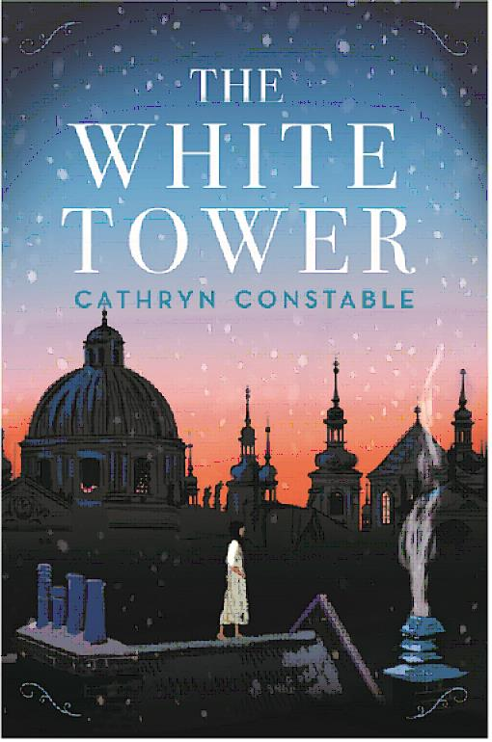
英文书名：The White Tower
作 者：Cathryn Constable
出 版 社：Chicken House
代理公司：ANA
出版日期：2017年1月
代理地区：中国大陆、台湾
审读资料：电子稿/样书
页 数：待定
类 型：12-14岁儿童文学

卖点提炼：

- From the worldwide bestselling author of The Wolf Princess-over 100,000 copies sold.
- Science meets dreamy reality in this rich, atmospheric adventure.
- Magical realism at its best for ages 10-14.

内容简介：

Livy is stunned when she is offered a place at Temple College, a prestigious school for the very brightest – because she is not. Recently, Livy’s been drawn to the roof of the school, where, amongst the towering stone sentinels, she dreams she can step into the sky. But her dreams are more real than she thinks …

作者简介：


After leaving Cambridge University to become a journalist, Cathryn Constable wrote for a number of publications before turning her hand to writing for children. She lives in Islington, London.

媒体评价：

Praise for THE WOLF PRINCESS:

‘… thrilling and magical …’ FOYLES
‘… an engrossing, deeply atmospheric story.’ DAILY TELEGRAPH

谢谢您的阅读！
请将回馈信息发至：李馥辰(Cindy Li)
安德鲁﹒纳伯格联合国际有限公司北京代表处
北京市海淀区中关村大街甲59号中国人民大学文化大厦1705室, 邮编：100872
电 话：010-82509406
传 真：010-82504200
Email：Cindy@nurnberg.com.cn
网 站：Http://www.nurnberg.com.cn
新浪微博：http://weibo.com/nurnberg
豆瓣小站：http://site.douban.com/110577/


