新 书 推 荐

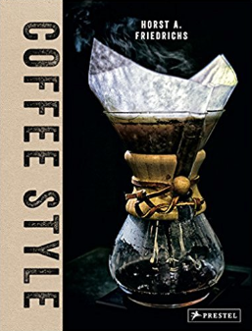
中文书名：《》
英文书名：Coffee Style
德文书名：Coffee Style: Kaffee Kult Genuss
作 者：Horst A. Friedrichs, Nora Manthey
出 版 社：Random House Germany
代理公司：ANA/ Susan Xia
页 数：208页（包含内文图片）
出版时间：2017年7月
代理地区：中国大陆、台湾
审读资料：电子稿
类 型：时尚生活

内容简介：
For some, coffee is a means of getting through the morning. For others, it is a way of life. Fascinated by artisanal coffee culture, celebrated photographer Horst A. Friedrichs turns his lens toward every aspect of coffee - from beans to espresso machines, and from baristas to consumers. Stepping inside the worlds best coffee shops, Friedrichs shows just how sophisticated the practice of making coffee has become. Delicious shots of classic drip cones and decades-old Chemex coffee makers are interspersed with images of beakers filled with dark liquid simmering over a flame and brewers extracting the perfect concentrate to be poured over ice. He also captures coffee's fashion aesthetic - from witty and vintage t-shirts to upscale extracts and felt filters. Nora Manthey's texts profile the leading minds of the third wave and reveal their transformative craft. As luscious as a freshly poured cup of espresso, this is a delightfully irresistible book that will be at home on any coffee table.
作者简介：
Nora Manthey is a freelance journalist based in London.

Horst A. Friedrichs's photographs have appeared in Stern, the Independent, and the New York Times. He is the author of Drive Style, I'm One: 20th Century Mods, Or Glory: 21st Century Rockers, and Cycle Style (all by Prestel). He lives in London.

谢谢您的阅读！
请将反馈信息发至：夏蕊（Susan Xia）
安德鲁·纳伯格联合国际有限公司北京代表处
北京市海淀区中关村大街甲59号中国人民大学文化大厦1705室
邮编：100872
电话：010-82504406
传真：010-82504200
Email：susan@nurnberg.com.cn
网址：http://www.nurnberg.com.cn
微博：http://weibo.com/nurnberg
豆瓣小站：http://site.douban.com/110577/

