图 书 推 荐
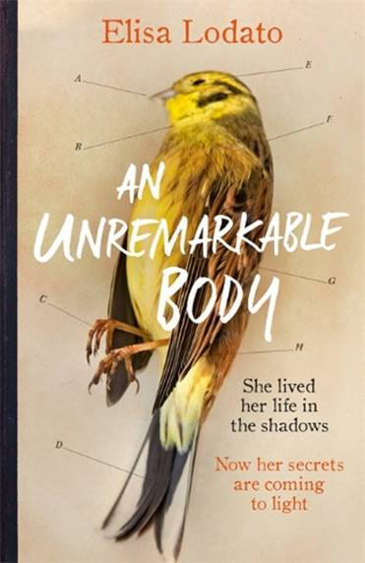
中文书名：《伟大的躯体》
英文书名：AN UNREMARKABLE BODY
作 者：Elisa Lodato
出 版 社：Weidenfeld & Nicolson
代理公司：Curtis Brown/ANA/Vicky Wen
页 数：288页
出版时间：2019年3月
代理地区：中国大陆、台湾
审读资料：电子稿
类 型：文学

- Shortlisted for the 2018 Costa First Novel Award!

内容简介：

EVERY MOTHER IS A WOMAN WITH A PAST

When Katharine is found dead at the foot of her stairs, it is the mystery of her life that consumes her daughter, Laura. The medical examiner's report, in which precious parts of Katharine's body are weighed and categorised, motivates Laura to write her own version of events; to bear witness to the unbearable blank space between each itemised entry. It forces her to confront a new version of the woman she knew only as her mother - a woman silenced by her own mother, and wronged by her husband. A woman who felt shackled by tradition and unable to love freely.

With the heart of a memoir and the pace of a thriller, AN UNREMARKABLE BODY reveals an overwhelming desire to make sense of an unfulfilled life - and to prove that an unremarkable body does not mean an unremarkable life.

作者简介：

Elisa Lodato grew up in London and read English at Pembroke College, Cambridge. After graduating she went to live in Japan where she spent a year teaching, traveling and learning to speak the language. On returning to the UK she spent many happy years working for Google before training to become an English teacher. Helping pupils to search for meaning in a text inspired Elisa to take up the pen and write her own. Her first novel, An Unremarkable Body, was long-listed for the Bath Novel Award 2016. Elisa lives in Surrey with her husband and two children.
媒体评价：

“A beautifully told tale of love and loss, which ever so gently reaffirms that no life is indeed unremarkable . . . Lodato probes the secrets that are scattered through one character's life and draws us into her world . . . absorbing and compelling . . . startlingly bittersweet . . . I couldn't stop reading and now I'm done I wish I could read it all over again.”
----Ronnie Turner, book blogger

“This novel pulls you in and will have you racing to reach the end.”
----GOOD HOUSEKEEPING

“Lodato's skill is that of Katharine's pathologist; precise, delicate and thorough. A tender dissection of brutal truths.”
----Dexter Petley, author of WHITE LIES

“An uplifting story.”
----GRAZIA

“An intriguing tale of love, loss and missed opportunities . . . although infused with sadness, it is written with verve and delivers an amazing twist.”
----Deirdre O'Brien, SUNDAY MIRROR

“An incredibly moving story of maternal love, sacrifice, and how little we know about those closest to us. This beautifully-written novel had me gripped until the last page.”
----Chloë Mayer, author of THE BOY MADE OF SNOW

“AN UNREMARKABLE BODY is clever, evocative and sensitively written. There's so much to love about this book. These characters will creep into your thoughts.”
----Polly Courtney, author of FERAL YOUTH

“A haunting debut about grief, loss and motherhood - and a woman's identity beyond that role.”
----THE POOL

“An Unremarkable Body is infused with sadness but avoids being morbid or cloying. It is written with verve, pace and sensitivity. A fabulous debut that also delivers an amazing twist as a final flourish.”
----THE PEOPLE

“An Unremarkable Body is a well-crafted story of grief and loss. Beautiful, sensitive, and poignant.”
----Clarissa Goenawan, author of RAINBIRDS

谢谢您的阅读！
请将回馈信息发送至：文清（Vicky Wen）
安德鲁﹒纳伯格联合国际有限公司北京代表处
北京市海淀区中关村大街甲59号中国人民大学文化大厦1705室, 邮编：100872
电话：010-82449185
传真：010-82504200
Email: Vicky@nurnberg.com.cn
网址：www.nurnberg.com.cn
微博：http://weibo.com/nurnberg
豆瓣小站：http://site.douban.com/110577/
微信订阅号：ANABJ2002

