新 书 推 荐

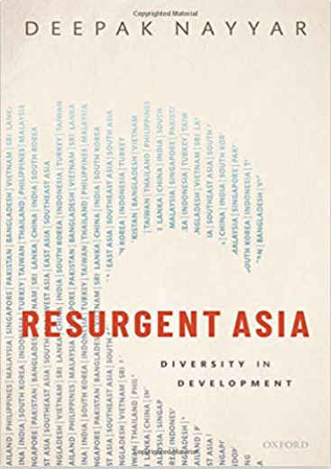
中文书名：《亚洲复苏:多样性发展》
英文书名：Resurgent Asia: Diversity in Development
作 者：Deepak Nayyar
出 版 社：Oxford University Press
代理公司：ANA/Jessica Wu
页 数：320页
出版时间：2019年10月
代理地区：中国大陆
审读资料：电子稿
类 型：经管

内容简介：

Gunnar Myrdal published his magnum opus Asian Drama, in 1968, to conclude that Asia's development prospects were gloomy. Since then, contrary to Myrdal's expectations Asia has been transformed beyond recognition, the development of nations and living standards of people revolutionized. These transformations have been uneven across countries and unequal among people. Yet, Asia's economic progress in this short timespan has been remarkable and almost unprecedented in history.

Resurgent Asia provides an analytical narrative of Asia's incredible economic development, situated in the wider context of historical, political, and social factors. It also provides an economic analysis of underlying factors that assisted Asia's growth and the critical issues in the process of development.

Resurgent Asia studies not only the sub-regions East, Southeast, South, and West Asia, but also the major countries - China, India, South Korea, Indonesia, Turkey, Thailand, Philippines, Malaysia, Singapore, Pakistan, Bangladesh, Vietnam, and Sri Lanka- which account for more than four-fifths of Asia's population and income.

Key USPs:

·Assesses how development thinking and development outcomes in Asia have changed since Gunnar Myrdal published Asian Drama 50 years ago
· Situates development in Asia within historical perspectives and political and social factors
· Connects the present with the past to reflect on the future of Asia
· An open access title available under the terms of a CC BY-NC-SA 3.0 IGO licence

作者简介：

Deepak Nayyar is Emeritus Professor of Economics at Jawaharlal Nehru University, New Delhi, and an Honorary Fellow of Balliol College, Oxford. He was previously Distinguished University Professor of Economics at the New School for Social Research, New York and taught at the University of Oxford, the University of Sussex, and the Indian Institute of Management, Calcutta. He served as Vice Chancellor of the University of Delhi, and as Chief Economic Adviser to the Government of India. He has published widely in academic journals. His books include Asian Transformation: An Inquiry into the Development of Nations, and Catch Up: Developing Countries in the World Economy, both Oxford University Press.

媒体评价：

I read Resurgent Asia with a pulsating joy and a lingering feeling that something momentous is at stake in Asia.
----Ashwani Kumar, Tata Institute of Social Sciences, Financial Express

Nayyar's painstaking statistical compilation demonstrates clearly as to what policies worked and what could not.
----Sanjaya Baru, Institute for Defence Studies & Analysis, The Indian Express

This is a positive story that combines marshalling of data and culling of stories about growth over the past 50 years.
----Siddharth Singh, Open the Magazine

Contents
1: Historical perspective and initial conditions
2: The rise of Asia
3: The macroeconomics of growth
4: Structural change and economic transformation
5: Openness and industrialization
6: Markets, governments, and politics
7: Unequal outcomes for countries and people
8: Asian development and the world economy
9: Contemplating the future

谢谢您的阅读！

请将反馈信息发至：吴伊裴（Jessica Wu）
安德鲁·纳伯格联合国际有限公司北京代表处
北京市海淀区中关村大街甲59号中国人民大学文化大厦1705室
邮编：100872
电话：010-82449901
传真：010-82504200
Email：jessica@nurnberg.com.cn
网址：http://www.nurnberg.com.cn
微博：http://weibo.com/nurnberg
豆瓣小站：http://site.douban.com/110577/

