新 书 推 荐

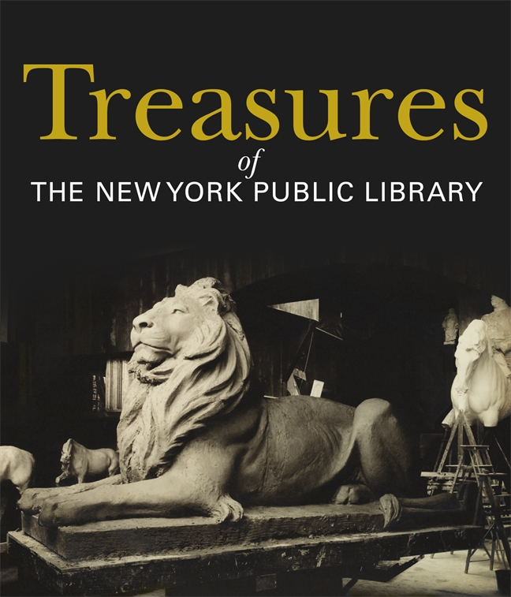
中文书名：《纽约公共图书馆的珍宝》
英文书名：Treasures of the New York Public Library
作 者：New York Public Library
出 版 社：St. Martin’s Press
代理公司：ANA/Connie
出版时间：2021年2月
代理地区：中国大陆、台湾
页 数：352页
审读资料：电子材料
类 型：艺术/历史

内容简介：

为纽约公共图书馆(New York Public Library)的档案馆《珍宝》展览配上一本插图丰富的书

在它的三座研究图书馆的墙壁内，纽约公共图书馆是一个奇迹的宫殿，包含超过4600万件不同的收藏品，包括珍贵的书籍、地图、绘画、印刷品、雕塑、照片、电影、录音、家具、蜉蜉蜉影、珍贵和重要的历史文献等等。

为了纪念纽约公共图书馆成立125周年，图书馆在其标志性的第42街建筑的一层精致的Gottesman大厅举行了第一次永久性展览：纽约公共图书馆的珍宝波隆斯基展览。

伴随这次展览的官方书籍是《珍宝》：一本华丽的四色卷书，展示了图书馆藏书的深度和广度。宝藏中充满了历史创造者和改变了世界的影响者的创作，包括纽约警察局收藏的各种物品，如托马斯·杰斐逊手写的独立宣言;最初的权利法案；查尔斯·狄更斯的桌子上；乔治·华盛顿手写的告别演说；玛雅·安杰卢、查尔斯·狄更斯、T.S.艾略特、杰克·凯鲁亚克、弗拉基米尔·纳博科夫、玛丽·雪莱、弗吉尼亚·伍尔夫等多位作家的手稿材料：古腾堡圣经；马尔科姆·艾克斯的公文包；最初的小熊维尼娃娃；现存的唯一一封由克里斯托弗·哥伦布写给费迪南国王关于他的发现的信，以及一块约公元前2300年的苏美尔楔形文字石碑。

《珍宝》是纽约公共图书馆送给世界的礼物。

作者简介：

纽约公共图书馆（The New York Public Library）是一个免费为纽约和其他地区的人提供教育和信息的设施。在布朗克斯区、曼哈顿和斯塔顿岛有92个地点，包括研究和分馆，图书馆向从幼儿到学者的所有人提供免费资料、电脑使用、课程、展览、节目等等，近年来参观人数和流通人数都创下了记录。纽约公共图书馆每年为超过1700万的读者服务，全球还有数百万人在使用其网站上的资源。为了提供如此广泛的免费程序，纽约公共图书馆依赖于公共和私人资金。了解更多关于如何在他们的网站上支持。
媒体评价：

以下是《纽约时报》关于此次《珍宝》展览的媒体报道：

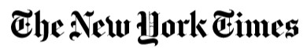
Treasures to Be Un-Hidden at New York Public Library
By James Barron
March 12, 2019

It is an almost incomprehensible number: 46 million. That is how many items the New York Public Library says it has in its collection, and not all of them are books.

There is a 16th-century globe that shows how little European cartographers knew in those days. North America appears as a smattering of islands. Near the Equator are the Latin words for “Here lie dragons.”

There is a draft of the Bill of Rights with two possible constitutional amendments that were never ratified.

And there is a handwritten draft of the Declaration of Independence by Thomas Jefferson. There is what looks like a semicolon after “We hold these truths to be self-evident” — not the comma that appeared in the printed version. And there is material that was deleted before the Second Continental Congress adopted it, including a condemnation of the slave trade. What did Jefferson mean? And, did the comma make a difference in the very first line?

The president of the library, Anthony W. Marx, hopes that people will ask such questions when the library puts these treasures on display next year in a new gallery, along with a sizable list of other intriguing items that it has acquired over the years. Among them is a copy of “A Christmas Carol” by Charles Dickens — specifically, the copy that Dickens carried on an American tour in the mid-19th century, with notes he scribbled in the margins about passages he read aloud during lectures.

Want more Dickens? The gallery will have his letter opener, made from the paw of his cat Bob, to whom the curators say Dickens was passionately devoted.

Want a dog rather than a cat? The gallery will have Elizabeth Barrett Browning’s notebook. Amid drafts of poems is a page with a sketch of her dog Flush.

Also going into the gallery will be a copy of “The Green Book,” the guide for black travelers in the days of Jim Crow that was made famous by the 2018 film starring Viggo Mortensen and Mahershala Ali. At the Academy Awards on Feb. 24, the film won best picture, and Mr. Ali won best supporting actor.

These items have always been available to scholars and researchers, but the library hopes to broaden awareness by showing them in the new gallery in its main building on Fifth Avenue at 42nd Street in Manhattan. The goal is to pique the interest of visitors — to make them wonder what else the library stowed away over the years as it carried out its mission of collecting and preserving the world’s knowledge.

“At a time when the very notion of fact is in dispute, we store the records that have all the facts,” Dr. Marx said. “It’s essential that people understand that and use what’s here to be informed.”

And there is a lot to use. Dr. Marx, who became president of the library in 2011 after eight years as president of Amherst College, said that when he arrived, he was “stunned and shocked to see the treasures we have here that most people don’t know exist.”

“That’s because we don’t show them very often,” he said. “The Bill of Rights, we only showed at the Bicentennial for a couple of days” in 1976.

“We all agree it is our responsibility to keep these treasures safe, and we will,” he said. “But it is also our responsibility not just to keep them in a safe.”

But the library is not a museum and is not trying to become one. Still, like a museum, it cannot show everything it has at any one time. So for starters, Dr. Marx said that the library’s curators had picked some of its “most historically powerful and important material” for the exhibition space.

The gallery project is part of a $317 million master plan, adopted in 2017, that also calls for turning some office space into a cafe. The gallery will occupy a large room a few steps away — Gottesman Hall, which had housed temporary exhibitions.

The project — the remodeling of Gottesman Hall and the curator who will oversee it — is being paid for from a $12 million donation from the Polonsky Foundation and the financier Leonard S. Polonsky, who has long lived in London but has New York roots. He grew up in Brooklyn, attended Townsend Harris High School (where he was Student Council president and editor of the literary magazine) and New York University before going on to Oxford and the Sorbonne.

Also envisioned in the master plan is a new education center where high school and college classes can learn how to do primary research — and actually do some.

The gallery in Gottesman Hall will give the library a way to capitalize on New York’s tourism economy, which has defied predictions that the Trump administration’s protectionist policies and America-first rhetoric would change where travelers decide to go. The number of visitors to the city rose to a record high of 65.2 million in 2018, the ninth straight annual increase.

But tourism is not something the library tracks closely. Library officials do not have detailed data on how many people passing between the lions that keep watch at the main entrance are tourists visiting a famous New York landmark, how many are ordinary readers looking for a book and how many are scholars or researchers seeking to examine an obscure volume that can be found only at the library.

Still, Dr. Marx estimated that half are tourists and half are researchers. Surveys have indicated that about 30 percent of the visitors live outside of New York City.

Whatever the figures, the exhibition of treasures will be about much more than show and tell. “This isn’t simply an opportunity to see things in glass cases, but to understand the importance of primary research,” said William Kelly, the director of the library’s four research centers. “It’s a chance to unearth stories from the material.”

Consider the library’s copy of the Jefferson draft, one of four known to exist. Dr. Marx said it showed how he edited one of America’s essential documents. “You can see that the most hallowed document in American history was up for debate up to the very last minutes,” he said.

He and Dr. Kelly moved on to the only known copy of the first printing of a letter from Christopher Columbus from 1493 that said, as Dr. Marx put it, “I think I found something.” Dr. Marx said it summarized Columbus’s vision for the New World, opening the way to “every argument for colonialism that would be invented in the 300 years after.”

“It’s an amazing thing to contemplate,” he said. “I taught third-world development and colonialism at Columbia for 13 years, and I didn’t know this letter existed. It’s an amazing teaching tool. Read the original, debate it.”

谢谢您的阅读！
请将回馈信息发至：萧涵糠(Connie Xiao)
安德鲁﹒纳伯格联合国际有限公司北京代表处
北京市海淀区中关村大街甲59号中国人民大学文化大厦1705室, 邮编：100872
电话：010-82449325
传真：010-82504200
Email: Connie@nurnberg.com.cn
网址：www.nurnberg.com.cn
微博：http://weibo.com/nurnberg
豆瓣小站：http://site.douban.com/110577/
微信订阅号：ANABJ2002


