新 书 推 荐
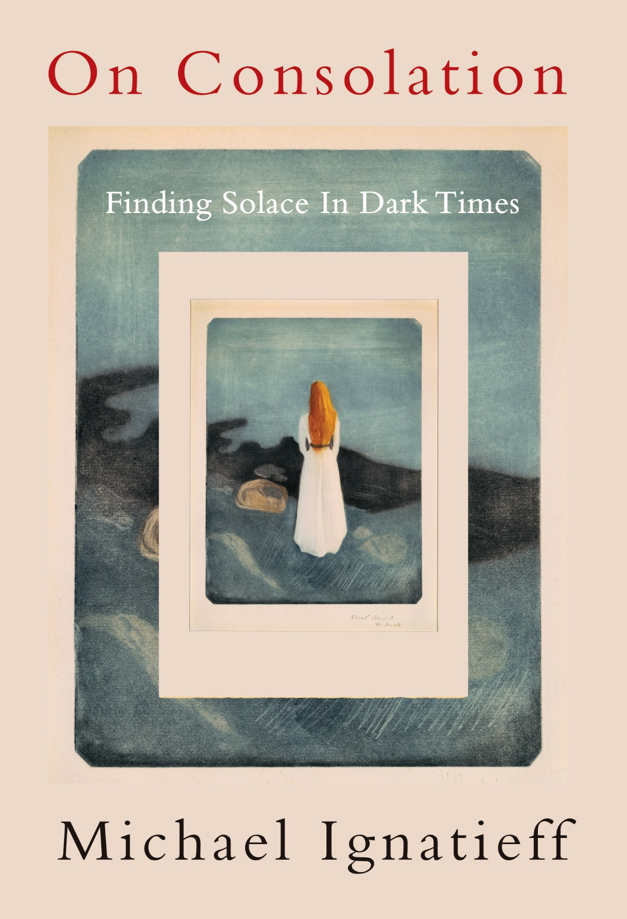
中文书名：《安慰论：如何在困境中获得安慰》
英文书名：ON CONSOLATION: FINDING SOLACE IN HARD TIMES
作 者：Michael Ignatieff
出 版 社：Knopf
代理公司：Westwood/ANA/Claire Qiao
出版时间：2021年11月
代理地区：中国大陆、台湾
页 数：316页
审读资料：电子稿
类 型：励志

本书版权已授：西班牙，德国，荷兰，加拿大，德国，意大利，罗马尼亚，英国，美国

中文繁体字版已授权

内容简介：

Oct. 1, Kirkus Reviews, review
“The noted academic and former politician examines the nature of consolation as a means of helping us accept the tragic reality of our lives. ‘Consolation is what we do, or try to do, when we share each other’s suffering or seek to bear our own,’ writes Ignatieff. ‘What we are searching for is how to go on, how to keep going, how to recover the belief that life is worth living.’ The author is generous in providing cases in point. Foremost is Job, the biblical figure whom God tested with exquisitely awful punishments. The great lesson of Job, Ignatieff suggests, is not that he eventually bows to his tormentors, but that he teaches us to ‘refuse the false consolations of those who deny what we have endured.’ The author then turns to the Psalms, which 'have enabled men and women in pain, throughout the ages, to grasp the commonality of their experience.' Both Job and the Psalms, he adds, give us the language to express our hurt. Cicero may not have been the greatest model of probity, but the Roman philosopher adds to that literature, as does Marcus Aurelius, the Stoic emperor, whom Ignatieff credits with setting a noble example: ‘For it is consoling to know that not even an emperor can get through the night, alone with his thoughts. That is something we can share with him.’ Montaigne turned to his thoughts, alone in his tower, in the face of a terrible religious civil war that had lasted for 30 years. Having witnessed the peasants in the countryside around him prepare for their plague-borne deaths by digging their own graves and awaiting the end, he found consolation for his impending demise. Marx and Lincoln also figure in these pages, as does Cicely Saunders, the founder of the hospice movement. Ignatieff concludes that consolation is a species of grace, which makes the consoler an angel in disguise. An inspiration for those in need of words to carry on with life.”

Sept. 13 Publishers Weekly, review
“Great minds find meaning in great sorrow in this searching meditation from historian Ignatieff (Fire and Ashes). Old texts, Ignatieff writes, are 'still there to help us in our hour of need, to perform their ancient task once again,' and he surveys a variety of thinkers’ responses to death, bereavement, sickness, political disappointment, and civilizational collapse. These include Job’s questioning of a seemingly callous God, Paul’s promise that suffering leads to eternal life with Christ, and the stoic acceptance of misfortune by Roman statesmen Cicero and Marcus Aurelius. He also covers the humanist tradition of essayist Michel de Montaigne, philosopher David Hume, and sociologist Max Weber, who eased mortality’s sting with a focus on life’s daily pleasures, self-actualization, and devotion to one’s calling; Holocaust survivor Primo Levi’s project of bearing witness to the horror of Auschwitz; and hospice movement founder Cicely Saunders’s vision of dying as a valedictory summation of life. Ignatieff’s explorations of mainly post-religious discourses of consolation are erudite and elegant, though more impactful are his vivid biographical sketches of his subjects holding themselves together through failures, terminal illness, or looming execution, sometimes with the help of others’ kindness. These stories of perseverance inspire and, in their way, console. (Nov.)”

Publishers Weekly, Top Ten Religion/Spirituality Fall Announcements

本书来自加拿大最多产的思想家之一：对真正安慰的意义和如何实现的细致研究。

慰藉某人----在生命的痛苦和损失中成为意义和理解的来源----是一个人所能做的最困难的事情之一。越来越多的人不再于宗教机构中寻找安慰，而是通过个人和社交网络来找寻安慰。越来越少的人将它与政治传统联系在一起，尤其是那些告诉我们要战斗、抵抗现状而不是接受的左派。

迈克尔·伊格纳季耶夫（Michael Ignatieff）探讨了我们这些生活在世俗世界中的人，没有摆脱痛苦的来世的安慰思想，如何通过过去的宗教结构找到一种现代形式的安慰。伊格纳季耶夫利用犹太教和基督教传统中的诗篇历史，重现这些杰作，来了解其中话语的力量和极限。

《安慰论》对我们当前的时代具有悲剧性的现实意义，但也正因为如此，它才更有必要。通过这本书，我们学会了寻找安慰的意义----平衡斗争与屈服，接受失败与持久的希望之光。

作者简介：
迈克尔·伊格纳季耶夫（Michael Ignatieff）（中文名：叶礼庭）是作家、历史学家、加拿大自由党前领导人、哈佛大学肯尼迪政府学院新闻、政治和公共政策爱德华·R·默罗教授。他现任匈牙利布达佩斯中欧大学的校长和院长。他的著作包括《陌生人的需要》（The Needs of Stranger）、《俄罗斯相册》（The Russian Album）、《疤痕组织》（Scar Tissue）、《血液与归属》（Blood and Belonging）、《战士的荣誉》（The Warrior’s Honor）、《以赛亚·柏林：生命》（Isaiah Berlin: A Life）、《两害相较,取其轻》（The Lesser Evil）、《火与灰烬》（Fire and Ashes）和《普通的美德：分裂世界的道德秩序》（The Ordinary Virtues: Moral Order in a Divided World）。

谢谢您的阅读！
请将反馈信息发至： 乔明睿（Claire）
安德鲁﹒纳伯格联合国际有限公司北京代表处
北京市海淀区中关村大街甲59号中国人民大学文化大厦1705室, 邮编：100872
电话：010-82449026
传真：010-82504200
手机：15804055576
Email: Claire@nurnberg.com.cn
网址：www.nurnberg.com.cn
微博：http://weibo.com/nurnberg
豆瓣小站：http://site.douban.com/110577/
微信订阅号：ANABJ2002

