新 书 推 荐

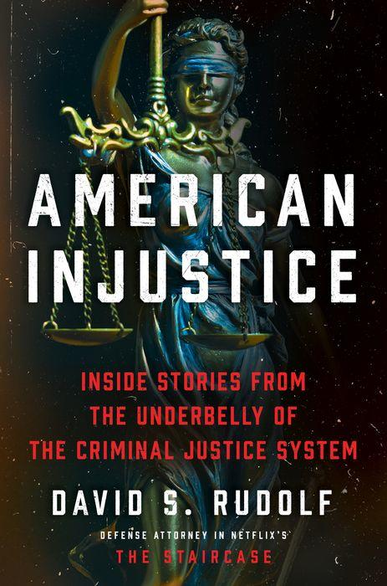
中文书名：《美国式不公正：刑事司法系统的薄弱之处》
英文书名：AMERICAN INJUSTICE: Inside Stories from the Underbelly of the Criminal Justice System
作 者：David Rudolf
出 版 社：Harpers Custom House
代理公司：Inkwell/ANA/Lauren Li
页 数：368页
出版时间：2022年1月
代理地区：中国大陆、台湾
审读资料：电子稿
类 型：大众社科/非小说

内容简介：
仅在过去的30年里，就有超过2800名无辜的美国囚犯在因没有犯下的罪行而被判刑后被释放，他们的刑期加起来超过了25000年。可怕的是，这个数字只占同期被错误指控和定罪的实际人数的一小部分。

著名的刑事辩护和民权律师大卫·鲁道夫（David Rudolf）几十年来一直在为被错误指控的人辩护。在《美国式不公正》一书中，他利用自己在美国刑事法律体系中多年的经验，揭示了存在于各级执法部门的不当行为以及随之而来的悲惨后果。鲁道夫通过他的一些最重要的案件追踪这些主题，包括《楼梯悬案》中著名的迈克尔·彼得森审判中的新细节，他带领读者进入犯罪现场，检查犯罪者留下的法医证据；重新审视未解决的谋杀案，详细说明真正的罪犯如何以及为何从未被起诉；揭示确认性偏见如何导致警察和检察官采用使错误的逮捕和起诉更有可能的策略；并揭露贫穷和种族主义如何从根本上扭曲了这个系统。

在《美国式不公正》中，鲁道夫为那些被错误指控的受害者发出了声音，并以最鲜明的方式展示了法律错误行为对人类的影响。《美国式不公正》将扣人心弦的真实犯罪报道和对美国民权的尖锐观察巧妙地融合在一起，带领读者了解亟待改革的司法系统的幕后情况。

作者简介：
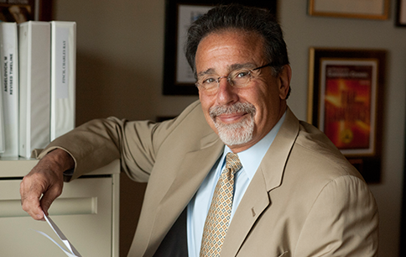
大卫·S·鲁道夫（David S. Rudolf）是美国最杰出的审判律师之一。他是获得韦比奖（the Webby Award）的刑事司法播客 "滥用权力 "（Abuse of Power）的共同主持人，他曾在联合国大学法学院和国家审判辩护研究所教授审判辩护，并在杜克大学法学院教授刑事诉讼。他还曾在美国律师协会刑事司法分会和全国刑事辩护律师协会担任过领导职务。鲁道夫因其在Netflix纪录片《楼梯悬案》中的表现而获得了全世界的赞誉，该片现正被改编为HBO Max的系列剧集。
作者官网：https://davidsrudolf.com/

媒体评价：
Good Morning America interview
https://www.goodmorningamerica.com/culture/video/david-rudolf-talks-book-american-injustice-82435979

“I’ve known David Rudolf since 1975 when we began our careers as public defenders in the Bronx. He is a brilliant and passionate advocate whose searing critique of the way power is abused in America’s criminal legal system is based on firsthand experience in the trenches, sophisticated insight, and a willingness to speak truth to power."
-- Barry Scheck, Co-Founder of & Special Counsel to The Innocence Project, Professor of Law, Cardozo Law School
“For readers seeking to top up their outrage about abuses in criminal justice, this book makes a fine companion to Bryan Stevenson’s Just Mercy and Emily Bazelon’s Charged. A stellar—and often shocking—report on a broken criminal justice system.”
-- Kirkus Reviews (starred review)
“Trial lawyers are storytellers, and when the trial lawyer is one of the very best, the stories could not be more riveting, or told with more passion. American Injustice is filled with compelling narratives, beautifully told, sweeping the reader along to the final conclusions. They are accounts of injustice and abuses of power that were not aberrant but seemingly embedded in case after case that Rudolf recounts. The impact is chilling. This is an important book not only for players in the criminal legal system, but for a public that truly needs to know.” -- Hon. Nancy Gertner (Retired)
“David Rudolf has written a searing indictment of the American criminal justice system. This terrific book is neither a polemic nor an academic treatise. By describing the cases from his amazing career, Rudolf has written a very engaging and powerful first-person account of how justice and injustice are actually done in the United States.”
-- Erwin Chemerinsky, Dean and Jesse H. Choper Distinguished Professor of Law, University of California, Berkeley School of Law
"David Rudolf has been confronting injustice for decades. In this exciting book, his powerful voice for justice will inspire the new generation and inform us all."
-- Michael E. Tigar, lawyer, teacher, author of Sensing Injustice: A Lawyer’s Life in the Battle for Change
"By sharing first-hand accounts of people falsely accused and unjustifiably prosecuted, Rudolf vibrantly demonstrates just how quickly and how permanently an innocent person’s life can be destroyed. This is a sobering, infuriating, and essential examination of the flaws and failures of the country’s legal system."
-- Booklist
“Defense attorney Rudolf debuts with a searing look at systemic failures in the U.S. justice system… Enriched by Rudolf’s firsthand experience and heartfelt compassion for his clients, this is a harrowing call for change.”
-- Publishers Weekly

谢谢您的阅读！
请将回馈信息发至：李文浩 （Lauren Li）
安德鲁﹒纳伯格联合国际有限公司北京代表处
北京市海淀区中关村大街甲59号中国人民大学文化大厦1705室, 邮编：100872
电话：010-82449901
传真：010-82504200
Email: JHuang@nurnberg.com.cn
网址：www.nurnberg.com.cn
微博：http://weibo.com/nurnberg
豆瓣小站：http://site.douban.com/110577/
微信订阅号：安德鲁书讯


