新 书 推 荐
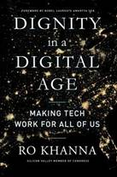
中文书名：《数字时代的尊严》
英文书名：DIGNITY IN A DIGITAL AGE
作 者：Ro Khanna
出 版 社：Simon & Schuster
代理公司：ANA/Lauren Li
页 数：368页
出版时间：2022年2月
代理地区：中国大陆、台湾
审读资料：电子稿
类 型：大众社科

内容简介：

美国国会议员罗•卡纳（Ro Khanna）提供了一个革命性的方案来应对美国的数字鸿沟，为所有人提供更大的经济繁荣。

在数字时代，获得技术及其创造的收入的不平等是美国面临的最紧迫问题之一。在那些在科技行业淘金的人和那些被数字革命甩在后面的人之间存在着经济鸿沟；在沿海科技行业的人和那些工作已经自动化的中心地带的人之间存在着地理鸿沟；在技术获取方面存在着不平等--没有电脑的学生、有不稳定WiFi的农村工人，以及大量不能在家里工作的工人。

《数字时代的尊严》正面应对这些挑战，并想象数字经济如何为全国各地的人们创造机会，而不至于使他们背井离乡。硅谷的议员罗•卡纳（Ro Khanna）提出了一个使数字创新民主化的愿景，以建立经济上有活力和包容性的社区。卡纳议员认为，我们必须引导这些强大的力量来创造一个更加健康、平等和民主的社会，而不是受制于科技对我们经济的重塑。

作者简介：
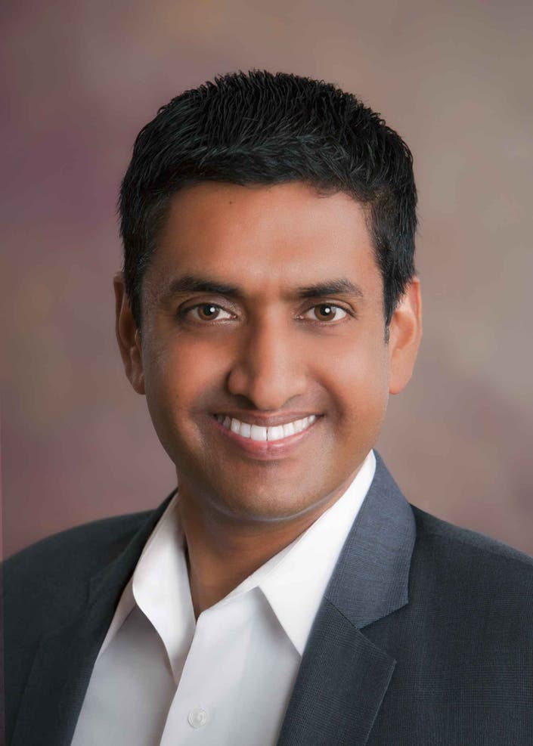
罗•卡纳（Ro Khanna）出生于1976年9月13日。他因是一名政治家而受欢迎并曾在美国总统奥巴马手下担任美国商务部副助理部长。罗•卡纳的年龄是45岁。2017年开始担任加州第17国会区的代表。他成为参议员伯尼-桑德斯的2020年总统竞选活动的全国联合主席 。

媒体评价：
“In this deeply considered and precisely detailed examination of technology’s impact on the country’s financial future and emotional present, Khanna presents policy initiatives that aim to bring civility back to public discourse, both online and in person, and to level the employment playing field. With both anecdotal accounts and factual evidence, Khanna champions the responsible use of technology to improve lives and unite factions.”
—Booklist

"Khanna has a nuanced take on the tech industry and offers genuine solutions to significant problems plaguing the country... [a] commonsense call for change."
—Publishers Weekly

“In this passionate and inspiring book, Khanna offers a vision for creating spaces for rational exchange in digital media that do not serve first and foremost economic interests. I am impressed by the precise imagination of this well-informed politician.”
—Jürgen Habermas, Professor Emeritus of Philosophy, Johann Wolfgang Goethe University of Frankfurt am Main

“Is there any dignity in digital? That’s a great question to ask in the wake of the attack on the Capitol on January 6, 2021, which got a toxic assist from tech giants like Facebook. It seems more clear than ever—from misinformation to hate speech, from screen addiction to the immense wealth held by tech billionaires—that tech is working against us more than for us, as it was intended at the dawn of the internet age. It’s to Ro Khanna’s credit then that he is trying to change the narrative so that we can democratize the inventions that were paid for by the American people and let us all share in the wonders they are capable of delivering. If you are interested in trying to even the digital playing field as we move to even more critical technologies of the future, you should read this book to find out how.”
—Kara Swisher, New York Times columnist and cohost of Pivot and host of Sway podcasts

“In his new book, California Representative Ro Khanna rolls out a vision to train rural as well as urban job-seekers to build 'digital' roads, bridges, and other aspects of infrastructure. Calling simultaneously for effective regulation of Big Tech, and protection of local community, Khanna envisions redistributing opportunities from coastal cities to rural middle-America, bridging cultural differences, and creating a new cosmo-local culture. An exciting vision, brilliantly rendered—a must read.”
—Arlie Russell Hochschild, author of Strangers in Their Own Land: Anger and Mourning on the American Right

“This book is a highly principled, empirically grounded, progressive blueprint for building an inclusive society in which all Americans share a common national identity and participate in constructive dialogue. It is founded on the possibilities of sharing technology much more widely, on building the skills and capabilities of all people, and on the basic principles of inclusion and participatory democracy to chart a path to a flourishing society.”
—James J. Heckman, Nobel Prize winner and professor of economics at the University of Chicago

“Congressman Ro Khanna’s book, Dignity in a Digital Age, is both a practical and aspirational guide to the future of tech, governance, and equity. Congressman Khanna leans on critical race and gender theorists, economists, and philosophers to articulate a vision for the future of the technology sector that centers racial and gender justice and eschews the digital segregation that has defined the tech sector since its infancy. Dignity in a Digital Age asks the question, ‘What could our country look like if we legislated and designed for marginalized people to lead the next era of Silicon Valley?’ and leads its reader to a measured understanding of how our country can’t afford any other alternative. Too often, the voices of people of color who’ve called for a radical reimagining of technology companies, their hiring and retention practices, and the products they produce, have been shouted down as too radical or their ideas too impractical. Dignity in a Digital Age not only amplifies those leaders, their stories, and their solutions, but provides a legislative and policy roadmap for anyone unsure of how to reach that vision.”
—Kimberlé Crenshaw, co-founder of the African American Policy Forum and professor of law at UCLA and Columbia University

"It might seem counterintuitive for a member who represents Silicon Valley to write a book on expanding technology to the middle of the country, but that is precisely why it is so important. In this ‘shake the snow globe’ moment, Representative Khanna makes a compelling case for place-based policymaking and how a more well-dispersed innovation economy can help rising cities thrive.”
—Steve Case, author of The Third Wave, chairman and CEO of Revolution, and cofounder of America Online

“In Dignity in a Digital Age, Khanna provides a compelling vision of how spreading opportunities in the technology revolution across America can contribute to healing the nation's wounds. Today's technologies allow workers to collaborate on projects with diverse people in disparate locations while staying rooted in their communities. This joint work has the potential to humanize differences and increase the democratic intelligence of the body politic, allowing America to live up to its founding vision.”
—Charles Taylor, Professor Emeritus of Philosophy, McGill University

“Ro Khanna is a great American dreamer. His dream, powerfully presented here in personal, political, and philosophical registers, is of a twenty-first-century democracy—multiracial and multiethnic, with fair opportunity for all to participate in the extraordinary fruits of American technological innovation. Deeply rooted in values of equality, freedom, and public reason, Khanna’s democracy is also rooted in places—from redwood forests to Gulf Stream waters, from diamond deserts to waving wheat fields. It is a democracy in which strong attachments to families, neighborhoods, and local communities—places that people call their homes—is married to a capacious, generous, inclusive sense of justice. This is the American democracy that my grandparents immigrated for, that my father defended on the beaches of Normandy and in the Ardennes Forest, and that I hope my own children live in. We are in danger of losing it. But with people like Ro Khanna fighting for it, with great moral clarity and political energy, we all have reason to hope.”
—Joshua Cohen, coeditor of Boston Review and member of faculty, Apple University

MARKETING/PUBLICITY
Publicity
NATIONAL TV
TK The Last Word with Lawrence O'Donnell / MSNBC
JAN 31, 2022 Late Show with Stephen Colbert / CBS / LINK
FEB 1, 2022 PBS NewsHour / PBS / LINK
FEB 1, 2022 Morning Joe / MSNBC / LINK
FEB 2, 2022 Squawk Box / CNBC / LINK
FEB 3, 2022 Balance of Power / BLOOMBERG TV
FEB 3, 2022 The ReidOut / MSNBC
FEB 4, 2022 Real Time with Bill Maher / HBO
FEB 5, 2022 MSNBC Live with Ayman Mohyeldin / MSNBC
FEB 6, 2022 After Words / CSPAN / Taping 1/24 / LINK
FEB 6, 2022 Fareed Zakaria GPS / CNN
FEB 8, 2022 Cavuto: Coast to Coast / Fox Business Network
NATIONAL RADIO
FEB 2, 2022 The Thom Hartmann Program
NATIONAL PRINT
TK THE NATION / Review
JAN 20, 2022 WALL STREET JOURNAL / Author Essay / Online 1/20; Print 1/22 / LINK
LOCAL TV
FEB 9, 2022 San Francisco, CA / ABC (KGO - San Francisco) / Midday Show
LOCAL RADIO
FEB 2, 2022 New York, NY / WNYC-AM/FM (NPR) / The Brian Lehrer Show / LINK
FEB 4, 2022 Los Angeles, CA / KPCC / Air Talk with Larry Mantle
FEB 8, 2022 Detroit, MI / WDET-FM (DETROIT NPR) / CultureShift
LOCAL PRINT
JAN 28, 2022 Boston Globe / Op-Ed / LINK
ONLINE
TK The Young Turks / Video Interview
TK The Nation's Start Making Sense Podcast / Interview
TK THE ECONOMIST / Podcast
TK Brookings Institution / Podcast
TK JFK35 Podcast / Interview
TK Morning Brew / Interview
JAN 24, 2022 New York Times - On Politics Newsletter / Author Profile / LINK
JAN 25, 2022 The New Republic / Book Mention / LINK
JAN 28, 2022 Washington Post Tech 202 newsletter / Review and Q&A / LINK
JAN 29, 2022 THE GUARDIAN (US) / Q&A / LINK
JAN 30, 2022 National Book Review / Round-up / LINK
JAN 30, 2022 THE GUARDIAN (US) / Review / LINK
JAN 31, 2022 SHELF AWARENESS / Media Heat / Appearance: Late Show with Stephen Colbert / LINK
JAN 31, 2022 New Statesman / Podcast / LINK
JAN 31, 2022 Los Angeles Times / Mention / LINK
FEB 1, 2022 THE DAILY CALLER / Book Excerpt / LINK
FEB 1, 2022 Fortune / Round-up / 5 new books to read in February / LINK
FEB 1, 2022 Jewish Insider / Round-up / Five books to read in February / LINK
FEB 1, 2022 Philadelphia Inquirer / Newsletter Interview / LINK
FEB 1, 2022 Yahoo Entertainment / Pick Up / Late Show / LINK
FEB 1, 2022 ABC News Live Prime / Video Interview / LINK
FEB 2, 2022 The Intercept / Podcast / Interview with "Deconstructed" podcast / LINK
FEB 2, 2022 Tech Policy Press / Review / LINK
FEB 2, 2022 Medium / Blog Review / LINK
FEB 2, 2022 The Atlantic / Excerpt / LINK
FEB 2, 2022 The Climate Pod / Podcast / LINK
FEB 7, 2022 Yahoo Finance / Video Interview
FEB 8, 2022 The Mehdi Hasan Show / Interview
TRADE REVIEWS
NOV 15, 2021 Publishers Weekly / Favorable / LINK
NOV 29, 2021 Kirkus Reviews / Mixed / LINK
DEC 1, 2021 Booklist / Favorable / LINK
AUTHOR EVENTS
TK Washington, DC / Brookings Institute / Author Event
TK San Francisco, CA / Commonwealth Club / Author Event
JAN 26, 2022 New Haven, CT / Yale Higher Education Leadership Summit / Virtual Event
FEB 2, 2022 Philadelphia, PA / Philadelphia Free Library / Virtual Event / In Conversation with Jonathan Tamari
FEB 7, 2022 Boston, MA / Kennedy Library Forum / Virtual Event / In Conversation with Arlie Hochschild
FEB 8, 2022 Philadelphia, PA / Philadelphia Inquirer / Virtual Event
FEB 10, 2022 / World Affairs Councils of America / Virtual Event / Cover to Cover Author Series
FEB 23, 2022 New York, NY / Cooper Union Great Hall / Author Event / LIVE SWAY PODCAST EVENT WITH KARA SWISHER Bookseller: The Strand
FEB 28, 2022 New York, NY / Council on Foreign Relations / Author Event
FEB 28, 2022 / Simon & Schuster Connects / With Will Hurd

谢谢您的阅读！
请将回馈信息发至：李文浩 （Lauren Li）
安德鲁﹒纳伯格联合国际有限公司北京代表处
北京市海淀区中关村大街甲59号中国人民大学文化大厦1705室, 邮编：100872
电话：010-82449901
传真：010-82504200
Email: JHuang@nurnberg.com.cn
网址：www.nurnberg.com.cn
微博：http://weibo.com/nurnberg
豆瓣小站：http://site.douban.com/110577/
微信订阅号：安德鲁书讯


