新 书 推 荐
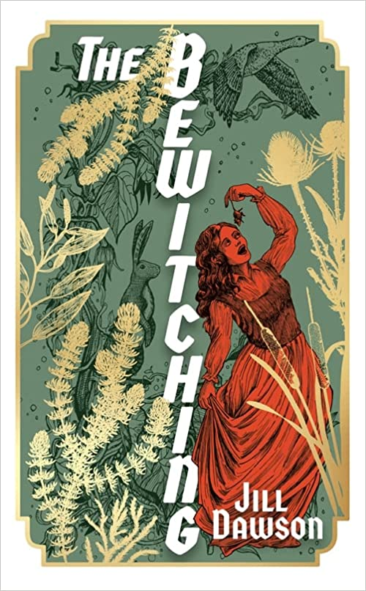
中文书名：《被判定为妖魔的人们》
英文书名：The Bewitching
作 者：Jill Dawson
出 版 社：‎ Sceptre
代理公司：United Agents/ANA/Claire Qiao
出版时间：2022年7月
代理地区：中国大陆、台湾
页 数：320页
审读资料：电子稿
类 型：文学

内容简介：

“一位令人手不释卷的文学作家……引人深思。”
----保拉·霍金斯

这部令人触目惊心的小说取材于16世纪的女巫案，但讲述的却是亘古不变的故事。

爱丽丝·塞缪尔也许又老又尖酸刻薄，但她不傻。拜访她在芬兰村的新邻居时，她怀疑斯罗克莫顿的家人并不像看上去那样敬畏上帝，并发现孩子们有问题。然而，当其中一个女儿指控她使用巫术时，爱丽丝没有意识到事情会迅速升级，也没有意识到自己处于危险之中。

随着对爱丽丝不利的证据越来越多，很快整个村庄都被卷入了对村民的疯狂迫害之中。

《被判定为妖魔的人们》对英国历史上被忽视的一段历史进行了深刻的探索，生动地展示了封闭社会中爆发的野蛮部落主义，以及受害者是如何被灌输邪恶思想的。

作者简介：

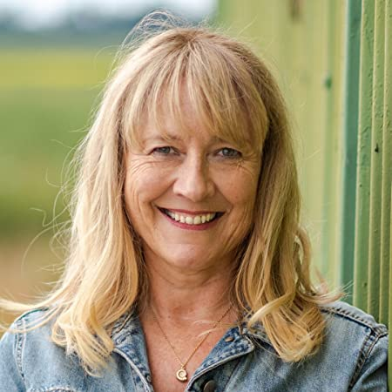
吉尔·道森（Jill Dawson）的小说包括《弗雷德和伊迪》(曾入围橘子奖和惠特布莱德年度小说奖)、《看我消失》(曾入围橘子奖)和《犯罪作家》(曾获得东盎格鲁年度小说奖)。作为一名获奖诗人，她还编辑了几本诗歌和短篇小说选集。她曾获得过许多奖学金，包括东安格利亚大学的创意写作奖学金。2008年，她成立了新作家指导计划Gold Dust，并于2020年当选为英国皇家文学学会会员。她住在剑桥郡沼泽区。

热评：

'Novels about witch hunts are not rare beasts, but The Bewitching, which is based on the true story of the witches of Warboys, is a particularly fine example. Tension builds, events spiral out of control and it builds to a devastating finale.'- The Times

“This summer's hottest proof.” Louise Doughty, author of Apple Tree Yard

“I read The Bewitching on holiday - it's a brilliant novel - brava! So vividly written, and such a convincing take on what might have happened - also really gripping and FUNNY. I do love a properly literary page turner.” Paula Hawkins, author of The Girl on the Train

“Jill Dawson really has the gift of tongues: The Bewitching tells an ancient and terrible tale, of women silenced, monstered and vilified and makes it profoundly involving, vivid and new. Dawson has a talent for evoking a time and place and people that is so nuanced and compelling it feels uncanny and she brings all a poet’s skill for the seductive texture of life to this breathlessly exciting narrative.” Christobel Kent author of The Loving Husband

“This is a vivid recollection of 16th Century life in the Fens and a powerfully moving tale about cruelty, persecution and power. As for witchcraft, not so much, for the evil at the heart of this brilliant novel has a more earthly source.” Bookseller, Book of the Month

“Dawson has a talent for evoking a time and place and people that is so nuanced and compelling it feels uncanny, and she brings all a poet’s skill for the seductive texture of life to a breathlessly exciting narrative.” Christobel Kent, author of The Loving Husband, The Crooked House, What She Did, Deep Water

“Jill Dawson is our most consummate historical novelist. She crafts magic out of darkness and light. Nothing evokes the past as vividly as her deft prose. And dark as The Bewitching is, with its eerie echoes of our own times, we know we are safe in her superb, story-telling hands.” Philip Hoare, author of Albert & the Whale

“Jill Dawson is a magnificent writer. I would read her shopping lists.” Cathy Rentzenbrink, author of The Last Act of Love

It has also been picked as one of the most anticipated summer reads for 2022

谢谢您的阅读！
请将反馈信息发至： 乔明睿（Claire）
安德鲁﹒纳伯格联合国际有限公司北京代表处
北京市海淀区中关村大街甲59号中国人民大学文化大厦1705室, 邮编：100872
电话：010-82449026
传真：010-82504200
手机：15804055576
Email: Claire@nurnberg.com.cn
网址：www.nurnberg.com.cn
微博：http://weibo.com/nurnberg
豆瓣小站：http://site.douban.com/110577/
微信订阅号：ANABJ2002

