新 书 推 荐
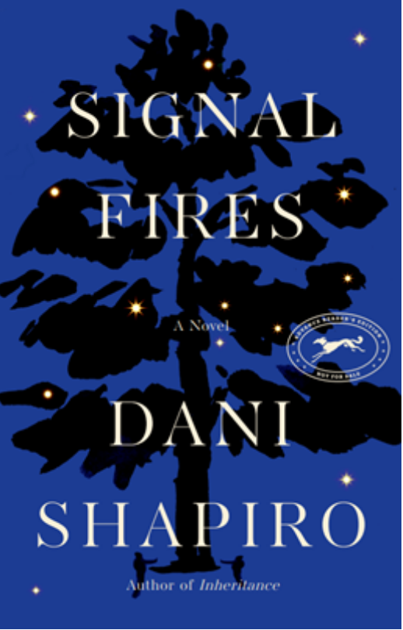
中文书名：《信号弹》
英文书名：SIGNAL FIRES
作 者：Dani Shapiro
出 版 社：Knopf
代理公司：WME/ANA/Lauren Li
页 数：224页
出版时间：2022年10月
代理地区：中国大陆、台湾
审读资料：电子稿
类 型：文学小说
版权已授：瑞士、西班牙、意大利、希腊、立陶宛

内容简介：
是我们存在于时间，还是时间存在于我们？

人生有许多可能的弧线，像夜空中划过的流星。这里的地震会引发那里的地震。断层线加深了。电线被绊住了。改变了一件事，一切都会改变。

迪姆斯街的社区似乎和其他社区没什么两样。孩子们在街上玩耍，青少年们莽莽撞撞，父母们总是因为担忧摇头。但是威尔夫（Wilf）一家的平静生活被一场意外打断——一个小女孩死于一场车祸，现场的橡树是迪姆斯街18号的标志。出车祸那天晚上，是威尔夫家哪个孩子在开车？这将成为家族中最深的秘密，一个危险到永远不会说出去的秘密。

街对面，申克曼（Shenkman）一家搬进来了，新婚夫妇怀了个男孩。申克曼一家也有自己的秘密，很快，他们的小儿子发现自己已经准备好打破束缚，追随自己的激情。当威尔夫一家和申克曼一家在一个寒冷、繁星点点的夜晚意外相遇时，他们的家庭以他们从未想象过的方式交织在一起——过去、现在和未来。

在时间的各个阶段中，丹妮（Dani）运用流畅的笔法，向我们展示了在生命和死亡中，我们的能量永远不会消失，它只是改变了形状——而时间就在我们体内，在我们周围，一下子就存在了。《信号弹》是一部迷人又感人的家庭传奇故事，是对爱与失去、年轻与年老、欢乐与悲伤、出生与死亡的感人见证，以及我们在这个地球上的时间不是线性的那种挥之不去的感觉。

娱乐周刊（Entertainment Weekly ）：
“我最近经常使用迁移这个词，因为感觉我们的生活模式已经改变了很多，”作者说。“这18个月要么让我们完全疏远，要么让我们完全软化。”对于夏皮罗来说，她感到非常幸运，能在这么多事情中找到这个故事来讲述。像许多人一样，她在雾霾中游荡，烘焙面包酵母，度过了一些的日子，但一旦她重新发现了现在的信号之火，她开始每周写作七天，把整本书写在纸上。她引用了同事兼朋友里克·鲁索（Rick Russo）的一封电子邮件，这封邮件完美地概括了那个时代：“讲故事，任何故事。一些小的，甜蜜的，诚实的，真实的。它们以前很重要，现在也很重要。”

作者简介：

达尼·夏皮罗（Dani Shapiro），著有畅销回忆录《写作进行时》（STILL WRITING），《风险》（DEVOTION）以及《慢动作》（SLOW MOTION），以及五本小说作品。她的文章常刊登于《纽约客》、《格兰他》、《铁皮房》（Tin House）、《一个故事》（One Story），Elle、《纽约时报》、《洛杉矶时报》等一线媒体报刊之上，并曾被“美国生活”（This American Life）播放。夏皮罗最近应奥普拉邀请，参加了她的Super Soul Sunday节目录制。

夏皮罗曾在哥伦比亚大学、纽约大学、新学院以及卫斯理大学教授写作项目，还是意大利波西塔诺赛铃兰写作大会（Sienland Writers Conference）的创始人之一。

媒体评价：

“Shapiro returns after the memoir Inheritance with a beautiful exploration of the connections between two families and the reverberations from a teenager’s lie. In 1985 Avalon, N.Y., 15-year-old Theo Wilf drives his 17-year-old sister Sarah and her friend Misty home after a night of partying. After he accidentally drops the car lighter down his shirt, he crashes the car into the tree in front of their house. Ben, Theo and Sarah’s surgeon father, rushes to save Misty’s life, but fails, and in an impulsive decision, Sarah tells Ben that she was driving. Then, in 1999, shortly after the Shenkman family moves in across the street, Ben helps deliver their infant, Waldo, during an emergency birth. Shapiro continues to jump around in time, unspooling the consequences of these two fateful nights ‘like so many wobbly tops set spinning.’ As Theo becomes a chef and Sarah a screenwriter, both wrestle with their guilt, while Ben, who never really gets to know the Shenkmans, is left alone to deal with his wife’s dementia and develops a bond with Waldo in 2010. Shapiro imagines in luminous prose how each of the characters’ lives might have gone if things had turned out differently. It’s an intriguing meditation.”
----Publishers Weekly, starred review

“A wonderful novel, full of insight and compassion” ----Mary Lawson

“Wears its philosophical intentions on its sleeve; well-developed characters and their interesting careers seal the deal.”
----Kirkus Reviews

“Wise, deeply perceptive, suffused with light in spite of life's darkness, Dani Shapiro's SIGNAL FIRES is an amazing novel. Shapiro inhabits her characters with rare lucidity and compassion, and renders their ordinary lives transcendent.”
----Claire Messud, bestselling author of A BURNING GIRL

“Shapiro writes with compassion and a deep understanding of the damage that secrets wreak.”
----Library Journal

“SIGNAL FIRES cuts a gleaming window into our alternate lives so meticulously and gloriously that it is quite nearly a primer on how to live not only in the present, but in the past and future as well. Shapiro has crafted a stunning future classic.”
----Lisa Taddeo

“What a treat. I don’t know of anyone who writes about family with the same generous understanding and gem-cut sentences as Dani Shapiro. SIGNAL FIRES confirms her as an artist of the highest order.”
----Gary Shteyngart, author of OUR COUNTRY FRIENDS

“SIGNAL FIRES is an urgent and compassionate meditation on memory, time, and space. In Shapiro's elegant convergence of narrative threads, she creates a world that's wrenching as it is wondrous.”
----Ruth Ozeki

“Because Dani Shapiro has delved so deeply into family secrets over the years, it’s no surprise that in SIGNAL FIRES she continues this exploration, both beautifully and searchingly. This novel is haunting, moving, and propulsive.”
----Meg Wolitzer

“The ongoing questions of ‘what if?’ for ALL of us are explored in such an profound way in SIGNAL FIRES. In recovery we often say ‘Life on life's terms.’ Life's terms, for the families in this book and the way those terms govern and connect them all, are gripping, unexpected and beautiful. Just like life. A masterful word weaving by a supremely talented writer. Observant and heartbreaking, familiar and so fragile.”
----Award-winning actress, author and activist Jamie Lee Curtis

谢谢您的阅读！
请将回馈信息发至：李文浩 （Lauren Li）
安德鲁﹒纳伯格联合国际有限公司北京代表处
北京市海淀区中关村大街甲59号中国人民大学文化大厦1705室, 邮编：100872
电话：010-82449901
传真：010-82504200
Email: JHuang@nurnberg.com.cn
网址：www.nurnberg.com.cn
微博：http://weibo.com/nurnberg
豆瓣小站：http://site.douban.com/110577/
微信订阅号：安德鲁书讯


