作 者 推 荐

从娱乐记者到小说家
西萨拉·拉姆斯特(Kirthana Ramisetti)

作者简介：

西萨拉·拉姆斯特(Kirthana Ramisetti)是《新闻日报》和《纽约每日新闻》的前娱乐记者，她写了大量关于富人和名人的生活（和死亡）的故事，并在写这部小说时借鉴了这些经历。她拥有爱默生学院的创意写作硕士学位，并在《华尔街日报》、《娱乐周刊》、《大西洋》等杂志上发表过文章。

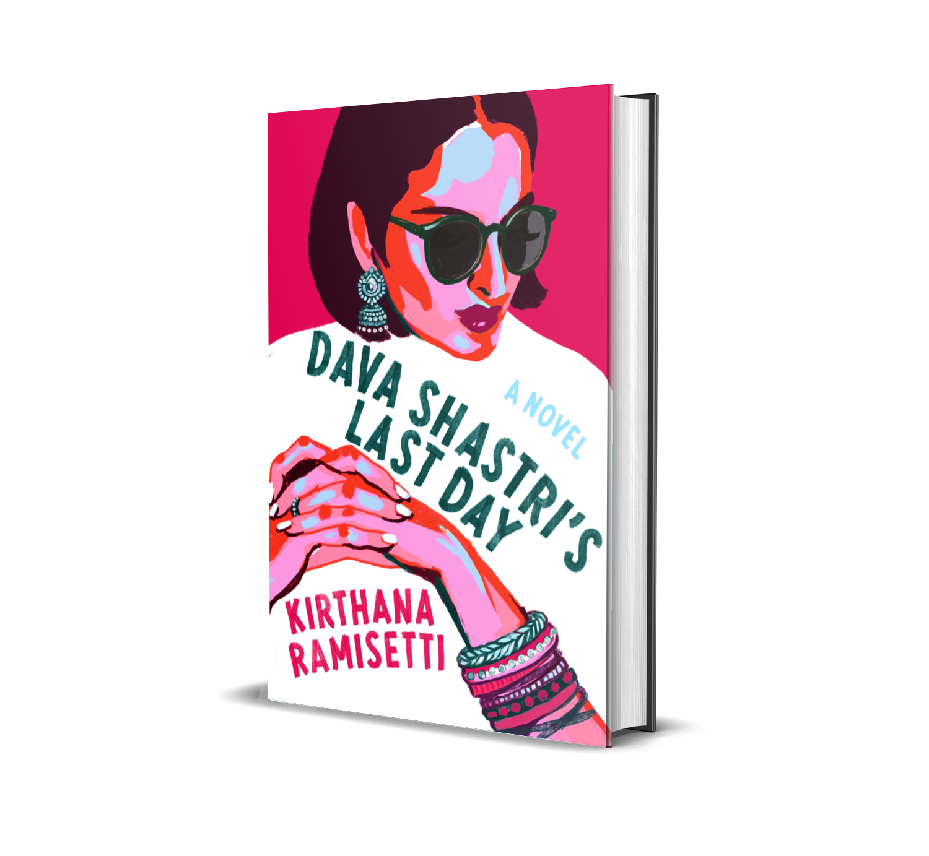
中文书名：《达瓦·夏斯特里的最后一天》
英文书名：DAVA SHASTRI’S LAST DAY
作 者： Kirthana Ramisetti
出 版 社：Grand Central Publishing
代理公司：Grand Central /ANA/Leah Guo
出版时间：2021年12月
代理地区：中国大陆、台湾
页 数：394页
审读资料：电子稿
类 型：大众文学
亚马逊排名：

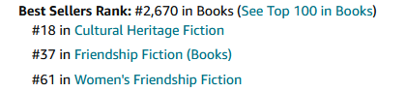

入围美国小说中心首部小说奖候选名单
该小说已被选为优质系列改编作品：
https://variety.com/2021/tv/news/dava-shastris-last-day-kirthana-ramisetti-veritas-1235050167/
https://variety.com/t/veritas-entertainment-group/

《达瓦·夏斯特里的最后一天》是早安美国图书俱乐部12月的精选书目——check out Kirthana Ramisetti’s announcement on GMA 西萨拉将预先录制对黛博拉·罗伯茨（Deborah Roberts）的采访，预计在12月14日播出。该书作为与亚马逊书评萨拉·盖尔曼（Sarah Gelman）合作的节日礼物指南的一部分，将在12月1日的《观点》节目（The View）中被推荐。

亚马逊的编辑们每个月都会在各种类别中选择最优秀的书籍。今年12月，《达瓦·夏斯特里的最后一天》被亚马逊选为2021年12月最佳图书名单（Best Books of the Month for December 2021）中的特色首发书籍。

中央车站启动了营销活动，向图书推荐达人发出了邮件，包括受达瓦·夏斯特里标志性的音乐合辑启发的特殊书签和在Spotify上收听播放列表的可扫描代码。

内容简介：

早安美国书友会精选
《时代》杂志评选的2021年秋季最值得期待的作品
《华盛顿邮报》、《Bustle》、《Goodreads》和《Debutiful》——“小众品味的下一个选择”
2021年秋冬出版商市场热门图书
入围2021年小说中心首部小说奖候选名单

这部发人深省、引人入胜的处女作向读者讲述了一个多元文化家庭的故事，一位身家过亿的女族长为了检视自己的遗产，提前放出了自己去世的消息----这个决定让她的孩子们惊恐万分，也无意中暴露了她保守了一辈子的秘密。

“本书关于家庭责任，节奏铿锵，创意满纸。”
----艾玛·斯特劳布，《这里的所有成年人》的作者

作为世界上最富有的女性之一，达瓦•夏斯特里极其看重自己的声誉。然而，70岁时她被确诊患有脑癌，达瓦决定把她的死亡----就像她生命中的其他问题一样，牢牢掌控在手中。

她把四个已成年的孩子叫到自己的私人岛屿上，并透露了一个令人震惊的消息:除了身患绝症之外，她打算提前公布自己的死讯，这样她就有机会读自己的讣告了。

作为一个将人生奉献给艺术和妇女赋权的人，达瓦希望能读到赞扬她的慈善工作的文章。相反，她的“死亡”揭示了两个毁灭性的秘密，尽管在此之前，她以为自己已经成功将这两个秘密埋葬。

现在人尽皆知。

在她去世之前，她必须接纳自己所有的决定，并尽快与家人和解。

本书幽默诙谐，它审视了公共与私人的遗产，呈现了爱情的复杂性，以及家庭中永无休止的喜悦和悲伤。

媒体资讯：

Media confirmations:
- 8/1/21 – Library Journal – included in Fall preview
- 8/26 – Variety – option announcement
- 8/30 – Time – included in Most Anticipated Books of Fall 2021
- 9/9 – Washington Post – included in 15 books to read this fall
- 10/1 – Booklist – review
- 10/5 – WBUR.org – included in Fall books guide for Boston NPR affiliate
- 10/13 – Kirkus Reviews – review in 11/1 issue
- 10/20 – Parade – included in Fall book roundup
- 11/1 – Khabar – mention
- 11/1 – Goodreads – included in readers’ most anticipated books of November roundup
- 11/1 – Departures – included in monthly books column
- 11/3 – Bustle – included in monthly roundup
- 11/7 – Red Carpet Crash – review
- 11/7 – Debutiful – included in roundup
- 11/8 – Amazon Book Review – included in roundup of 2021 books not to miss
- 11/12 – Parade – included in bookish gifting guide
- 11/16 – WAMC/Northeast Public Radio – The Roundtable – book recommendations segment with Chatham Bookstore
- 11/29 – ABC-TV – Good Morning America – December book club selection announcement
- 11/29 – Desi Books – podcast interview
- 11/30 – Amazon Book Review – interview
- 11/30 – Book Riot – included in new releases roundup
- 11/30 – BookTrib – review
- 12/1 – Los Angeles Daily News – interview
- 12/1 – Orange County Register – ran LADN interview
- 12/1 – Literary Hub – original essay with book giveaway
- 12/1 – Book Stew (Wilmington Community Television) – interview
- 12/1 – ABC-TV – The View – recommended by Amazon Book Review’s Sarah Gelman in holiday book guide segment
- 12/14 – ABC-TV – Good Morning America – pre-taped interview with Deborah Roberts for book club
- 12/14 – Literary Hub – group author interview
- 12/14 – Reading with Robin – Instagram Live interview, 3pm ET
- 12/17 – Book Reporter – review
- Catapult – original essay
- Largehearted Boy – guest post
- Pop Literacy Podcast – interview (taping 12/6)
- The Shit No One Tells You About Writing Podcast – interview (taped 11/15)

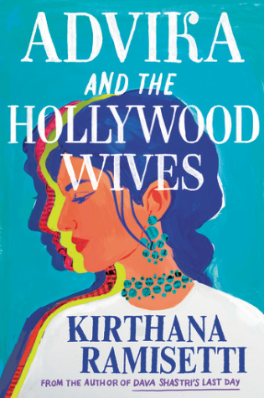
中文书名：《阿德维卡和好莱坞贵妇》
英文书名：ADVIKA AND THE CELEBRITY WIVES
作 者： Kirthana Ramisetti
出 版 社：Grand Central Publishing
代理公司：Grand Central /ANA/Leah Guo
出版时间：2023年4月
代理地区：中国大陆、台湾
页 数：384页
审读资料：电子稿
类 型：女性文学

内容简介：

来自《达瓦·夏斯特里的最后一天》的作者，讲述了扣人心弦的来自好莱坞的爱情与贪婪。

26岁的阿德维卡·斯里尼瓦桑认为自己是一个失败的编剧。为了支付生活账单并让自己（至少是切身地）与这个行业保持联系，她开始在A级活动中担任调酒师，她参加了2016年的奥斯卡颁奖典礼的官方宴会。在宴会上，一个如电影般的梦成了真，她遇到了传奇人物朱利安·泽尔丁----一个像保罗·纽曼（Paul Newman）一样英俊、但比保罗要更位高权重的电影制片人，他刚刚获得了第五个最佳影片奖。尽管他们的年龄相差41岁，但阿德维卡还是没能逃脱他的魔掌，夜晚点燃了他们旋风般的激情。

阿德维卡被朱利安奢华的生活方式和恋慕的目光迷住了，但朱利安只喜欢谈论他的成就和有名的朋友，每当提及他以前的关系时，他就会悄无声色地转移话题。在他们结婚一个月后，朱利安的第一任妻子----著名女演员伊妮德·洛克哈特突然去世。美国名人网报道说，伊妮德留下了惊人的遗嘱：一卷电影胶片和10万美元将被赠与“朱利安的小娇妻”，但有一个惊人的条件：阿德维卡必须先和他离婚。

阿德维卡从她的爱情迷雾和对两年前失去的双胞胎姐妹的悲痛中被唤醒，她因伊妮德的遗嘱和朱利安突然的、莫名其妙的成家冲动感到不安，阿德维卡终于深入了解了他三个前妻的生活，借此了解到了真正的朱利安。然而，她很快意识到，她对她的新丈夫了解甚少，而且这个人真的很危险。

媒体评价：

“Kirthana Ramisetti is a gifted storyteller, and Advika and the Hollywood Wives is such a gift. The glitz and underlying darkness of Hollywood make for a setting as complex and compelling as Ramisetti's characters, and every page of this smart, sharply-observed novel rings with insight—and with heart.”
—Meena Harris, #1 New York Times bestselling author
“A Cinderella tale with a dark twist. Beneath the glamorous exterior of this page-turner is a thoughtful story about female empowerment and what happens when promises of happily ever after don't quite meet fairy tale expectations.”
—Margarita Montimore, USA Today bestselling author
“Kirthana Ramisetti is quickly becoming the go-to author for nuanced stories about fame, family, and love. Advika and the Hollywood Wives is an insightful and moving portrayal of a woman fighting for what she deserves. Told with equal parts humor and heart, this delightful novel is sure to be a favorite for book clubs!”
—Saumya Dave, Author of What a Happy Family
“Advika and the Hollywood Wives is my favorite kind of novel: smart yet unassuming, entertaining, and deeply compassionate. With sharp characters and complex insight on fame, ambition, love, and loss, Kirthana Ramisetti has given us a page-turner for movie buffs and book worms alike.”
—Liv Stratman, Author of Cheat Day
“Advika and the Hollywood Wives is my favorite kind of page-turner: packed with juice, humor, intrigue, and a complex heroine on a quest to discover what’s real beyond the mirage of all that glitters. Kirthana Ramisetti’s knowledge of celebrity culture shines through in every scene, and I couldn’t help but binge!”
—Dawnie Walton, author of The Final Revival of Opal and Nev
“Kirthana Ramisetti has a knack for the intriguing, propulsive kind of writing that had us sneaking our mother’s paperbacks as teens. Like Dava Shastri, Advika is a good old-fashioned page-turner, centered around a character we’ve never seen in fiction, but sorely needed to meet.”
—Priyanka Mattoo, writer and filmmaker
“This delicious book is for all of us who love romantic comedies—and yet also mistrust the ways Hollywood romantic tropes can stifle our individuality and creativity in real life. Ramisetti’s zippy, nuanced take on the Bluebeard tale is especially insightful about who gets to be a professional storyteller, and about the pressure to squeeze our lives and stories into the boxes prescribed by popular culture.”
—Kate Reed Petty, author of True Story
“This book is deliciously suspenseful. I raced through the pages and found not just a delightful intrigue but also a thoughtful exploration of manipulation, power, and the legacy of sisterhood.”
—Marie Rutkoski, author of Real Easy
“Suspenseful and cinematic, Advika and the Hollywood Wives will have you on the edge of your seat from the very first page through the nail-biting grand finale. Kirthana Ramisetti is a novelist in the tradition of Jane Austen, masterfully blending complex human psychology and sharp comedy to bring her finely drawn characters to vivid life. This book is both a cautionary tale about power imbalance in a relationship (trust your instincts, ladies!) and a valentine to friends who are like family.”
—Erin Carlson, Author of I'll Have What She's Having: How Nora Ephron's Three Iconic Films Saved the Romantic Comedy

谢谢您的阅读！
请将回馈信息发至：郭丹娅(Leah Guo)
安德鲁﹒纳伯格联合国际有限公司北京代表处
北京市海淀区中关村大街甲59号中国人民大学文化大厦1705室, 邮编：100872
电话：010-82509406
传真：010-82504200
Email: Leah@nurnberg.com.cn
网址：www.nurnberg.com.cn
豆瓣小站：http://site.douban.com/110577/
新浪微博：安德鲁纳伯格公司的微博_微博 (weibo.com)
微信订阅号：ANABJ2002

