新 书 推 荐
《死后的八十九个问题》
Eighty-nine questions for after

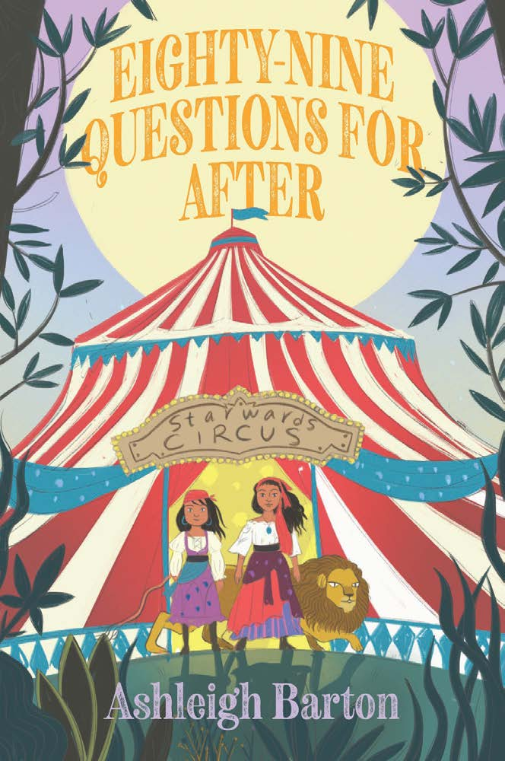
中文书名：《死后的八十九个问题》
英文书名：Eighty-nine questions for after
作 者：Ashleigh Barton
出 版 社：Hachette Australia
代理公司：Hachette Aus/ANA
页 数：288页
出版时间：2026年7月28日
代理地区：全球版权
审读资料：电子稿
类 型：9-11岁儿童文学

生命之上，还有思考！死亡与成长的对话，比答案更珍贵。

2022年澳大利亚儿童图书委员会（CBCA）年度图书奖作家新作

不只是提问——更是成长。献给每一个困惑生命、敬畏生活的少年。

本书卖点：

- 深度主题：死亡议题结合成长思考，超越单纯的温情故事，引导孩子正视生命。
- 普适可读：节奏舒缓、情感真挚，适合所有处于成长困惑期的孩子，极易引发情感共鸣。
- 治愈内核：用温柔的笔触化解对死亡的恐惧，传递珍惜当下、热爱生活的正向理念。
- 受众精准：贴合9-11岁孩子的认知特点，文字细腻不晦涩，兼顾可读性与思想性。

内容简介：

Ester Star is a germophobe and hypochondriac and she’s convinced she’s going to die. To prepare for her imminent and inevitable demise, Ester keeps a list of all the questions she hopes to have answered in the afterlife – things she knows she’ll never have the answers to during her lifetime. What really happened to the dinosaurs? Just how big is the universe? Are ghosts real?

She’s up to eighty-nine questions and counting.

When Ester’s usual after-school sitters announce they are mov’ing away, her mum comes up with an alternative arrangement that turns her world upside down. Every day after school, Ester is to spend her afternoons with Mum at work. At a hospice. Terrified of all the things she might catch at a hospice, Ester is anxious every second she’s there.

But soon she meets Joan, an elderly lady who used to be in the circus. Joan tells Ester she doesn’t believe in the afterlife, but she does have just one question she’ll regret never having answered while she’s alive.

With the help of Peter, another kid who spends his afternoons at the hospice, and her new next-door neighbour, a tech whizz named Mackenzie, Ester sets out to have Joan’s question answered.

Will Ester realise there’s more to life than worrying about dying?

作者简介：

Ashleigh Barton is a bestselling children's author from Sydney, Australia. After completing a law degree, Ashleigh decided she preferred books and spent the next six years working in publishing where she ran marketing and publicity campaigns for internationally renowned authors and illustrators. Now she writes books of her own, in between looking after her three small children and freelance copywriting. Her picture book What Do You Call Your Grandma? has been shortlisted in the 2022 CBCA Book of the Year Awards.

请将反馈信息发至：版权负责人
Email：Rights@nurnberg.com.cn
安德鲁·纳伯格联合国际有限公司北京代表处
北京市海淀区中关村大街甲59号中国人民大学文化大厦1705室, 邮编：100872
电话：010-82504106, 传真：010-82504200
公司网址：http://www.nurnberg.com.cn
书目下载：http://www.nurnberg.com.cn/booklist_zh/list.aspx
书讯浏览：http://www.nurnberg.com.cn/book/book.aspx
视频推荐：http://www.nurnberg.com.cn/video/video.aspx
豆瓣小站：http://site.douban.com/110577/
新浪微博：安德鲁纳伯格公司的微博_微博 (weibo.com)
微信订阅号：安德鲁纳伯格联合国际北京代表处

