新 书 推 荐
《好奇探险家凯凯诺》
Kekeno, Curious Explorer

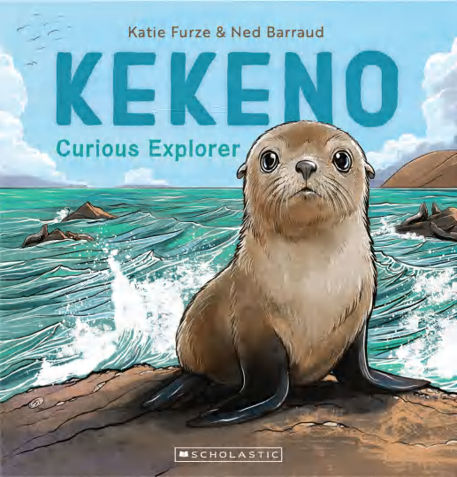
中文书名：《好奇探险家凯凯诺》
英文书名：Kekeno, Curious Explorer
作 者：Katie Furze and Ned Barraud
出 版 社：Scholastic Aus
代理公司：Scholastic Aus
页 数：32页
出版时间：2026年5月
代理地区：全球版权（除ANZ）
审读资料：电子稿
类 型：儿童知识绘本

“跟随新生小海豹，探索大海与陆地的奇妙世界。”
新西兰国宝级野生动物绘本，讲述毛皮海豹的成长与生存
诗意文字 + 细腻插画，带孩子走进真实的海洋动物世界

本书卖点：

·新西兰自然科普系列重磅新作：与《猫头鹰：夜间猎手》《大蜥蜴：活化石》《森林蝙蝠：神秘夜行客》同系列，带孩子认识新西兰珍稀野生动物。
·聚焦濒危毛皮海豹，知识满满：新西兰毛皮海豹曾濒临灭绝，如今重返海岸。本书跟随一只勇敢的小海豹，记录它第一年的学习、捕猎、生存与探险。
·细腻写实插画，还原自然之美：内德・巴罗的精美插画，生动展现新西兰岩石海岸的壮阔与震撼，海浪、荒野、海洋生物栩栩如生。
·实用科普资源，适合多场景阅读：家庭、教室、图书馆优质科普读本，是送给热爱自然、海洋与探险孩子的完美礼物。
·附真实科普知识，拓展视野：内含海豹生物学与历史知识页面，故事之余收获科学知识，兼具趣味性与教育性。

同系列作品：

《大蜥蜴：活化石》
《猫头鹰：夜间猎手》
《森林蝙蝠：神秘夜行客》

内容简介：

“Gulls screech. Waves splash.
Baby Kekeno sniffs the salty air, shakes his flippers and looks around.”

Aotearoa New Zealand’s fur seals once teetered on the brink of extinction, yet today many have returned to our mainland shores. This story follows one spirited pup through his first year of life as he learns to hunt, survive, and explore both sea and land, offering a vivid window into the secretive world of these remarkable marine mammals.

作者简介：

Katie Furze writes children’s fiction and non-fiction, including picture books, short stories, articles, plays, readers and novels. This is her fourth non-fiction picture book with Scholastic. Katie lives in Auckland. She has a master’s degree in creative writing and is fascinated by science and nature.

Ned Barraud studied art in Otago and Illustration at Victoria University and has since authored and illustrated a multttude of children’s books and journals including the ‘Explore and Discover’ series about different ecosystems in New Zealand. His other books with Scholastic include more in this series: Tuatara, a Living Treasure; Ruru, Night Hunter; Pekapeka, Secret Forest Bat, as well as his own At Home on the Farm and the playful Pu and Ru’s Bird Beak Clues and Honu and Blue’s Sealife Clues written by Jez Smith. Ned lives in Nelson with his wife and three children.

内页插图：

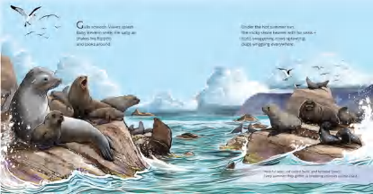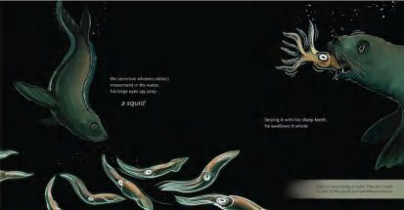

请将反馈信息发至：版权负责人
Email：Rights@nurnberg.com.cn
安德鲁·纳伯格联合国际有限公司北京代表处
北京市海淀区中关村大街甲59号中国人民大学文化大厦1705室, 邮编：100872
电话：010-82504106, 传真：010-82504200
公司网址：http://www.nurnberg.com.cn
书目下载：http://www.nurnberg.com.cn/booklist_zh/list.aspx
书讯浏览：http://www.nurnberg.com.cn/book/book.aspx
视频推荐：http://www.nurnberg.com.cn/video/video.aspx
豆瓣小站：http://site.douban.com/110577/
新浪微博：安德鲁纳伯格公司的微博_微博 (weibo.com)
微信订阅号：安德鲁纳伯格联合国际北京代表处

