新 书 推 荐

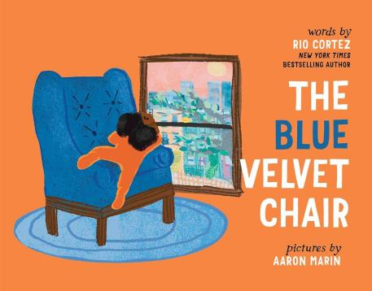
中文书名：《蓝色天鹅绒椅子》
英文书名：THE BLUE VELVET CHAIR
作 者：Rio Cortez and Aaron Marin
出 版 社：Simon & Schuster Children's Books
代理公司：SJGA/ANA
页 数：40页
出版时间：2025年8月
代理地区：中国大陆、台湾
审读资料：电子稿
类 型：故事绘本

- 在这本温馨动人的图画书中，一位小女孩坐在她最喜欢的椅子上，透过窗户凝望外面的世界，思考时间的流逝与季节的变换。本书由获奖诗人、《纽约时报》畅销书作者Rio Cortez创作。

内容简介：

A young girl looks out on the world from her favorite chair in this “quiet meditation on the sweet delight of simply observing the changing world” (Kirkus Reviews, starred review) by award-winning poet and New York Times bestselling author Rio Cortez.

In the morning, a young child opens her eyes, and, after one biiiiig streeeeetch, heads straight for her favorite place in the house: the blue velvet chair. Perched from the chair set by the living room window, the child daydreams about each season of the year and the changes that come with them. A now-snowy roof was once pelted by the slick rain of spring showers. Icy windows will once again transform into conveyors of sunshine and warmth against her skin.

And just as the seasons change, the child will continue to change too. But one thing will always remain the same: the coziness of the blue velvet chair.

媒体评论：

"A quiet meditation on the sweet delight of simply observing the changing world."
-- Kirkus Reviews, STARRED REVIEW

"The Blue Velvet Chair offers an excellent excuse to snuggle up with a loved one for storytime or some world-watching. Discover: The Blue Velvet Chair offers a poetic rumination on the world outside a child's window, from the familiar comfort of a favorite chair." -- Shelf Awareness

"The book hits the perfect note of familiarity and wonder... Viewers will delight in the little girl’s perspective and pointing out what they see, making for a perfect lapsit in a comfy chair with their own grown-up." -- BCCB

"A gentle look at constant change narrated from a comfortingly anchored place."
-- Publishers Weekly

作者简介：
Rio Cortez is the New York Times bestselling author of picture book The ABCs of Black History and adult poetry collection Golden Ax, which was longlisted for the 2022 National Book Award in poetry and the PEN Open Book Award. Born and raised in Salt Lake City, she now lives, writes, and works in Harlem, New York.

Aaron Marin has worn many hats in the past, holding positions as an officer in the Navy, a classically trained chef, and a summer camp baker. More recently, he returned to his childhood passion of illustration and now works as an illustrator and editorial artist in upstate New York. When not doodling new ideas, he likes to read a good book in a big comfy chair. See more of his work at Aaron-Marin.com.

内页插图：

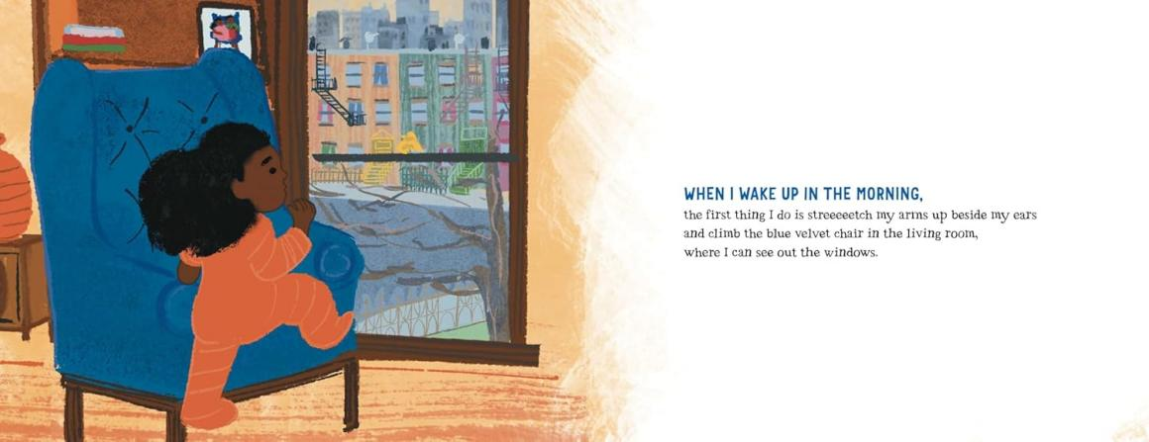


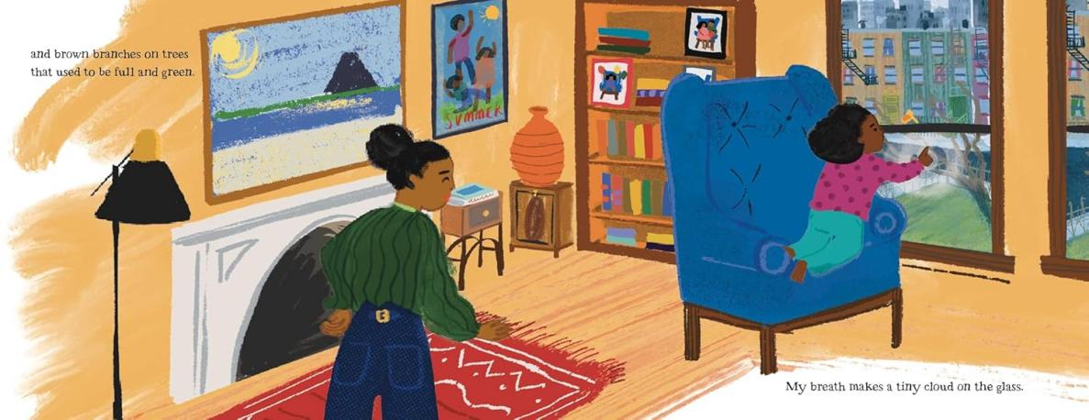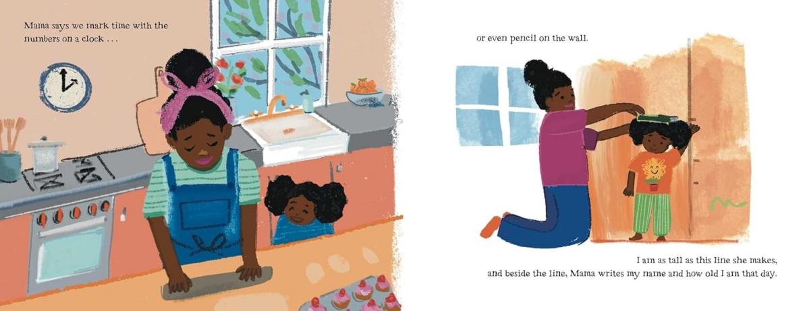
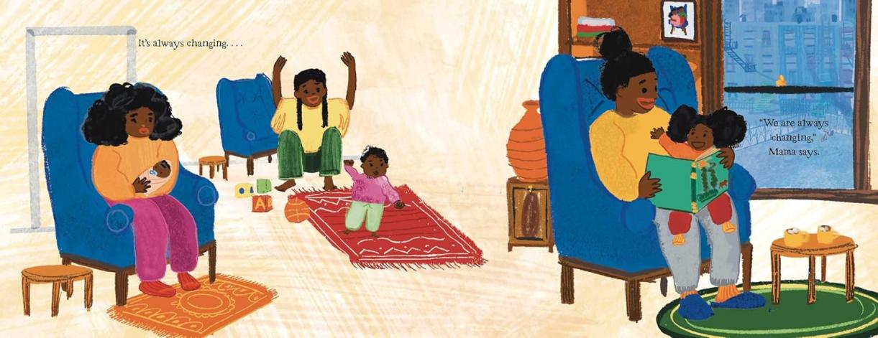

请将反馈信息发至：版权负责人
Email：Rights@nurnberg.com.cn
安德鲁·纳伯格联合国际有限公司北京代表处
北京市海淀区中关村大街甲59号中国人民大学文化大厦1705室, 邮编：100872
电话：010-82504106, 传真：010-82504200
公司网址：http://www.nurnberg.com.cn
书目下载：http://www.nurnberg.com.cn/booklist_zh/list.aspx
书讯浏览：http://www.nurnberg.com.cn/book/book.aspx
视频推荐：http://www.nurnberg.com.cn/video/video.aspx
豆瓣小站：http://site.douban.com/110577/
新浪微博：安德鲁纳伯格公司的微博_微博 (weibo.com)
微信订阅号：安德鲁纳伯格联合国际北京代表处

