新 书 推 荐

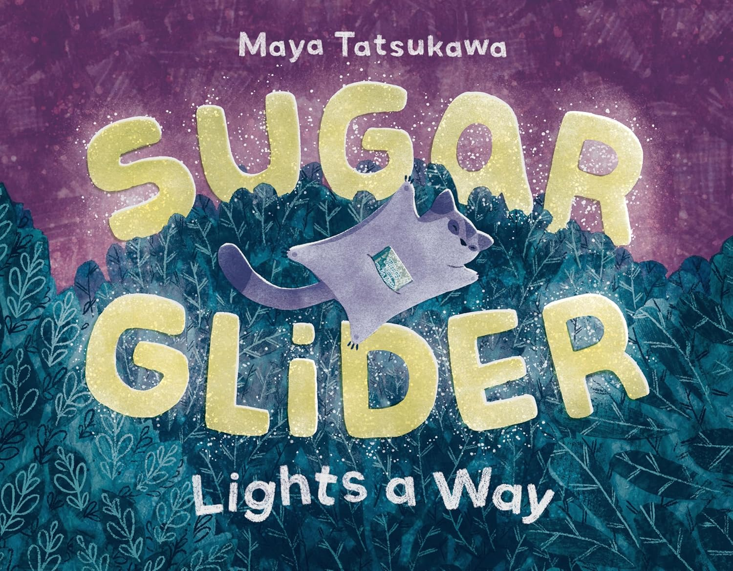
中文书名：《蜜袋鼯点亮前路》
英文书名：SUGAR GLIDER LIGHTS AWAY
作 者：Maya Tatsukawa
出 版 社：Holt Books for Young Readers
代理公司：SJGA/ANA
页 数：40页
出版时间：2026年8月
代理地区：中国大陆、台湾
审读资料：电子稿
类 型：知识绘本

- 本书出自西奥多·苏斯·盖泽尔奖(Theodore Seuss Geisel Award)获奖作品《我家有只熊》(THE BEAR IN MY FAMILY)作者之手。作者作品还有《水獭继续前行》(OTTER CARRIES ON)与《鼹鼠并不孤单》(MOLE IS NOT ALONE)。
- 本书讲述了一则迷人的故事：一只坚定的飞行森林生物寻找光亮，并发现其生物发光邻居所散发的微光。
- 本书配有精美、闪烁的插图，是一个关于创造性解决问题以及利用眼前资源找到解决方案的温馨故事。非常适合独立阅读的小朋友，以及那些对森林夜间生态充满好奇的读者。

内容简介：

In this charming picture book, a determined flying forest creature looks for light and discovers the glow of its bioluminescent neighbors.

On reading nights, Sugar Glider always curls up under the moon. But tonight, Moon is nowhere to be found!

As they chase Moon through the trees and behind the clouds, it seems the forest is full of other bright things―just not the moonlight Sugar Glider loves...

Will Sugar Glider find a way to read their book tonight?

Filled with beautiful, twinkling illustrations this cozy picture book is a story about creative problem solving and finding a solution with the resources in front of you. Perfect for independent little ones and those curious about the forest's nightlife.

作者简介：

Maya Tatsukawa is a children’s book illustrator and designer residing just out of Boston with her cat/studio manager. When she's not designing, illustrating, or thinking about children's books, you can find her baking cream puffs, eating ice cream, or searching for the perfect scone. She is the author and illustrator of Sunday Pancakes and The Bear in My Family.

内页插图：

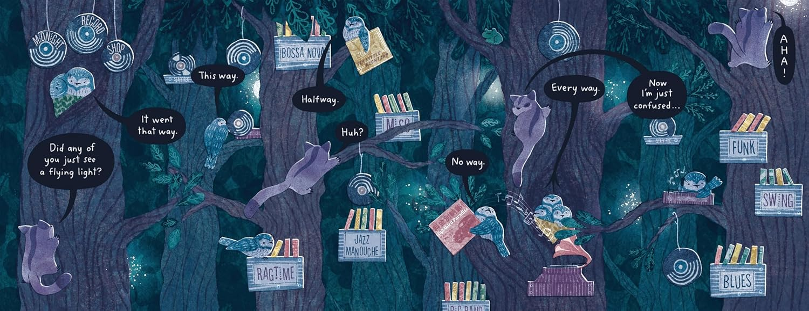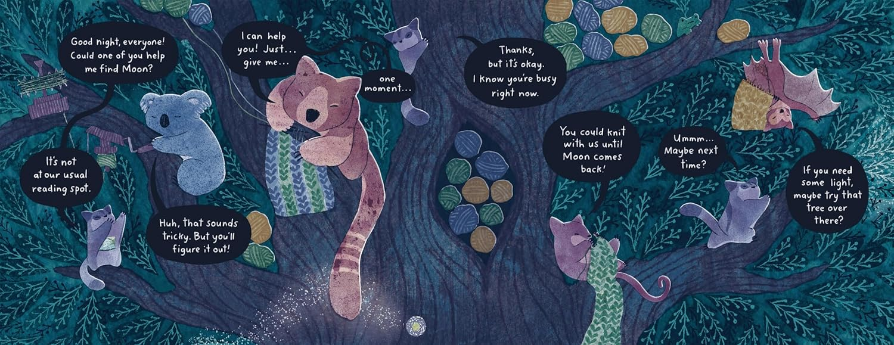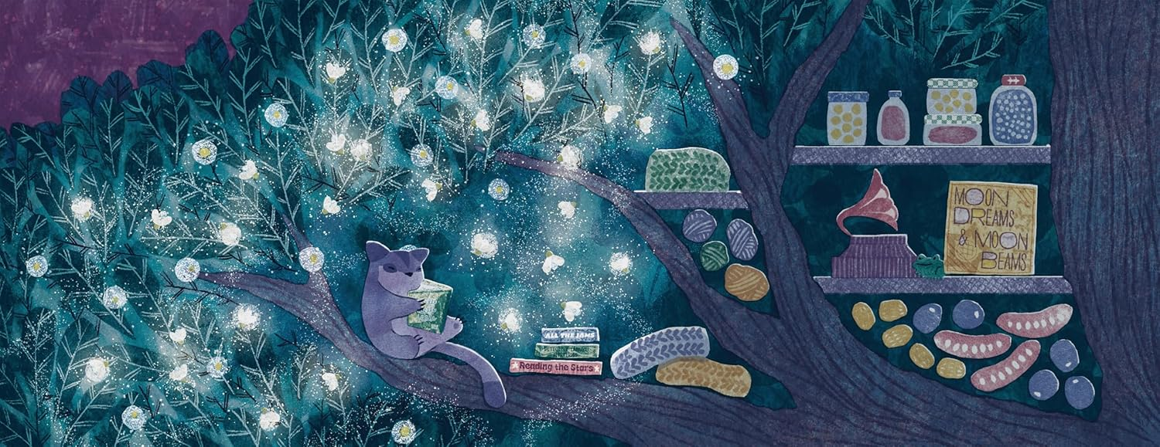
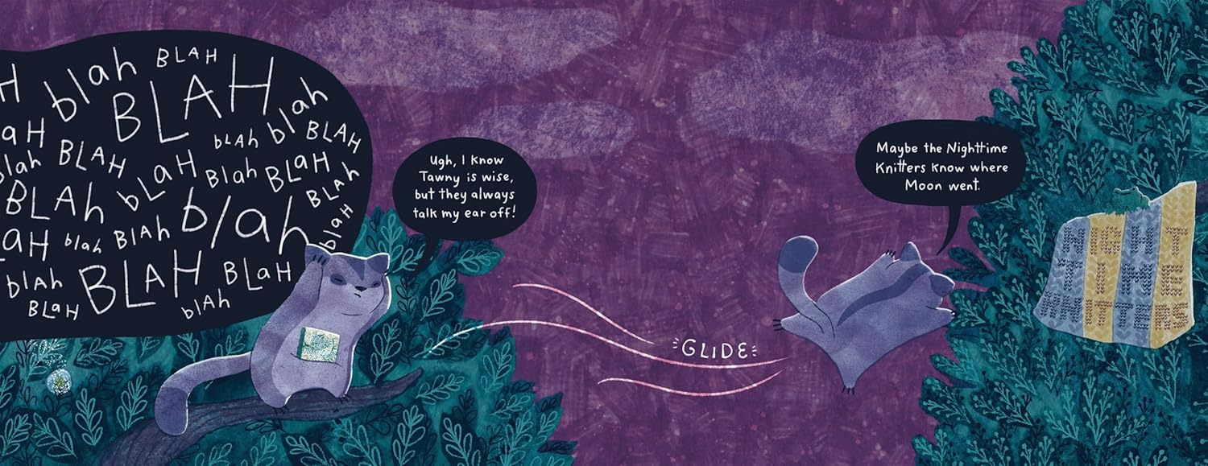

请将反馈信息发至：版权负责人
Email：Rights@nurnberg.com.cn
安德鲁·纳伯格联合国际有限公司北京代表处
北京市海淀区中关村大街甲59号中国人民大学文化大厦1705室, 邮编：100872
电话：010-82504106, 传真：010-82504200
公司网址：http://www.nurnberg.com.cn
书目下载：http://www.nurnberg.com.cn/booklist_zh/list.aspx
书讯浏览：http://www.nurnberg.com.cn/book/book.aspx
视频推荐：http://www.nurnberg.com.cn/video/video.aspx
豆瓣小站：http://site.douban.com/110577/
新浪微博：安德鲁纳伯格公司的微博_微博 (weibo.com)
微信订阅号：安德鲁纳伯格联合国际北京代表处

