新 书 推 荐
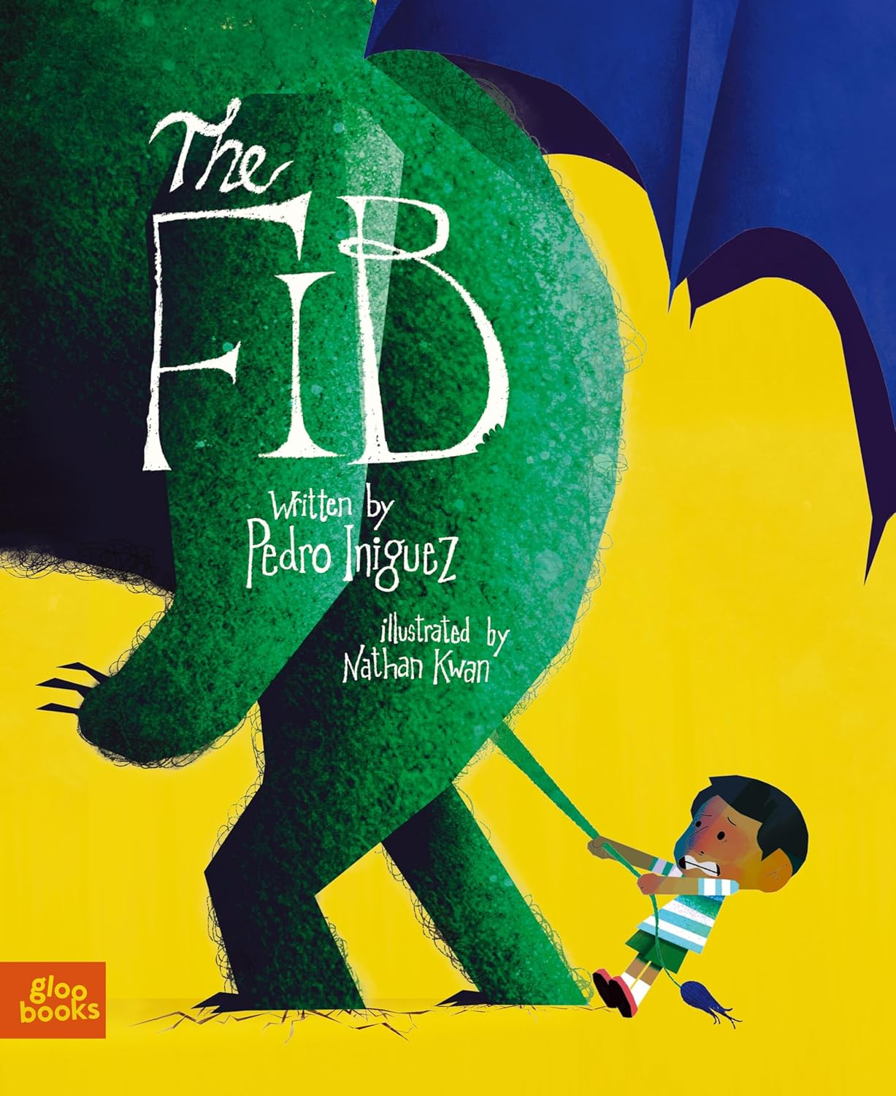
中文书名：《小谎言》
英文书名：The Fib
作 者：Pedro Iniguez and Nathan Kwan
出 版 社：Gloo Books
代理公司：Biagi
页 数：32页
出版时间：2025年10月
代理地区：中国大陆、台湾
审读资料：电子稿
类 型：故事绘本

【获奖情况】
2026年美国儿童图书委员会（Children's Book Council, CBC）儿童最喜爱图书
英国科幻协会奖（BSFA Award）青少年最佳小说提名
2025年《前言》独立图书奖（Foreword INDIES Book of the Year Awards）决赛入围作品
一个小谎言，一场大冒险，藏着最深刻的诚实必修课✨
温柔拆解谎言的代价，传递真诚的力量，陪孩子在成长中学会坚守本心
获多项认可的成长绘本，用魔法故事传递诚实真谛，适配全年龄段儿童

内容简介：

The line between imagination and lie blur in The Fib by Bram Stoker Award-winner Pedro Iniguez.

When Pepe struggles to find something exciting for show and tell, he spins a little lie about a magical creature with horns like a ram, claws like a bear, wings like a bat, eyes like an owl, and a tail like a lion. But, Pepe and his class soon discover that this harmless fib takes on a life of its own—literally—growing into a giant, uncontrollable monster that threatens to eat the entire school.

As chaos ensues, Pepe learns a valuable lesson: even the smallest fib can spiral out of control, but the truth holds the power to set things right. The Fib is a timeless story that weaves magic and morality into a powerful message about honesty, responsibility and the power of creativity.
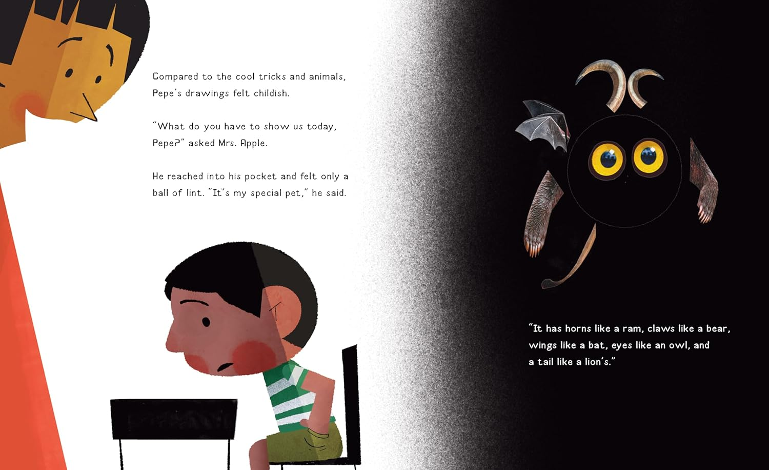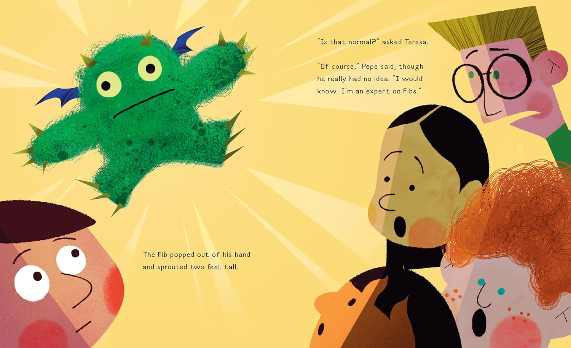
媒体评价：

“An effective and sympathetic exploration of lies—and the importance of telling the truth.”
―Kirkus Review

“A wise picture book about the snowballing consequences of dishonesty.”
―Foreword Reviews

“The Fib is a creative and memorable tale that teaches children about the impact of their words and the value of truth, while also celebrating the positive power of imagination.”
―The Children's Book Review

“A particular aspect of the illustrations that I liked, especially as a Hispanic, was the visual diversity of Pepe and his peers. Most of the picture books I read as a young girl rarely featured non-white characters, so it was heartwarming to see this detail in the story.”
―Abigail Ortiz, Pine Reads Review

“Brimming with beautiful art, wit and humor, this little book is big on ideas, heart, and joy!”
―Jorge R. Gutierrez, director of The Book of Life

“The Fib is fantastical fun ― and that’s the truth!”
―Wade Bradford, author of There's a Dinosaur on the 13th Floor and Dr. Seuss's Horton Hears a Boo!
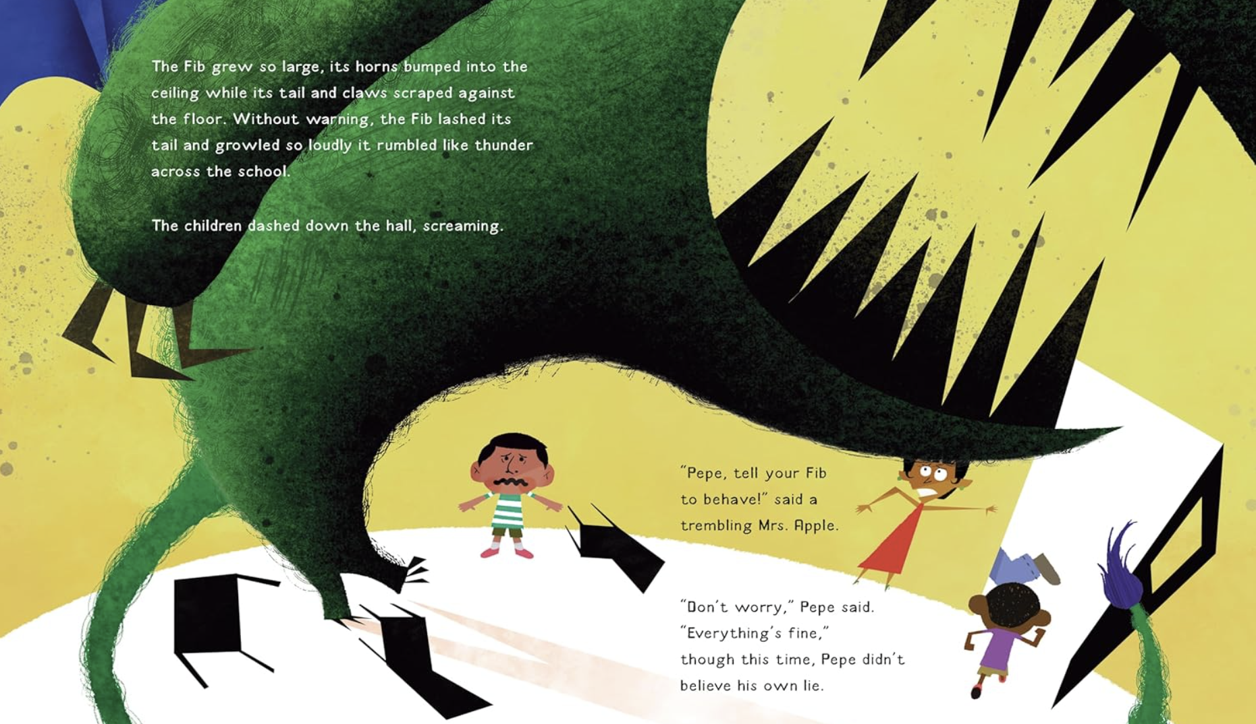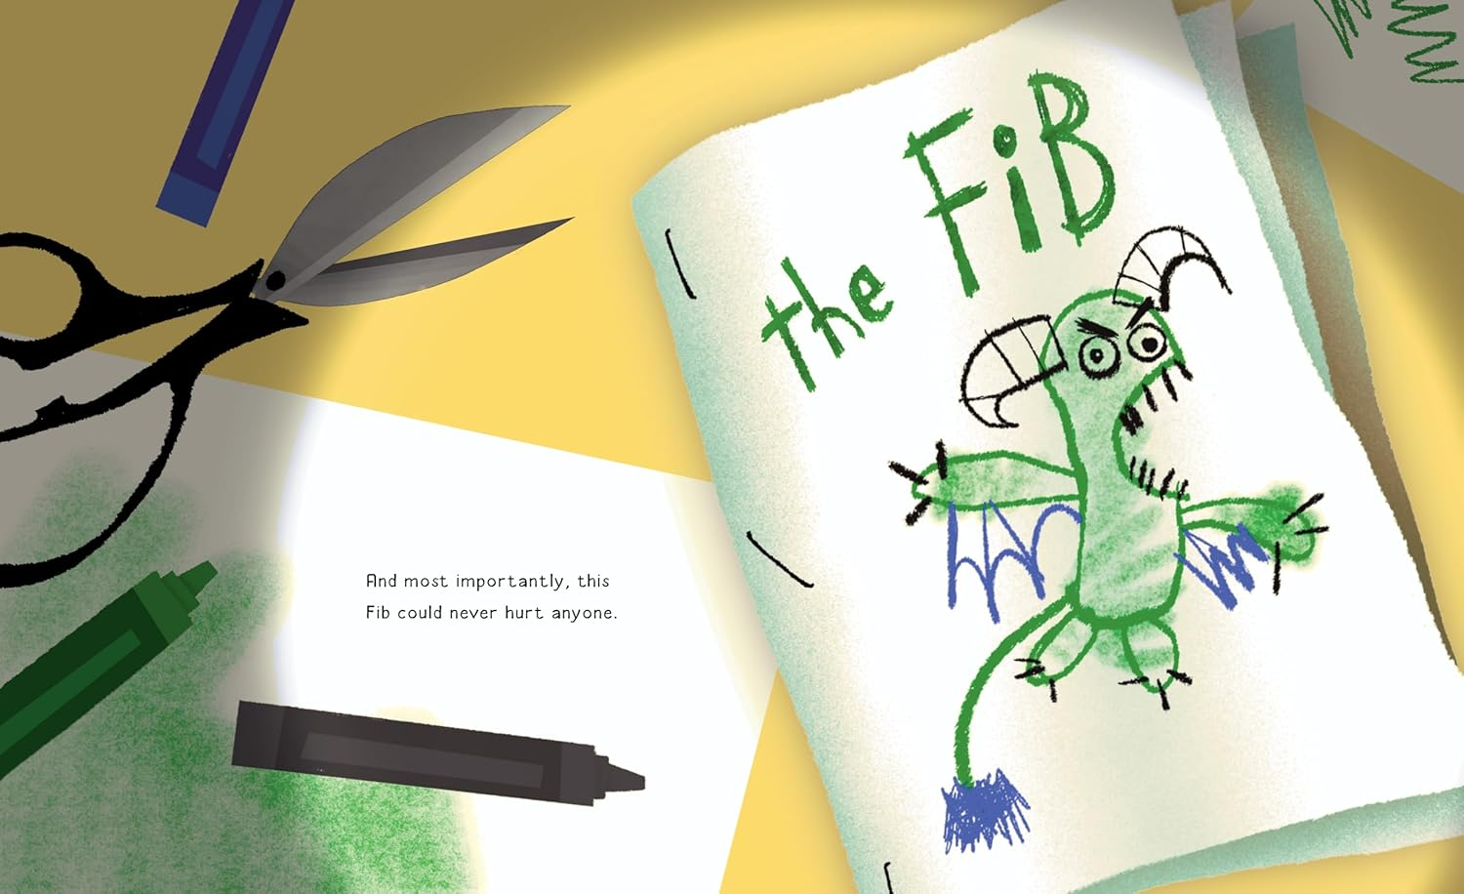
作者简介：


Pedro Iniguez is a Mexican-American Bram Stoker and Elgin Award-winning speculative fiction writer from Los Angeles. The Fib is his first picture book and he is the author of Mexicans on the Moon: Speculative Poetry from a Possible Future and the comic book Catrina’s Caravan, among several others. Apart from conducting writing workshops and speaking at several colleges, he has also been a sensitivity reader and has ghostwritten for award-winning apps and online clients. When he’s not reading, writing, daydreaming, or cooking, he likes to paint beside his Chihuahua, Cookie, and his turtle, Squirt.

Nathan Kwan is a Hong Kong-American illustrator, designer, and writer from Dallas, Texas. Unfortunately, he does not have a southern drawl. That would have been cool. The mildly offensive caricatures and comic strips he made as a tot introduced him to the world of illustration and animation where he found a collective calling of narrative storytelling. When he is not at his drawing table, he can be found cooking, at an indie cinema, or reading in a bookstore. Nathan is currently based in Cambridge, UK pursuing a Masters in Children's Book Illustration.

请将反馈信息发至：版权负责人
Email：Rights@nurnberg.com.cn
安德鲁·纳伯格联合国际有限公司北京代表处
北京市海淀区中关村大街甲59号中国人民大学文化大厦1705室, 邮编：100872
电话：010-82504106, 传真：010-82504200
公司网址：http://www.nurnberg.com.cn
书目下载：http://www.nurnberg.com.cn/booklist_zh/list.aspx
书讯浏览：http://www.nurnberg.com.cn/book/book.aspx
视频推荐：http://www.nurnberg.com.cn/video/video.aspx
豆瓣小站：http://site.douban.com/110577/
新浪微博：安德鲁纳伯格公司的微博_微博 (weibo.com)
微信订阅号：安德鲁纳伯格联合国际北京代表处

