新 书 推 荐
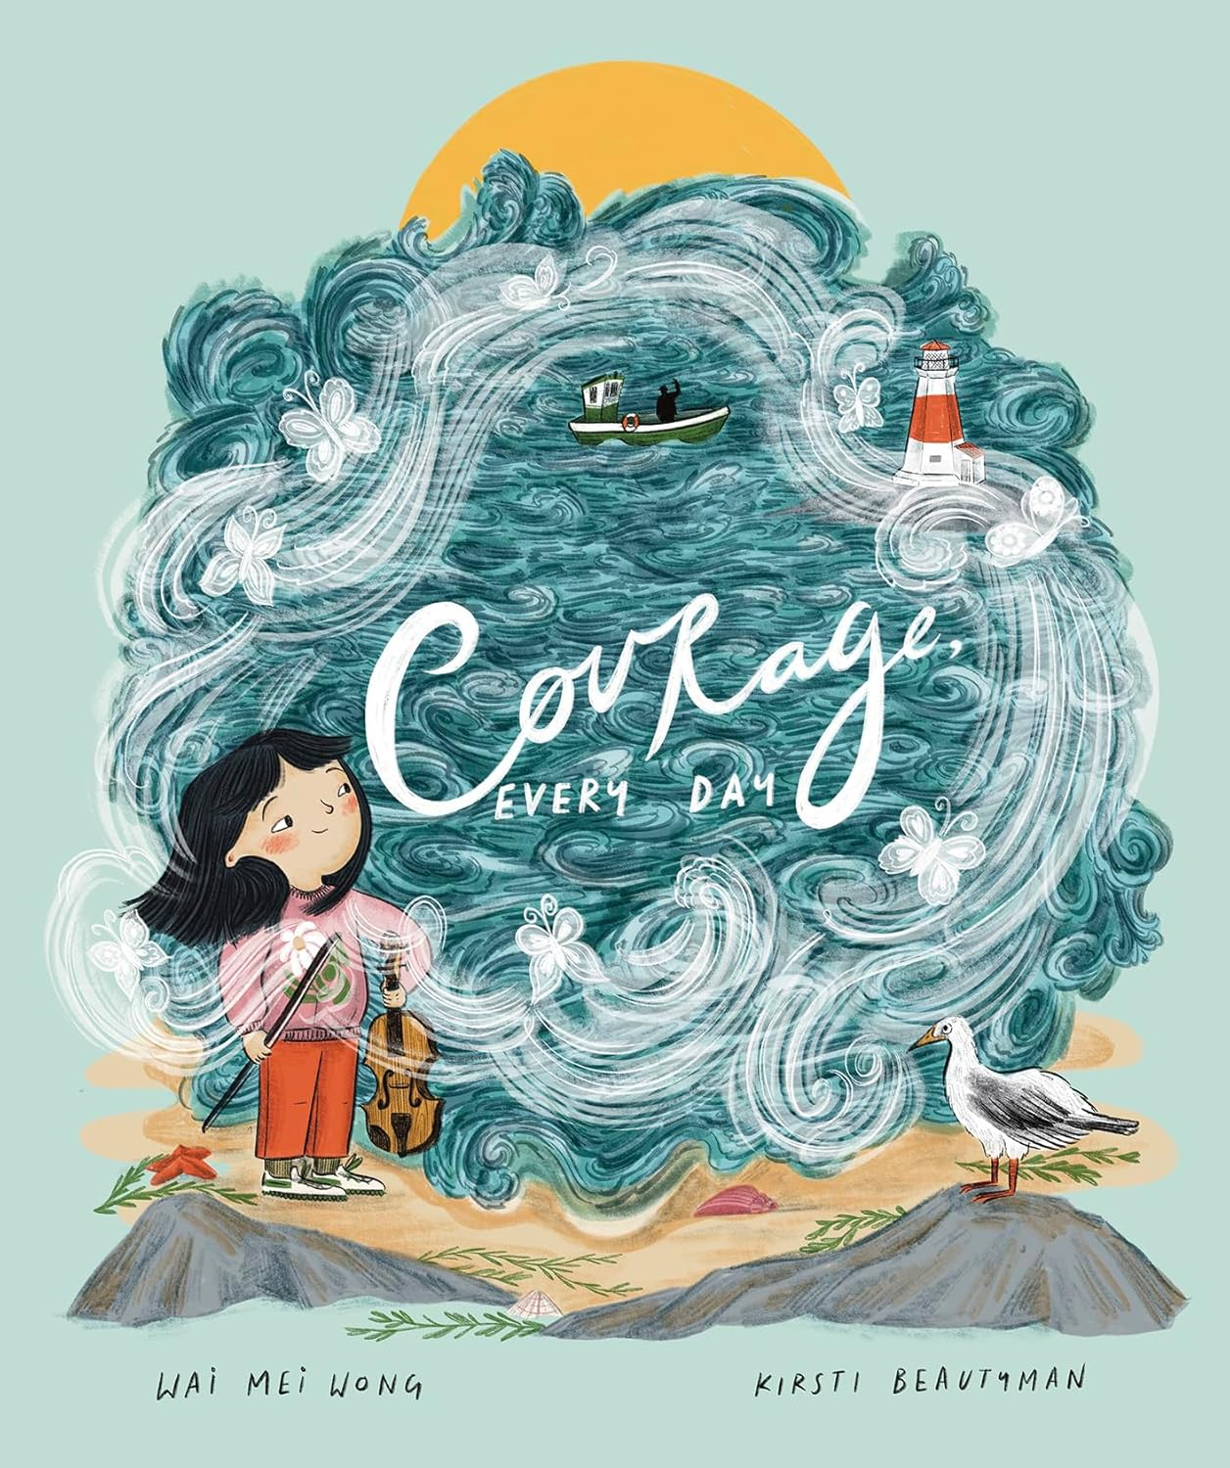
中文书名：《勇气，就在每一天》
英文书名：Courage, Every Day
作 者：Wai Mei Wong and Kirsti Beautyman
出 版 社：Tilbury House Publishers
代理公司：Biagi
页 数：32页
出版时间：2024年9月
代理地区：中国大陆、台湾
审读资料：电子稿
类 型：故事绘本
版权授权：阿拉伯语+希伯来语/金纳雷茨-兹莫拉出版社（Kinneret-Zmora）、德语/祖克苏斯出版社（Zuckersuss Verlag）

勇气从不是壮举，而是每天多一点坚持，多一点勇敢
本书用温柔文字，解锁勇气密码，送给每一个慢慢变勇敢的小朋友
用温柔海浪般的图画，让孩子在故事中感受勇气的温度，照亮成长的路

内容简介：

One girl's tummy flutters with butterflies. "Have courage," says Papa. But, she wonders, what exactly is courage? Papa lets her know that courage is the big, heroic feats--as well as the smaller everyday choices we make.

With comforting, lyrical text, this story shows young readers that they too can be courageous every single day. Backmatter includes a note for parents on helping children develop their own sense of courage. Full-color illustrations.
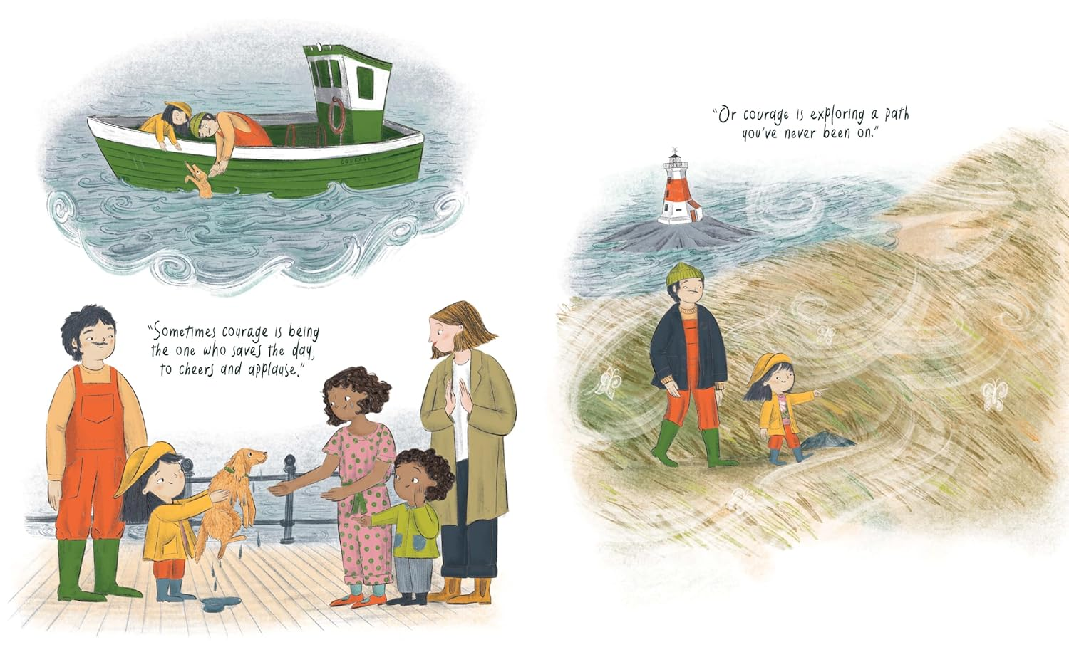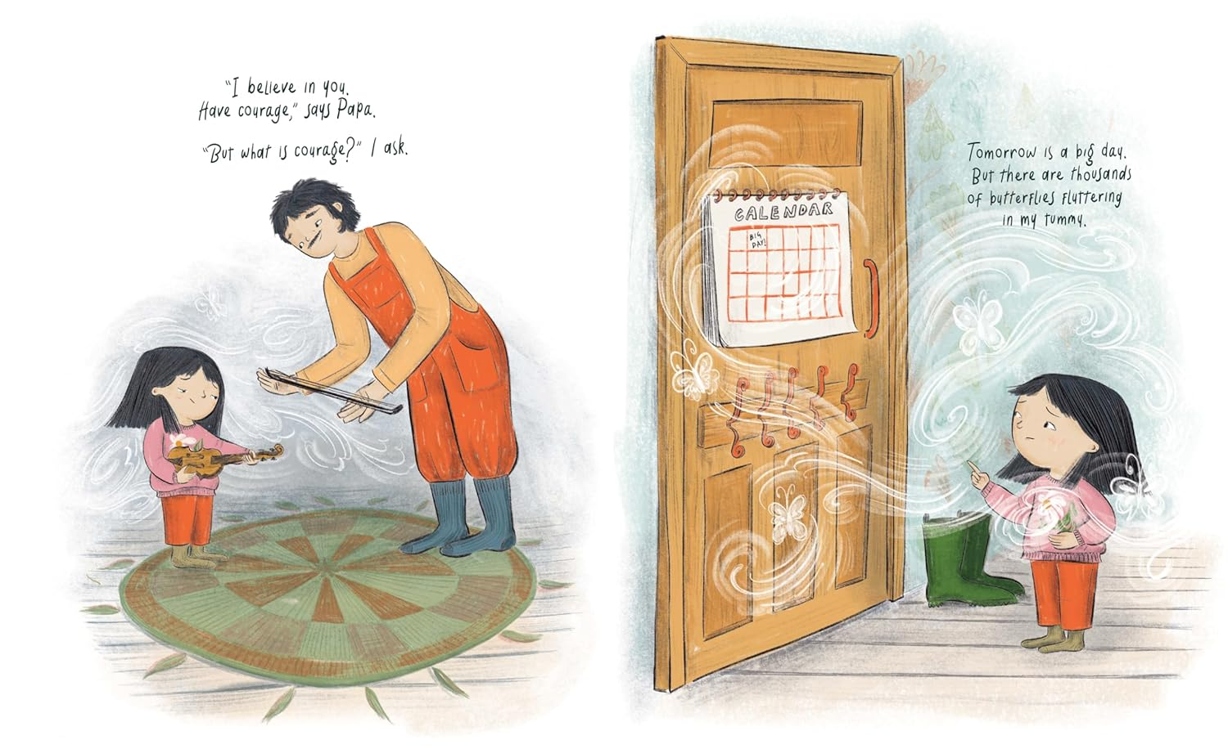
媒体评价：

“A sweet, instructive look at everyday bravery.”
——Kirkus Reviews

作者简介：
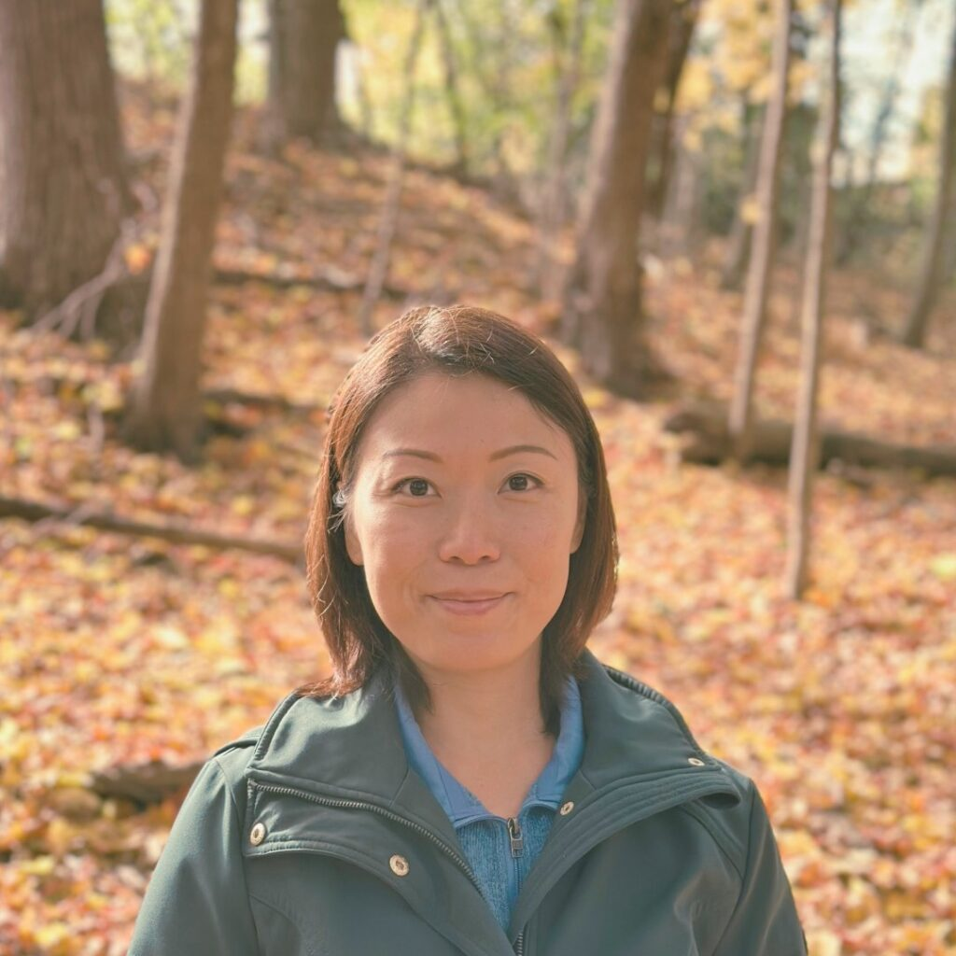
Wai Mei Wong is a former early childhood educator. Her previously authored works include I Love Myself (ORCA Book Publishers, 2024) and Hello, Dark (Pajama Press, 2021), which was shortlisted for the 2022 IODE Jean Throop Book Award and chosen for the 2022 CCBC Spring Best Book for Kids & Teens Selection. She lives in Toronto, Ontario.

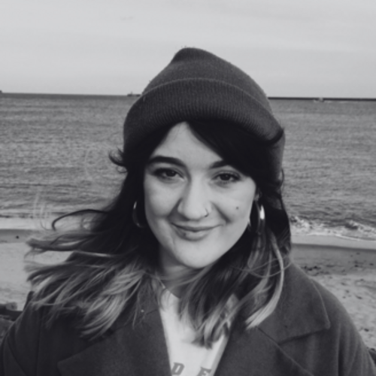
Kirsti Beautyman is an author and illustrator from the North East of England―working from her studio nestled away on the outskirts of Newcastle. Kirsti predominantly uses a culmination of digital, dry, and wet media to create her illustrations… and is prone to leaving a vibrant jumbled mess in her wake.

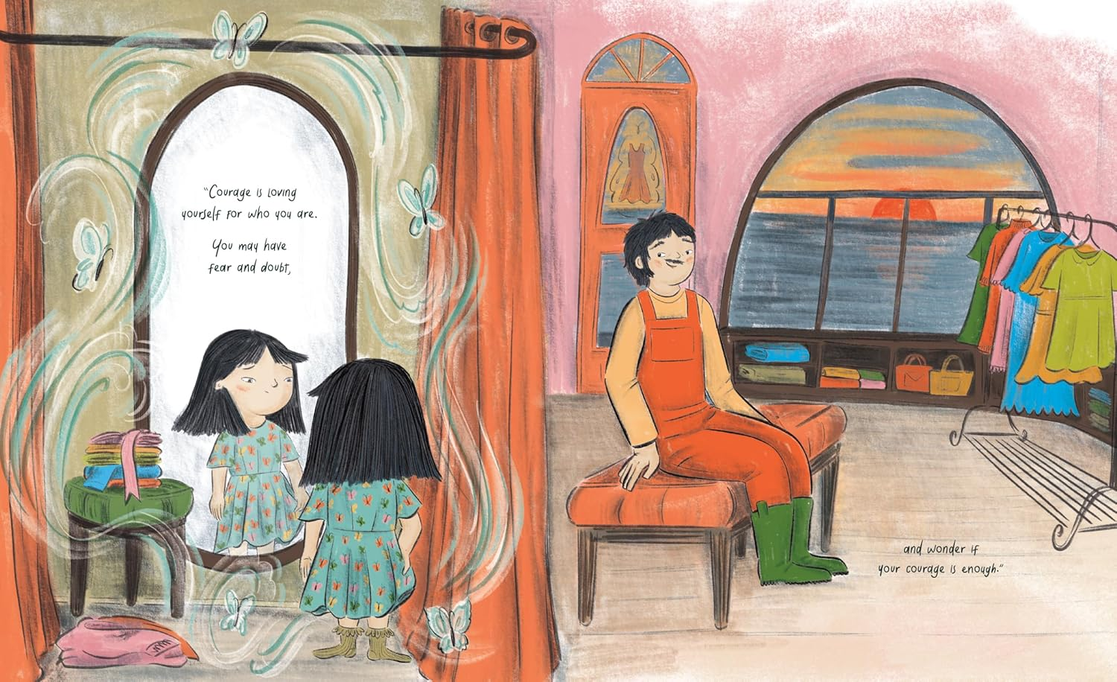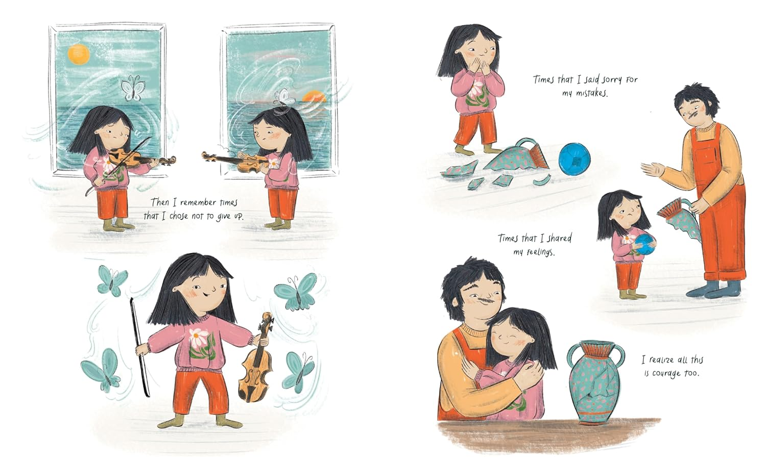

请将反馈信息发至：版权负责人
Email：Rights@nurnberg.com.cn
安德鲁·纳伯格联合国际有限公司北京代表处
北京市海淀区中关村大街甲59号中国人民大学文化大厦1705室, 邮编：100872
电话：010-82504106, 传真：010-82504200
公司网址：http://www.nurnberg.com.cn
书目下载：http://www.nurnberg.com.cn/booklist_zh/list.aspx
书讯浏览：http://www.nurnberg.com.cn/book/book.aspx
视频推荐：http://www.nurnberg.com.cn/video/video.aspx
豆瓣小站：http://site.douban.com/110577/
新浪微博：安德鲁纳伯格公司的微博_微博 (weibo.com)
微信订阅号：安德鲁纳伯格联合国际北京代表处

