系 列 推 荐
《佩格动起来》三册系列
PEG GETS CRACKIN’ 3-BOOK SERIES
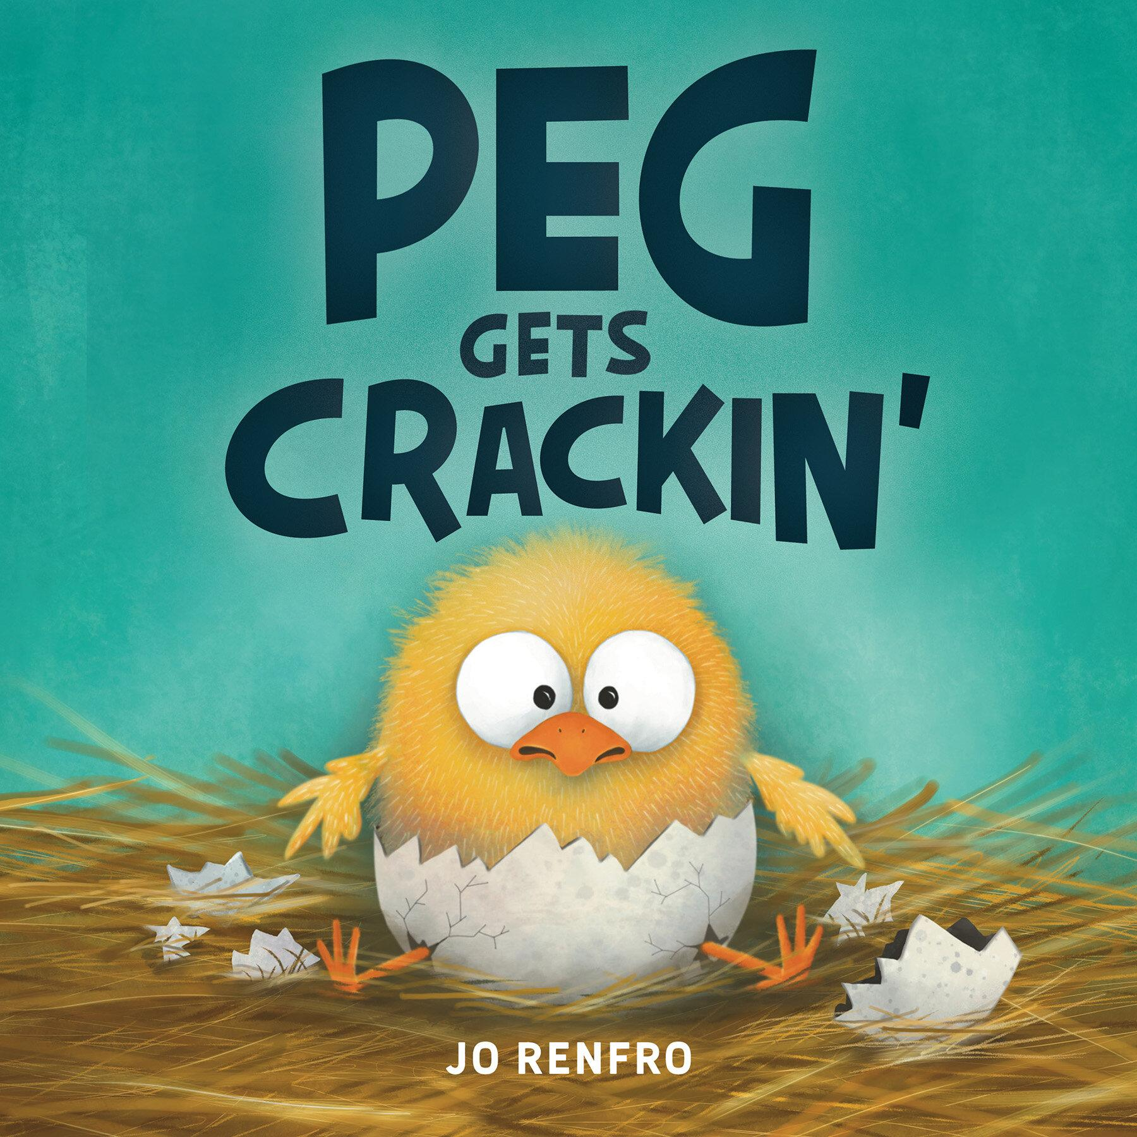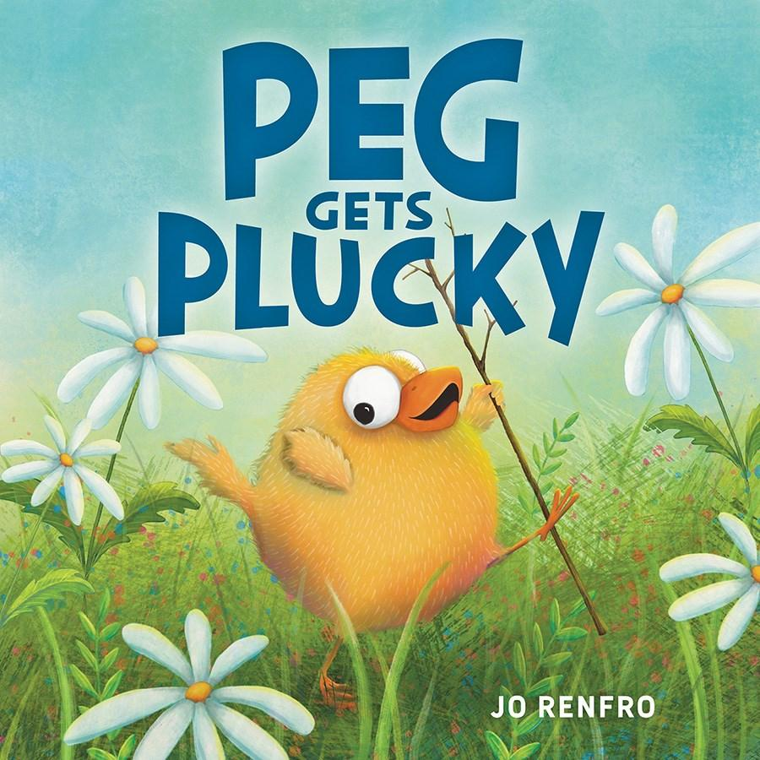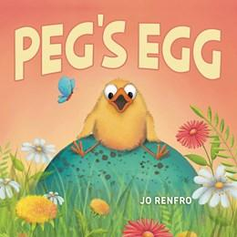
主角小萌鸡佩格形象可爱、性格鲜活，从 “害怕突破” 到 “坚持冒险” 再到 “接纳错误”，成长线清晰连贯，4-7 岁儿童易产生共鸣
《佩格动起来》获两大童书奖项认可，以农场幽默传递坚持理念
荣获2025年CBC儿童最喜爱图书奖
2024年月光童书奖最佳首作绘本类银奖
全系列延续乔・伦弗罗标志性幽默笔触，融入农场趣味场景，画风可爱、情节滑稽，兼顾趣味性与教育性，适配低幼读者阅读习惯
三册作品分别围绕 “突破自我”“坚持成长”“接纳错误” 三大核心，层层递进传递勇气、毅力与自信的成长理念，贴合儿童成长痛点

中文书名：《佩格动起来》（第一册）
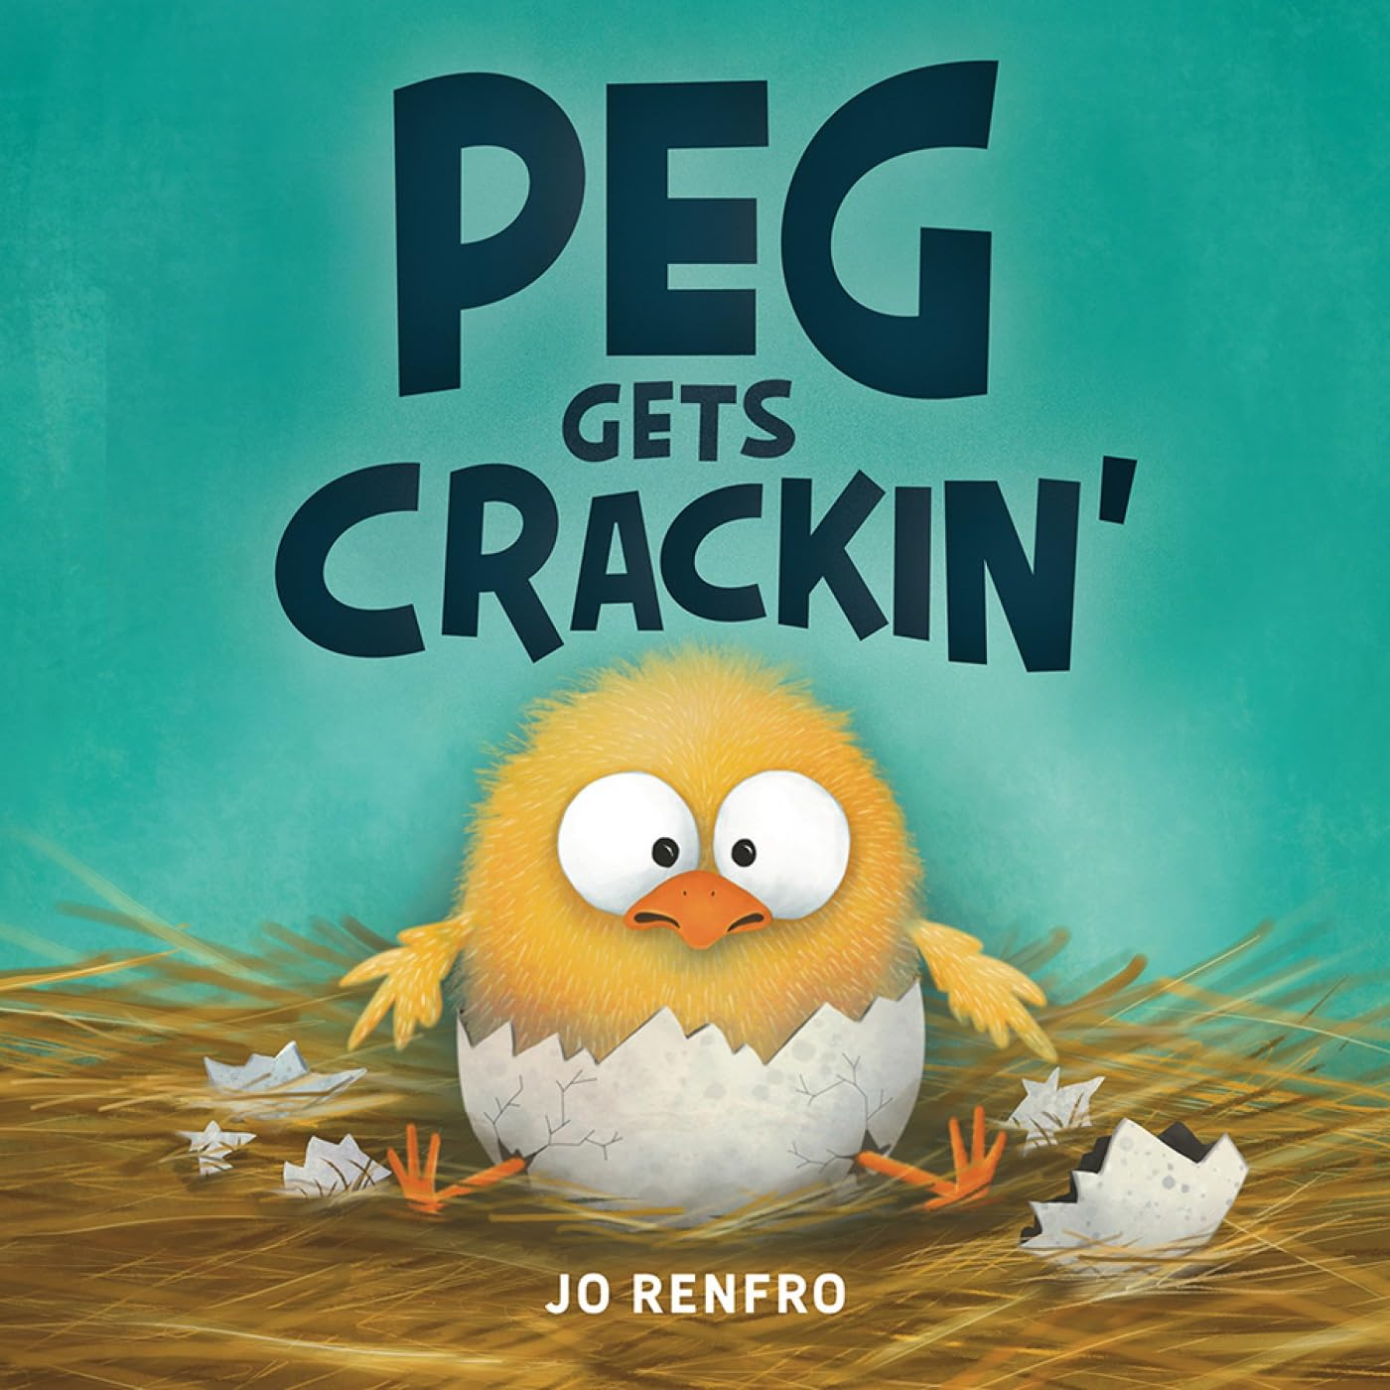
英文书名：PEG GETS CRACKIN’
作 者：Jo Renfro
出 版 社：Beaming Books
代理公司：Defiore
页 数：32页
出版时间：2024年2月
代理地区：中国大陆、台湾
审读资料：电子稿
类 型：4-7岁故事绘本

权威荣誉加持：荣获2025年CBC儿童最喜爱图书奖
2024年月光童书奖最佳首作绘本类银奖，专业口碑双保障

内容简介：

Time to get crackin'!

Peg is perfectly content within the safe, contained shell of her egg. While her siblings hatch around her, she imagines all the scary things waiting in the outside world--things that make her happy to stay an egg.

But even Peg must hatch. She grows, and grows, and one day . . . CRACK! Peg takes her first hesitant steps into the big, frightening world and discovers . . . the world isn't so bad after all. In fact, it's actually pretty wonderful!

Bursting with spirit and humor, Peg Gets Crackin' is packed with entertaining illustrations and perfect for read-aloud storytime. Young readers will giggle at Peg's antics and resonate with her journey to conquer her fears. You never know what exciting adventures are waiting just outside of your shell!

A 2025 CBC Children's Favorites Winner

A 2024 Moonbeam Children's Book Award Silver Winner, Best First Book - Picture

中文书名：《佩格变勇敢》（第二册）
英文书名：Peg Gets Plucky
作 者：Jo Renfro
出 版 社：Beaming Books
代理公司：Defiore
页 数：32页
出版时间：2025年3月
代理地区：中国大陆、台湾
审读资料：电子稿
类 型：4-7岁故事绘本

本书卖点：

·系列连贯性强：作为《佩格动起来》的续作，延续主角佩格的可爱人设，保持农场幽默风格，自带系列读者基础，衔接自然。

·媒体口碑加持：获《科克斯书评》好评，被评价为“贴合孩子自我怀疑的成长历程，主角可爱易共鸣”，口碑有保障。

·内核励志正向：传递“我能行”的成长信念，聚焦孩子在冒险中遇到的挫折与自我怀疑，引导儿童学会坚持、克服困难，培养毅力。

·情节贴近儿童：以小萌鸡徒步冒险为线索，还原孩子面对挑战时的退缩与挣扎，易引发共鸣，同时以幽默笔触缓解成长焦虑。

媒体评价：

“The story serves as a fitting example of just how much little ones are capable of when they stick to it, especially those who struggle with doubt... A meaningful journey featuring a relatable, adorable protagonist.” —Kirkus Reviews

内容简介：

With hilarious barnyard humor and an inspiring "I think I can" message, Peg Gets Plucky is an adorable picture book that encourages kids to persevere and find their can-do spirit on any adventure.

“It's foo far! I'm too tired! I'm too smaaaaaallll!”

Peg the chick is bold and ready for adventure. But when she sets off on a hike with the other barnyard animals, she is quickly overwhelmed. Adventures are hard! "I can't do it!" Peg declares. Or can she?

In this follow-up to Jo Renfro's story Peg Gets Crackin', Peg follows in the footsteps of every kid who has ever gone on a hike--or a walk around the block. With a hilarious storytelling voice and adorable illustrations, Peg Gets Plucky is perfect for any kid who's wondered if they have what it takes to keep going on an adventure.

中文书名：《佩格的蛋》（第三册）
英文书名：Peg’s Egg
作 者：Jo Renfro
出 版 社：Beaming Books
代理公司：Defiore
页 数：32页
出版时间：2026年2月
代理地区：中国大陆、台湾
审读资料：电子稿
类 型：4-7岁故事绘本

本书卖点：

·系列优势凸显：作为佩格系列新作，延续前作诙谐基调，主角佩格的幽默人设深入人心，自带系列读者基础，风格统一易吸引小读者。

·题材适配节日：核心围绕“蛋”展开，完美适配复活节阅读场景，同时兼具日常成长引导意义，适配多场景阅读需求。

·内核正向易懂：以幽默故事讲述“犯错”与“接纳自我”，引导儿童学会笑对尴尬时刻，培养自信与乐观的心态，贴合低幼儿童成长特点。

·创作风格鲜明：作者延续标志性幽默笔触，情节滑稽有趣，能让学龄前儿童全程保持兴趣，兼具趣味性与教育性。

内容简介：

The subject matter of Peg's Egg makes it perfect for the Easter season, and Peg's trademark humor will keep preschoolers giggling through this entertaining tale.

A hilarious story about making a mistake and learning to laugh at yourself.

One day, as Peg is running around chasing butterflies, she comes upon an egg! What is it doing out in the field by itself?! It's a big egg, and she wonders what it could be! A turtle? An ostrich? A DRAGON?

Peg takes her role of caretaker of the egg very seriously. She keeps the egg warm, protects it from the dog and the rain, sings it songs, and patiently waits for something to hatch. Until she discovers it's not an egg at all. Oh no! Peg is so embarrassed. How could she have made such a ridiculous mistake?

With similarly funny antics to Jo Renfro's Peg Gets Crackin' and Peg Gets Plucky, this new story is perfect for showing how humor and laughter can help overcome embarrassing moments.

作者简介：

Jo Renfro is an author and illustrator based in Colorado. She uses her sense of humor--cultivated from raising three kids, several dogs, numerous cats, and a potbellied pig named Matilda--to create stories that are lighthearted and inspirational. Her picture books include Peg Gets Crackin' and Peg Gets Plucky.

请将反馈信息发至：版权负责人
Email：Rights@nurnberg.com.cn
安德鲁·纳伯格联合国际有限公司北京代表处
北京市海淀区中关村大街甲59号中国人民大学文化大厦1705室, 邮编：100872
电话：010-82504106, 传真：010-82504200
公司网址：http://www.nurnberg.com.cn
书目下载：http://www.nurnberg.com.cn/booklist_zh/list.aspx
书讯浏览：http://www.nurnberg.com.cn/book/book.aspx
视频推荐：http://www.nurnberg.com.cn/video/video.aspx
豆瓣小站：http://site.douban.com/110577/
新浪微博：安德鲁纳伯格公司的微博_微博 (weibo.com)
微信订阅号：安德鲁纳伯格联合国际北京代表处

