新 书 推 荐
《当末日来临》
WHEN THE WORLD ENDS
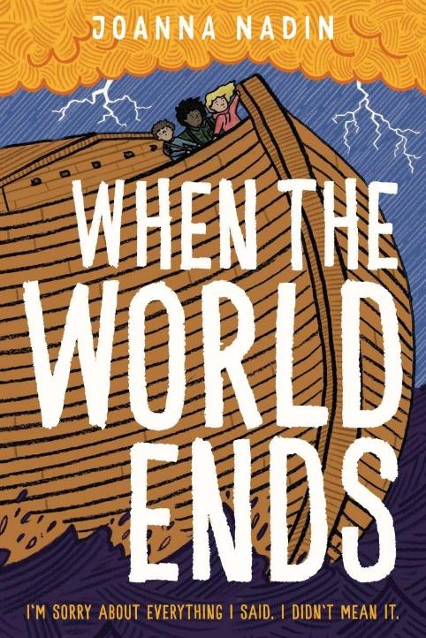
中文书名：《当末日来临》
英文书名：WHEN THE WORLD ENDS
作 者：Joanna Nadin
出 版 社：Fox and Ink Books
代理公司：A.M. Heath
页 数：286页
出版时间：2026年2月
代理地区：中国大陆、台湾
审读资料：电子稿
类 型：儿童文学

笑与泪交织的末日希望故事，在毁灭中看见人性的光芒与联结！
英国广播公司电视剧入围卡内基文学奖、英国电影学院奖、入围艾美奖作家
入选理查德与朱迪读书俱乐部推荐书目、第四电台年度好书、蓝彼得月度好书，还曾入围罗尔德·达尔幽默奖、最佳图书奖、青少年女王奖等多项奖项作家
泰晤士报推荐

本书卖点：

·独特治愈内核：末日题材却不压抑，以“绝望中的希望”为核心，笑与泪交织，探讨人性联结与共同体的意义，传递温暖与力量。

·知名作家力作：《无人之地》《孤独的乔》知名作者全新作品，作品入选《观察家报》月度章节书、《泰晤士报》每周儿童好书，被翻译成14种语言，口碑加持，可读性拉满。创作经验丰富，擅长刻画真实情感与成长困境，文字细腻有力量。

·高口碑盛赞：多位作家、媒体联合推荐，被称“深刻、精彩、充满希望”，精准捕捉人性本质，引发情感共鸣。

·全版权潜力巨大：泰晤士报推荐，影视版权可授权，适配多场景开发，市场前景广阔。

媒体评价：

‘Super-engaging and relatable.’ – Tia Fisher

‘A study in human connection and community and how, at the heart of things, that’s all we have or ever needed.’ – Rachel Delahaye

‘A searingly brilliant, important and beautifully written glimpse of a bleak yet hope filled future.’ – Liz Kessler

‘An engaing, well-told story with a few surprising stowaways.’ – The Times

内容简介：

An Observer Chapter Book of the Month A Times Children’s Book of the Week

A unique story of hope that’ll make you laugh and cry in equal measure, from the acclaimed author of No Man’s Land and Joe All Alone.

I’m sorry about everything I said. I didn’t mean it.

You think it will be silent when it rises.

But it comes in a thunder and rush, a clatter and clanking of cars smashing on lampposts and the sides of fried chicken shops, of things in the water that should be on land.

When the unthinkable happens to the planet, two ragtag groups of kids on opposite sides of England beat the odds and escape death. But they soon realise that the only way to be truly safe is to seek a place they’ve only heard about in stories. As their treacherous journeys unfold, can they Birdy Arbuthnot’s Year of Saying Yes help each other survive – even when the world is ending around them?

作者简介：

Joanna Nadin is the author of more than 80 books for children and adults, including the award-winning Penny Dreadful series, the Flying Fergus series with Sir Chris Hoy, and Carnegie-nominated middle grade novel Joe All Alone, which is now a BAFTA-winning and Emmy-nominated BBC TV series. She’s been a Richard and Judy Book Club choice, Radio 4 Book of the Year, and Blue Peter Book of the Month, and shortlisted for the Roald Dahl Funny Prize, the Best Book Award and Queen of Teen among many others. Her work has been translated into 14 languages. She also lectures on Creative Writing and Publishing on the acclaimed MA in Writing for Children at Bath Spa University.

请将反馈信息发至：版权负责人
Email：Rights@nurnberg.com.cn
安德鲁·纳伯格联合国际有限公司北京代表处
北京市海淀区中关村大街甲59号中国人民大学文化大厦1705室, 邮编：100872
电话：010-82504106, 传真：010-82504200
公司网址：http://www.nurnberg.com.cn
书目下载：http://www.nurnberg.com.cn/booklist_zh/list.aspx
书讯浏览：http://www.nurnberg.com.cn/book/book.aspx
视频推荐：http://www.nurnberg.com.cn/video/video.aspx
豆瓣小站：http://site.douban.com/110577/
新浪微博：安德鲁纳伯格公司的微博_微博 (weibo.com)
微信订阅号：安德鲁纳伯格联合国际北京代表处

