新 书 推 荐

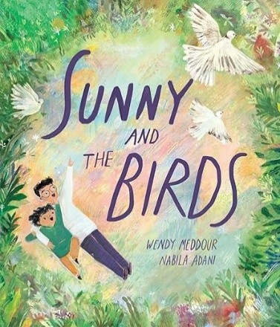
中文书名：《桑尼与小鸟们》
英文书名：SUNNY AND THE BIRDS
作 者：Wendy Meddour, Nabila Adani
出 版 社：OUP
代理公司：ANA
页 数：32页
出版时间：2026年2月
代理地区：中国大陆、台湾
审读资料：电子稿
类 型：故事绘本

- 本书聚焦家庭迁居、适应新环境的成长主题，真实刻画了移民家庭身处陌生环境的疏离与思乡之情。故事以男孩桑尼的行动为主线，针对父亲思念故土、眷恋家乡飞鸟的心境，用孩童的善意与巧思化解异乡生活的隔阂。
- 作品主题贴合儿童成长与校园教育，涵盖迁居适应、亲情陪伴、共情成长等多元内核。全书摒弃说教式表达，以真实故事引导孩子感知情绪、理解他人，帮助身处新环境的孩子缓解陌生与焦虑。同时适配儿童社会情感学习场景，可用于家庭教育疏导与课堂成长教育，是实用性极强的启蒙绘本。
- 本书兼顾故事性与知识性，实现文学阅读与自然科普的结合。在主线故事之外，书中融入丰富的鸟类科普知识，拓展阅读维度，打破普通绘本单一的叙事属性，能够激发孩子对自然观察与鸟类探索的兴趣，让孩子在阅读故事、感受亲情的同时，积累自然知识，实现身心成长与知识拓展同步提升。
- 作者温迪·梅杜尔为英国高校资深文学讲师、知名儿童文学作家，斩获多项国际大奖，其中包括 2020 年国际玛格丽特・怀兹・布朗儿童文学奖、2023 年英国文学教育协会杰出作品奖，作品被翻译为十余种语言。

内容简介：

From the author of Lubna and Pebble comes a tender and thought-provoking picture book about missing home, and the small acts of kindness that help us find our place in a new world.

When Sunny and his family move to a new country, everything feels unfamiliar—especially to his dad, who misses the doves’ coos in the morning and the swallows that swooped in the sunset. Sunny comes up with a plan to help make his father feel more at home in this new place.

Blending themes of immigration, migration, and family love, this heartwarming story fosters empathy and emotional understanding—perfect for families experiencing a move, newcomers adjusting to life in a new place, and classrooms exploring social-emotional learning. Includes fascinating facts about birds that will inspire young readers’ curiosity and passion for birding.

作者简介：


Professor Wendy (O’Shea) Meddour is the Director of Creative Writing at Exeter University, UK; and after gaining her PhD, she spent 8 years teaching English Literature at Oxford University. Her debut children's book was shortlisted for the Branford Boase Award for 'Outstanding first novel', and she has gone onto publish over 15 children's books with leading publishers (many of which have been translated into Arabic, Japanese, Chinese, German, Korean, Turkish, Spanish, French, Greek and Russian).
Winner of numerous awards (including The International Margaret Wise Brown Award for Children's Literature in 2020 and UKLA Outstanding Winner (2023)), Wendy's celebrated titles include the ‘Wendy Quill’ series, 'Lubna and Pebble' and 'The Friendship Bench'. Wendy is best-known for writing children’s books that address challenging topics in sensitive, funny and heartwarming ways.


Nabila Adani lives in Jakarta and enjoys illustrating different cultures around the world. She originally studied Industrial Product Design at Bandung Institute of Technology earning her degree in 2013, yet found her way into illustration later in life. She briefly worked as a product designer in Japan and Indonesia before moving to the United States to study children’s book illustration.
Now, back in Jakarta, she also holds art classes and grows mini libraries for kids near her home.

媒体评价：

"Wendy Meddour's story is written with great sensitivity. Presenting what for many immigrant families is a challenging time, she shows how with love, support, kindness and nature's healing power, the process of adjustment to a different life can begin. The richness and beauty of the natural world - real and remembered - is elegantly captured in Nabila Adani's misty illustrations and you can read the changing emotions in her portrayal of the two main characters." -- Jill Bennett, Red Reading Hub

"An evocative and moving story." -- LoveReading4Kids

"With its sensitive exploration of moving to a new country and the meaning of home, this evocative, illustrated story is perfectly pitched for the youngest readers." -- Pam Norfolk, Lancashire Post

"This sweet story of family love and acclimation to unfamiliar places is supported by illustrations that move between bright inside scenes with sharp lines and pastel, watercolor-evocative outdoor ones whose details are near magical." -- Foreword Reviews

内页插图：

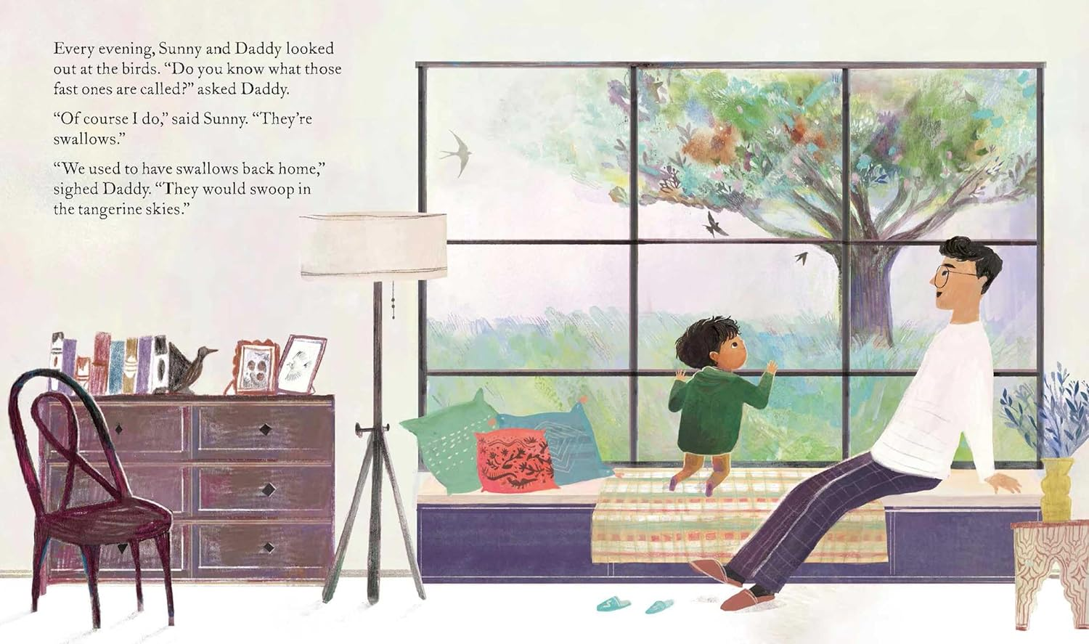
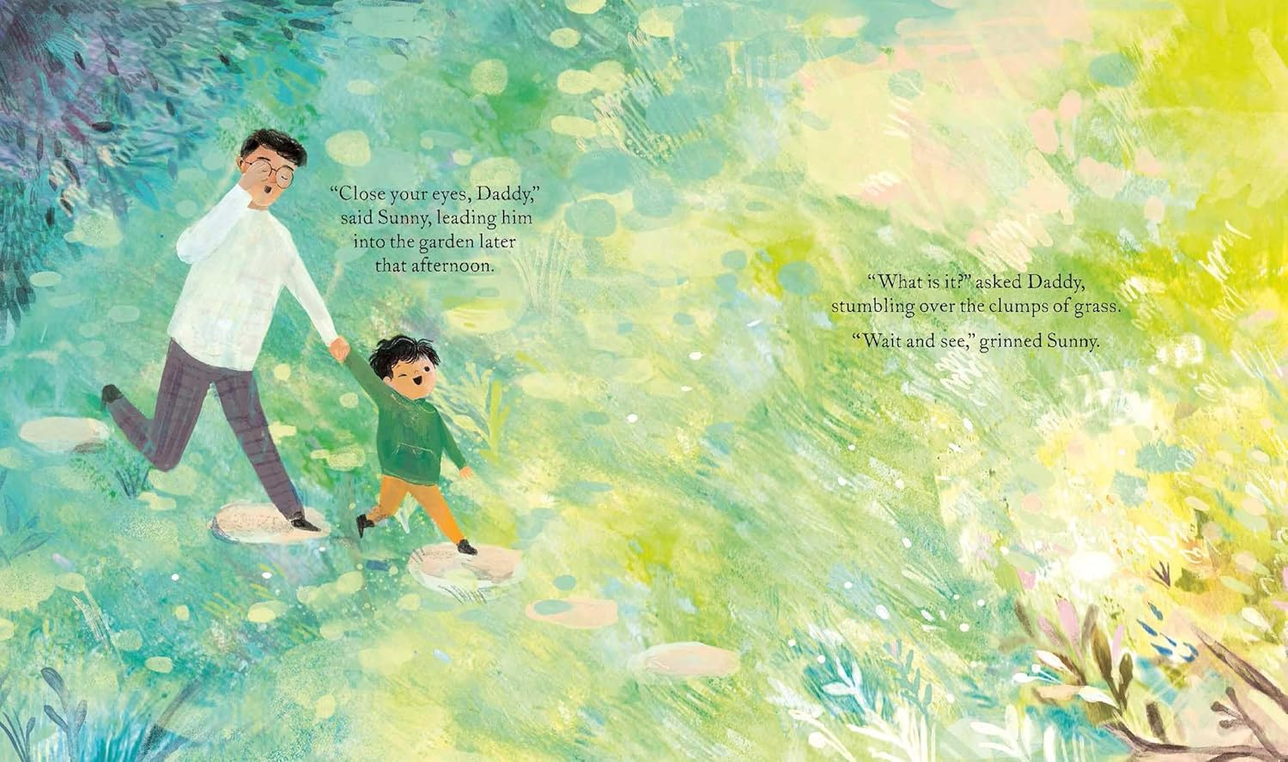
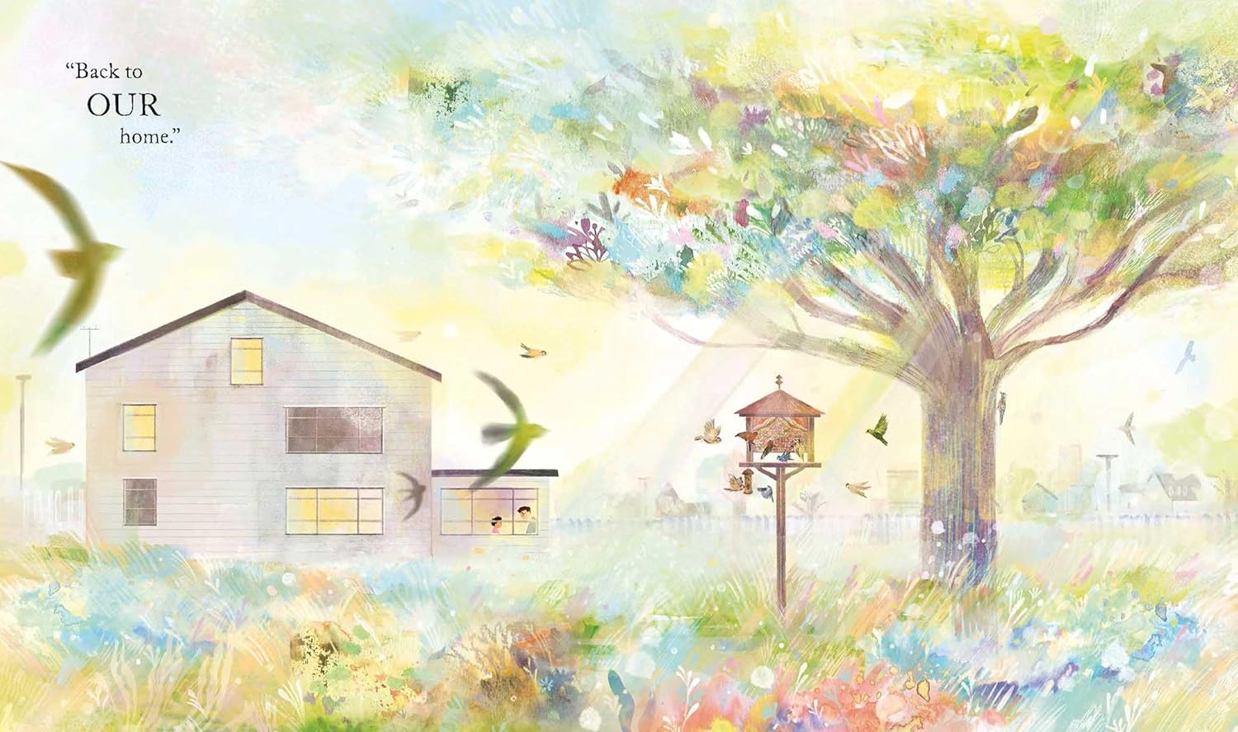

感谢您的阅读！
请将反馈信息发至：版权负责人
Email：Rights@nurnberg.com.cn
安德鲁·纳伯格联合国际有限公司北京代表处
北京市海淀区中关村大街甲59号中国人民大学文化大厦1705室, 邮编：100872
电话：010-82504106, 传真：010-82504200
公司网址：http://www.nurnberg.com.cn
书目下载：http://www.nurnberg.com.cn/booklist_zh/list.aspx
书讯浏览：http://www.nurnberg.com.cn/book/book.aspx
视频推荐：http://www.nurnberg.com.cn/video/video.aspx
豆瓣小站：http://site.douban.com/110577/
新浪微博：安德鲁纳伯格公司的微博_微博 (weibo.com)
微信订阅号：ANABJ2002


