新 书 推 荐

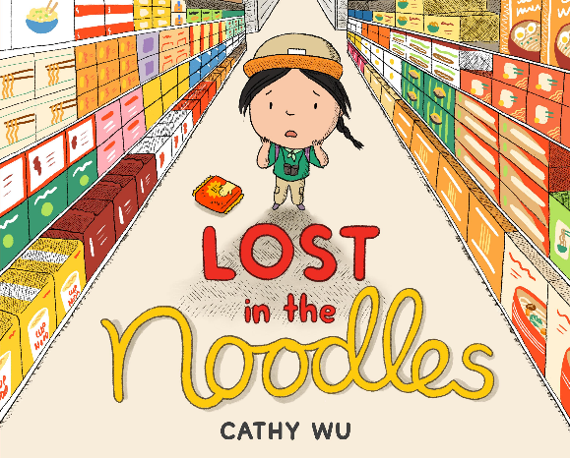
中文书名：《迷失在面条中》
英文书名：LOST IN THE NOODLES
作 者：Cathy Wu
出 版 社：Little Brown
代理公司：Little Brown/ANA
页 数：40页
出版时间：2027年4月
代理地区：中国大陆、台湾
审读资料：电子稿
类 型：故事绘本

- 绘本巧妙融合徒步探险背景与超市走失突发事件，情节充满趣味。围绕孩子与亲人走散这一常见问题展开，以温和、轻松的笔触直面孩童内心不安，极易令孩子共情。
- 摒弃说教式科普，依托主角Clover的心理转变与行动选择，潜移默化教会儿童走失后的应对方式。引导孩子建立保持冷静的意识，为家长提供绝佳的安全教育共读素材，学以致用。
- 作者Cathy Wu首作即斩获Little, Brown新锐艺术家奖项，笔下人物形象软萌生动，色彩明快柔和。作品内核温暖有力，在冒险故事中根植自立意识。

内容简介：

Clover and her papa head to the grocery store to stock up on snacks before their first hike together. But Clover’s in for a big adventure before they even reach the great outdoors . . .

"Oh no . . . I lost my papa! Should I retrace my steps? Where’d he go?"

When she gets separated from her papa, she reminds herself not to panic. The grocery store is a much safer place to get lost than in the great outdoors, after all. But it will still take smart thinking to get reunited with her papa. Will Clover’s wilderness skills come in handy sooner than expected?
This fresh and funny take on a relatable fear— getting separated from a parent in an unfamiliar place—is paired with a reassuring message of self-reliance.

作者简介：

Cathy Wu is the winner of the Little, Brown Emerging Artist Award for Popo & Meimei Can Help, her debut picture book. Cathy is a freelance designer and illustrator who runs a small paper goods business and draws playful portraits of people and pets. She lives in Seattle and invites you to visit her at itscathywu.com

内页插图：
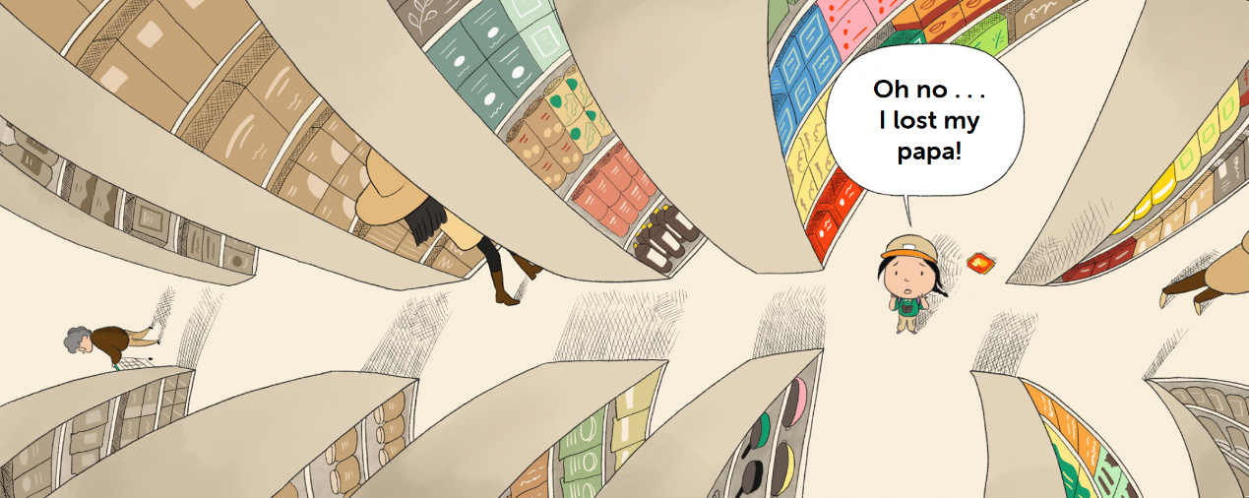
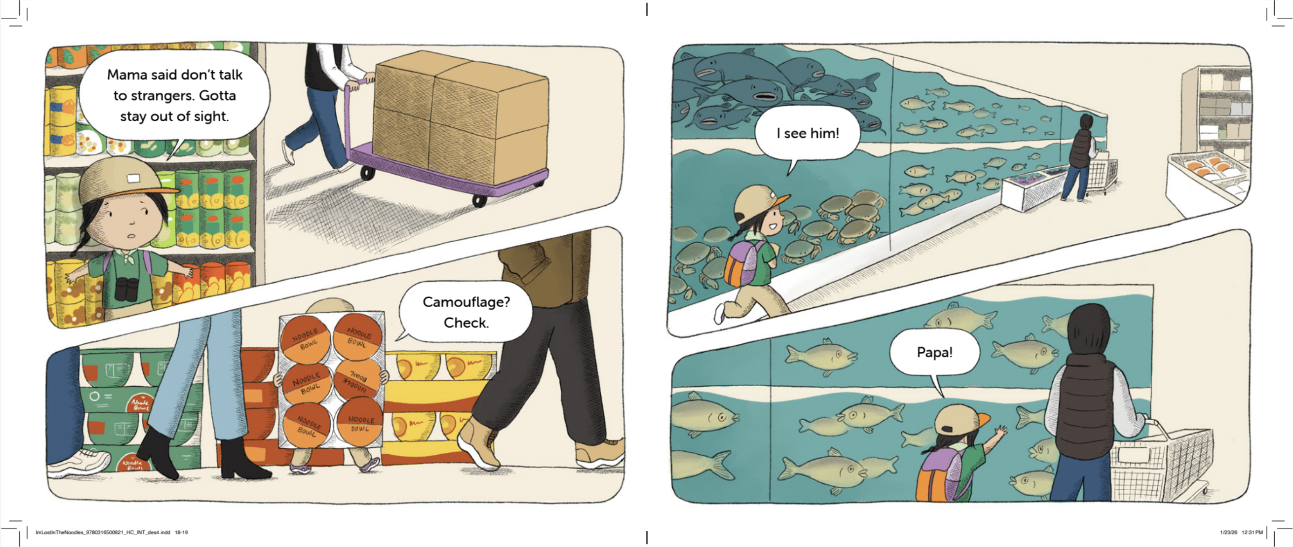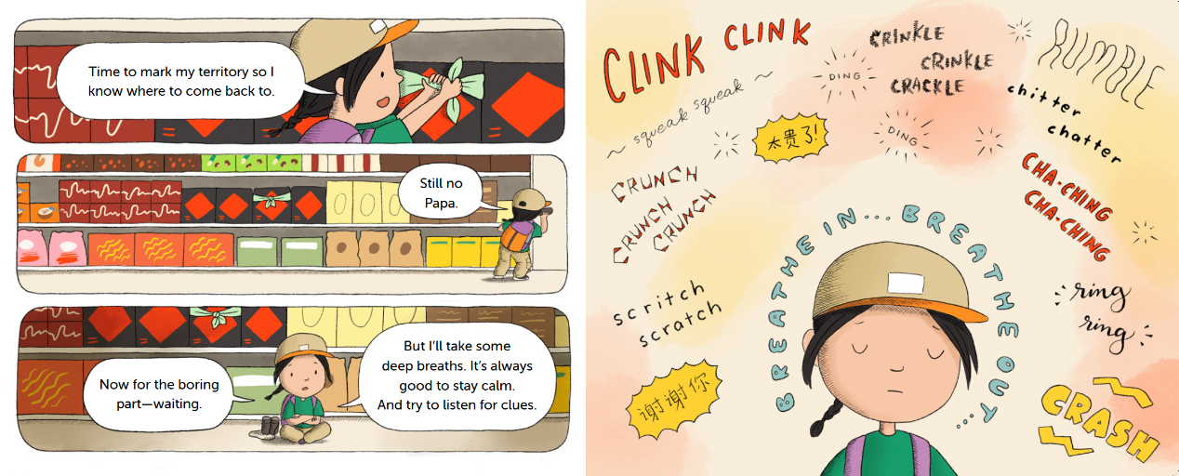

感谢您的阅读！
请将反馈信息发至：版权负责人
Email：Rights@nurnberg.com.cn
安德鲁·纳伯格联合国际有限公司北京代表处
北京市海淀区中关村大街甲59号中国人民大学文化大厦1705室, 邮编：100872
电话：010-82504106, 传真：010-82504200
公司网址：http://www.nurnberg.com.cn
书目下载：http://www.nurnberg.com.cn/booklist_zh/list.aspx
书讯浏览：http://www.nurnberg.com.cn/book/book.aspx
视频推荐：http://www.nurnberg.com.cn/video/video.aspx
豆瓣小站：http://site.douban.com/110577/
新浪微博：安德鲁纳伯格公司的微博_微博 (weibo.com)
微信订阅号：ANABJ2002


