系 列 推 荐
《追逐梦想》两册系列
Bendable & Gibbon Glenda: Pickleball Contender
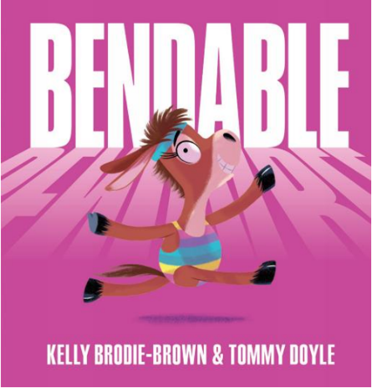
中文书名：《柔韧小骡子》
英文书名：BENDABLE
作 者：Kelly Brodie-Brown and Tommy Doyle
出 版 社：Scholastic Australia
代理公司：Scholastic Australia /ANA
页 数：32页
出版时间：2026年3月
代理地区：中国大陆、台湾
审读资料：电子稿
类 型：儿童故事绘本

爆笑追梦故事，又萌又治愈：一头笨笨的骡子能劈叉吗？能完美侧手翻吗？在希望与坚持中，骡子朱莉即将找到答案！
押韵幽默文本，朗朗上口超好听：节奏轻快、充满韵律的文字，搭配正向内核：你不必成为最棒的，只要尽力而为，就足够优秀。
超励志成长主题，温暖有力：讲述克服自我怀疑、建立自信、跌倒后勇敢再试一次的故事，给孩子满满的勇气与力量。
对标经典，受众明确：适合喜欢《独角兽塞尔玛》《长颈鹿不会跳舞》《梦幻体操》等励志绘本的读者，共鸣满满。

内容简介：

Mules are sturdy creatures, they’re resilient and strong.
Mules are known for hauling heavy burdens all day long.
Mules are trusty and robust, solid and dependable . . .
Mules, however, aren’t exactly known for being BENDABLE!

Can Julie the mule soar into the spotlight? Find out in this adorably inspiring story about reaching your goals, one tumble at a time!

内页插图：
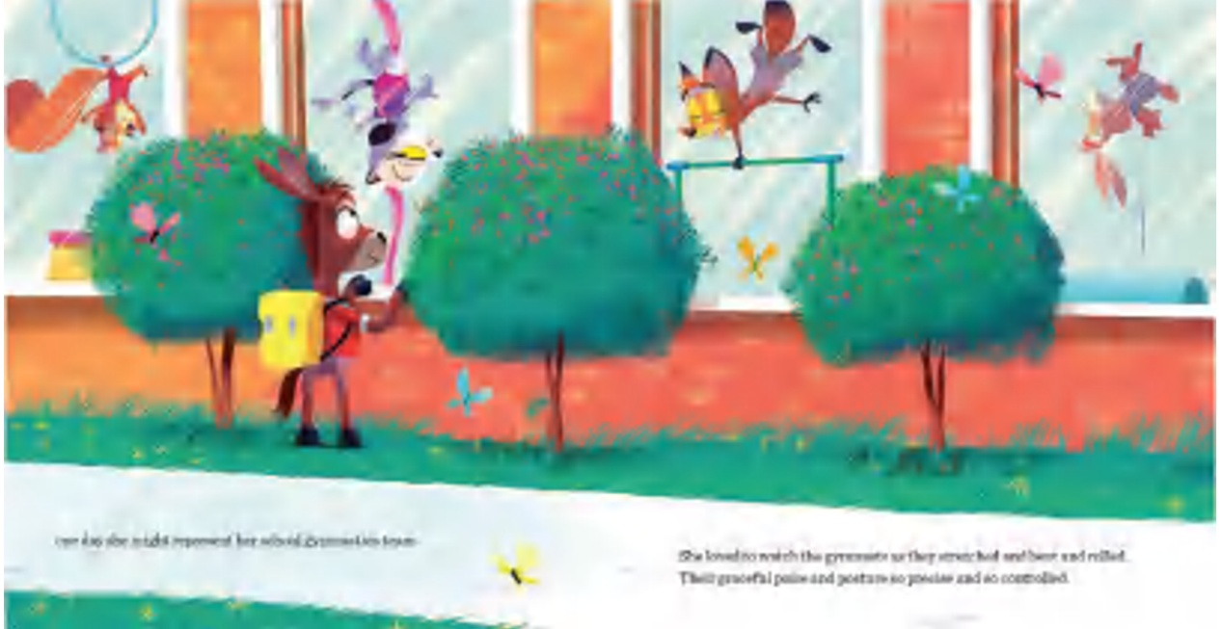

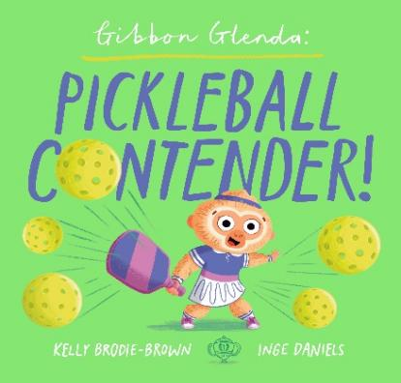
中文书名：《长臂猿格伦达：匹克球竞技选手》
英文书名：GIBBON GLENDA: PICKLEBALL CONTENDER
作 者：Kelly Brodie-Brown and Inge Daniels
出 版 社：Scholastic Australia
代理公司：Scholastic Australia /ANA
页 数：28页
出版时间：2026年7月
代理地区：中国大陆、台湾
审读资料：电子稿
类 型：儿童故事绘本

选取匹克球运动作为故事载体，搭配独特动物主角长臂猿，题材新颖。故事围绕偏执求胜的心态转变展开，引导儿童正视输赢，跳出单一胜负观，学会享受竞技本身。行文浅显流畅，是适合低龄段亲子共读的情绪启蒙类绘本。
全书插画统一采用饱和度饱满、色彩艳丽的平涂绘画风格，画面元素饱满，每一处场景都填充丰富细节，插画师常年以自然万物为创作灵感，画面充满鲜活自然气息。

内容简介：

Glenda was a gibbon with a solid claim to fame; when it came to playing pickleball, she’d never lost a game. Winning felt so wonderful, it became her sole ambition. She was obsessed with being best, she had to win every competition. But what happens when Glenda meets a new pickleball contender?

内页插图：
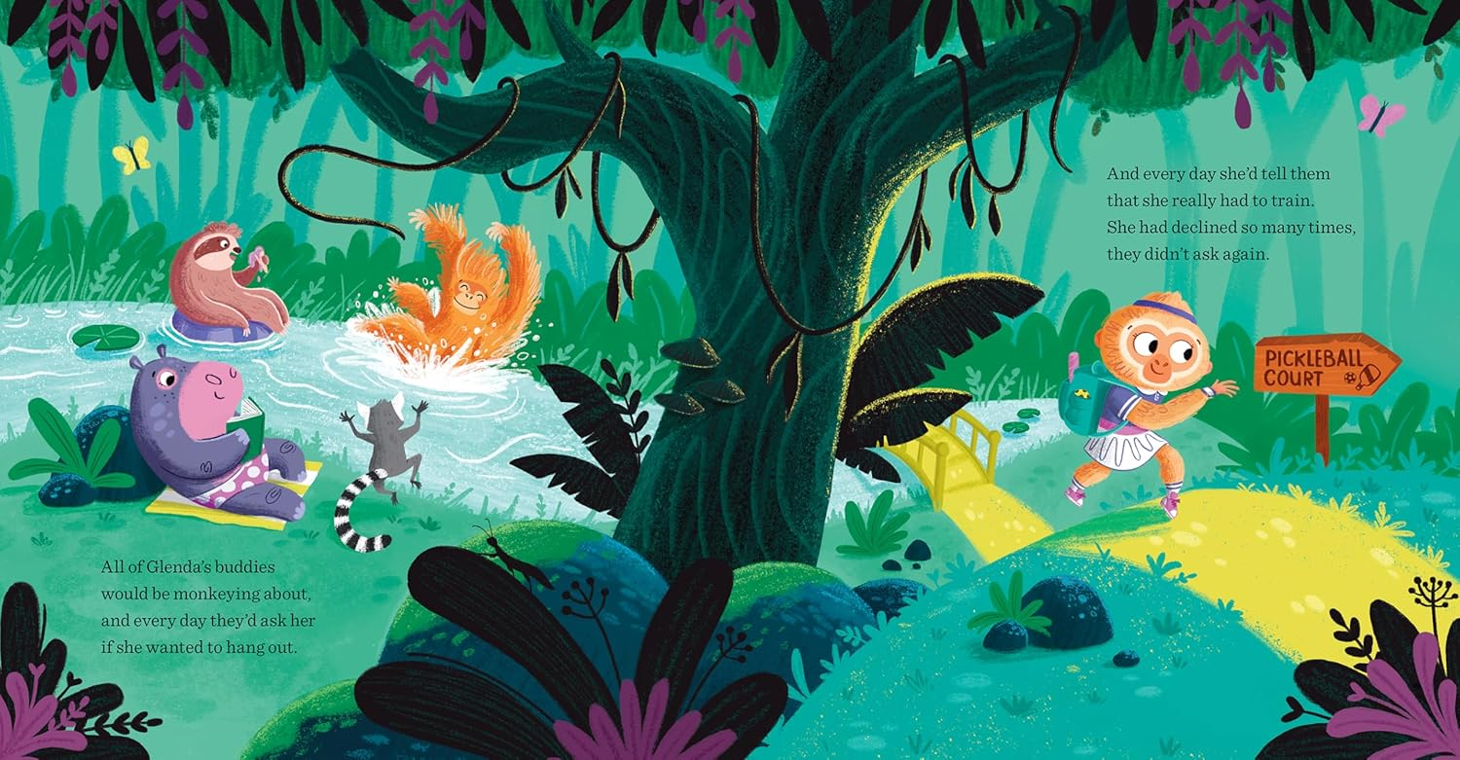
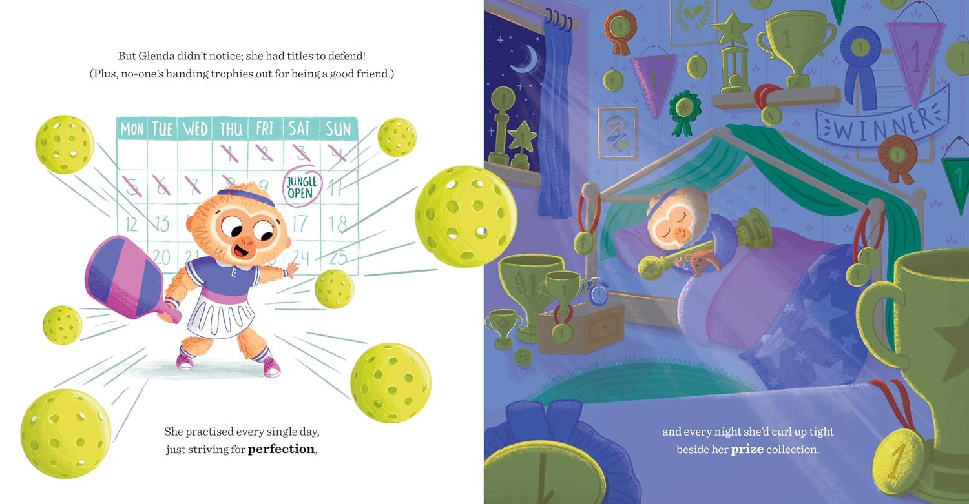
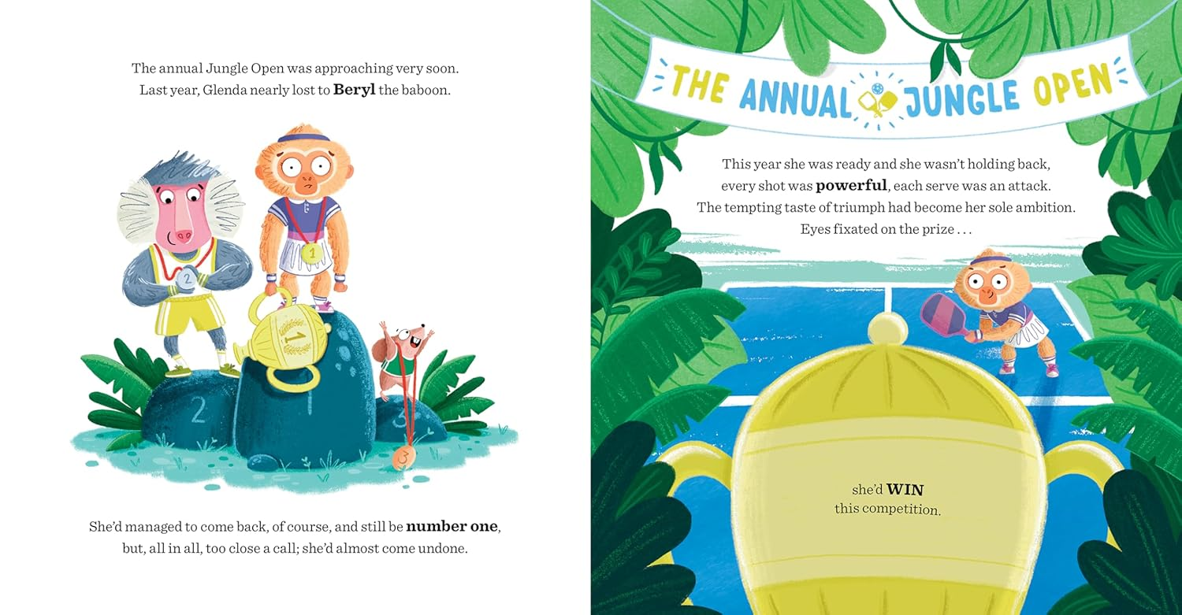

作者简介：

Kelly Brodie-Brown is a picture-book author based in Melbourne. Kelly worked in marketing and PR for a London-based film studio and completed a course in screenwriting at the London College of Communication. Kelly enjoys stories that impart an optimistic message about diversity, pride and acceptance and hopes to reflect this in her own writing.


Tommy Doyle is an illustrator and graphic designer based in Melbourne, Australia. Originally from Montreal, he relocated down under in 2007. He has been working in the industry for over twenty years. Illustration is a big passion of his and finds that it is an effective and creative way to communicate a message or an emotion. Tommy loves playing with shapes and textures, mixing digital and traditional mediums. Tommy is the illustrator of Busy Pride from the push, pull and slide Campbell series.


Inge Daniels is a freelance illustrator born in a small village in the Netherlands (Lierop). A graphic designer turned illustrator with a passion for picture books, her creative path has taken her through the UK and all the way to Australia, where she met her now-wife and their cat. These days she splits her time between Australia and the Netherlands. Always inspired by nature, she finds endless creativity (and occasional distraction) in the world around her.

请将反馈信息发至：版权负责人
Email：Rights@nurnberg.com.cn
安德鲁·纳伯格联合国际有限公司北京代表处
北京市海淀区中关村大街甲59号中国人民大学文化大厦1705室, 邮编：100872
电话：010-82504106, 传真：010-82504200
公司网址：http://www.nurnberg.com.cn
书目下载：http://www.nurnberg.com.cn/booklist_zh/list.aspx
书讯浏览：http://www.nurnberg.com.cn/book/book.aspx
视频推荐：http://www.nurnberg.com.cn/video/video.aspx
豆瓣小站：http://site.douban.com/110577/
新浪微博：安德鲁纳伯格公司的微博_微博 (weibo.com)
微信订阅号：安德鲁纳伯格联合国际北京代表处

