系 列 推 荐
流行文化涂色书系列
POP CULTURE COLORING BOOK SERIES

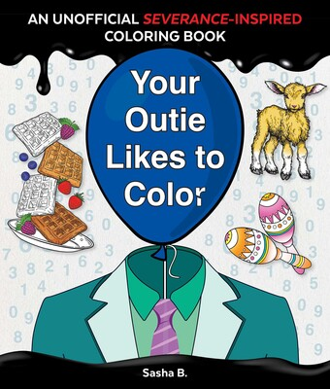
中文书名：《你的外在人格喜欢涂色》
英文书名：YOUR OUTIE LIKES TO COLOR
作 者：Blue Stones
出 版 社：Blue Stones
代理公司：BIAGI/ANA
页 数：8页
出版时间：2026年5月
代理地区：中国大陆、台湾
审读资料：电子稿
类 型：活动书

内容简介：

Inspired by the critically acclaimed series ʻSeverance,’ YOUR OUTIE LIKES TO COLOR offers 48 pages of strangely satisfying illustrations and colorable phrases that celebrate the highly questionable joys of work-life balance, Lumon-style. This unofficial coloring book invites fans to explore the surreal world of severed employees—one absurdly soothing page at a time. This is the ultimate companion for fans who know: the coloring is mysterious and important.

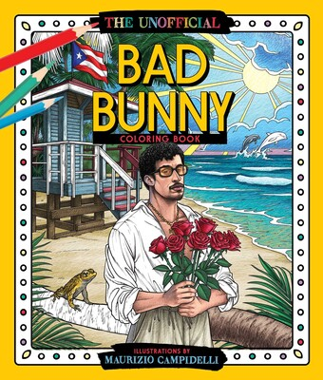
中文书名：《坏兔子涂色书》
英文书名：THE UNOFFICIAL BAD BUNNY COLORING BOOK
作 者：Blue Stones
出 版 社：Blue Stones
代理公司：BIAGI/ANA
页 数：48页
出版时间：2026年8月
代理地区：中国大陆、台湾
审读资料：电子稿
类 型：活动书

内容简介：

With nearly 50 million Instagram followers, a jaw-dropping presence at the Met Gala, and collaborations with everyone from Drake to Adidas, Bad Bunny is more than a musician—he’s a movement. THE UNOFFICIAL BAD BUNNY COLORING BOOK gives his fans what they want: more. Packed with bold illustrations to color, fun facts, and trivia about his rise from a grocery store bagger in Puerto Rico to a global superstar. By way of reminder, In just a few short years, Bad Bunny has become:

- The most-streamed artist globally on Spotify for three consecutive years (2020–2022), with over 12 billion streams in 2024 alone.
- Headlined the 2026 Super Bowl
- A Grammy and Latin Grammy Award winner, with a groundbreaking album (Un Verano Sin Ti) becoming the first all-Spanish album nominated for Album of the Year at the Grammys.
- A chart-topping artist with four #1 albums on the Billboard 200, including YHLQMDLG and El Último Tour Del Mundo—the first Spanish-language album to hit No. 1 in Billboard history.
- A fashion icon and progressive voice for the LGBTQ+ community and gender expression in Latin America

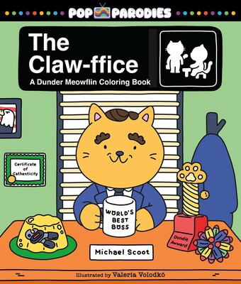
中文书名：《喵公室》
英文书名：CLAW-FFICE
作 者：Blue Stones
出 版 社：Blue Stones
代理公司：BIAGI/ANA
页 数：48页
出版时间：2026年12月
代理地区：中国大陆、台湾
审读资料：电子稿
类 型：活动书

内容简介：

Discover the coloring fun when your favorite paper-selling crew gets nine lives! Welcome to Dunder Meowflin, a feline reimagining of “The Office” - your favorite workplace known for its paper products, playful office antics, and questionable leadership decisions from the World’s Best Boss. THE CLAW-FFICE invites you to color through classic (and hilarious!) scenes as tabbies, tuxedos, and calicos claw through the daily grind at the company’s most chaotic branch. Light a room full of candles (without triggering the sprinklers!), queue up your favorite episodes, and color along with the cats of Dunder Meowflin!

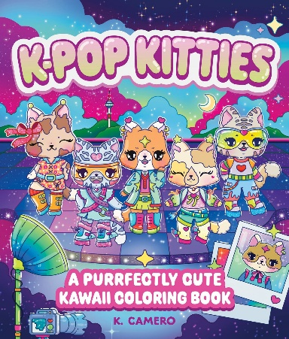
中文书名：《韩流猫咪涂色书》
英文书名：K-POP KITTIES COLORING BOOK
作 者：Blue Stones
出 版 社：Blue Stones
代理公司：BIAGI/ANA
页 数：48页
出版时间：2027年3月
代理地区：中国大陆、台湾
审读资料：电子稿
类 型：活动书

内容简介：
The glittering world of K-POP KITTIES is an all-ages coloring book where fabulous feline performers train hard, shine bright, and serve up nonstop stage presence. Charming scenes designed in the bold-and-easy style with uncluttered backgrounds make every page equal parts sparkle and comfort.

请将反馈信息发至：版权负责人
Email：Rights@nurnberg.com.cn
安德鲁·纳伯格联合国际有限公司北京代表处
北京市海淀区中关村大街甲59号中国人民大学文化大厦1705室, 邮编：100872
电话：010-82504106, 传真：010-82504200
公司网址：http://www.nurnberg.com.cn
书目下载：http://www.nurnberg.com.cn/booklist_zh/list.aspx
书讯浏览：http://www.nurnberg.com.cn/book/book.aspx
视频推荐：http://www.nurnberg.com.cn/video/video.aspx
豆瓣小站：http://site.douban.com/110577/
新浪微博：安德鲁纳伯格公司的微博_微博 (weibo.com)
微信订阅号：安德鲁纳伯格联合国际北京代表处

