新 书 推 荐

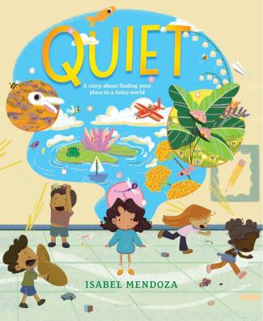
中文书名：《安静》
英文书名：Quiet
作 者：Isabel Mendoza
出 版 社：Bloomsbury
代理公司：Bloomsbury/ANA
页 数：32页
出版时间：2027年2月
代理地区：中国大陆、台湾
审读资料：电子稿
类 型：故事绘本

- 一本富有想象力的社交情感绘本，讲述一个安静的女孩在令人不知所措的世界中找到自己的位置。

内容简介：

A Friend for Henry meets A Boy with Big, Big Feelings in this imaginative social-emotional picture book about a quiet girl finding her place in an overwhelming world.

Bea likes the quiet.

When the world gets to be too much, she finds pockets of peace where she can read, imagine, dream--but the noise always seems to find her. Everyday things like playing at recess, participating in class, even interacting with siblings can be overwhelming, and it starts to feel like the world wasn't built for her.
But could it be there are others who feel the same way?

This imaginative picture book captures the experience of every quiet kid trying to find their place--and their people--in the world.

Perfect for:
- The shy kid in your life
- Teaching empathy
- Readers looking for stories featuring neurodivergence

媒体评论：

“This simple tale of belonging pairs well with art that's distinctive and anything but quiet…. An original, visually daring there's-a-friend-for-everyone story.” ―Kirkus Reviews

作者简介：

Isabel Mendoza is an illustrator and author that grew up in Merced, California and graduated from California College of the Arts. She often reflects her own experiences and daydreams into her stories, in the hopes to create a safe space for others to explore their own thoughts and emotions. She makes these stories despite her dear cat, Winnie, who seems determined to sabotage her work. Isabel is currently in Lodi, California, fighting Winnie off to make her next book.

内页插图：




请将反馈信息发至：版权负责人
Email：Rights@nurnberg.com.cn
安德鲁·纳伯格联合国际有限公司北京代表处
北京市海淀区中关村大街甲59号中国人民大学文化大厦1705室, 邮编：100872
电话：010-82504106, 传真：010-82504200
公司网址：http://www.nurnberg.com.cn
书目下载：http://www.nurnberg.com.cn/booklist_zh/list.aspx
书讯浏览：http://www.nurnberg.com.cn/book/book.aspx
视频推荐：http://www.nurnberg.com.cn/video/video.aspx
豆瓣小站：http://site.douban.com/110577/
新浪微博：安德鲁纳伯格公司的微博_微博 (weibo.com)
微信订阅号：安德鲁纳伯格联合国际北京代表处

