新 书 推 荐

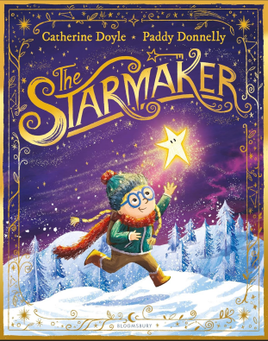
中文书名：《造星者》
英文书名：The Starmaker
作 者：Catherine Doyle (Author), Paddy Donnelly (Illustrator)
出 版 社：Bloomsbury
代理公司：Bloomsbury/ANA
页 数：32页
出版时间：2026年10月
代理地区：中国大陆、台湾
审读资料：电子稿
类 型：故事绘本
版权已授：法语、德语、希腊语、葡萄牙语

- 来自获奖二人组的魔法故事，颂扬代际友谊的重要性与传承珍贵传统的美好。
- 插画师Paddy Donnelly作品曾荣获2024年安邮爱尔兰图书奖(An Post Irish Book Awards)年度儿童图书、2023年爱尔兰识字协会双年度儿童图书奖(Literacy Association of Ireland Biennial Children's Book Award)，作品被选为2025年世界图书日(World Book Day)官方推荐图书之一。并曾四次提名卡内基插画奖(Carnegie Medal for Illustration)。

内容简介：

A magical and uplifting story from a prize-winning author-illustrator duo, celebrating the importance of intergenerational friendships and the beauty in passing on treasured traditions

In the little town of Gloam, every child receives their own special star from the Starmaker when they are born. Stella's star is her best friend, with a knack for adventure and a sixth sense for danger. Together they learn to ride a bike, build a fort and make the best ooey-gooey chocolate cake. And if Stella ever feels sad, her star sits very close to her heart to comfort her.

When Stella's tiny baby brother Leo won't stop crying and no-one can work out why, it's her star that nudges Stella to try and solve the mystery. Together they go on a journey into the deepest corners of Gloam to find a person who not only knows how to help baby Leo, but who also holds the key to Stella's special, starry destiny...

作者简介：


Catherine Doyle grew up in the West of Ireland. She holds a BA in Psychology and an MA in Publishing. Her award-winning and bestselling middle grade début, The Storm Keeper's Island is set on the magical island of Arranmore, where her grandparents grew up. The sequel, The Lost Tide Warriors, was published in July 2019, with the third to follow in March 2021. Catherine's modern re-imagining of Charles Dickens' A Christmas Carol, titled The Miracle on Ebenezer Street, was published by Puffin books in October 2020. She is also the author of the Young Adult Blood for Blood trilogy (Vendetta, Inferno and Mafiosa), which is often described as Romeo and Juliet meets the Godfather.


帕迪·唐纳利(Paddy Donnelly)是一位畅销且获奖的爱尔兰绘本作家和插画家。现居比利时，他运用多种插画风格，已创作超过30本绘本，包括《颠倒的灯塔》(The Upside-Down Lighthouse)、《消失的湖》(The Vanishing Lake)、《阿娃与橡子》(Ava and the Acorn)、《獾的书》(Badger Books)和《直升机上的狼》(Wolves In Helicopters)。《金色的野兔》(The Golden Hare)荣获2024年安邮爱尔兰图书奖(An Post Irish Book Awards)年度儿童图书，《狐狸与儿子裁缝铺》(Fox & Son Tailers)荣获2023年爱尔兰识字协会双年度儿童图书奖(Literacy Association of Ireland Biennial Children's Book Award)，并被选为2025年世界图书日(World Book Day)官方推荐图书之一。他曾四次提名卡内基插画奖(Carnegie Medal for Illustration)。帕迪在爱尔兰美丽的北海岸长大，周围环绕着关于巨人、魔法生物和变形动物的神话故事。他的叙事反映了他对自然和动物的热爱。他希望冥王星还是一颗行星。

内页插图：

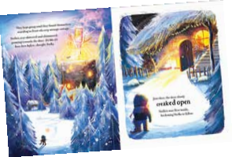

请将反馈信息发至：版权负责人
Email：Rights@nurnberg.com.cn
安德鲁·纳伯格联合国际有限公司北京代表处
北京市海淀区中关村大街甲59号中国人民大学文化大厦1705室, 邮编：100872
电话：010-82504106, 传真：010-82504200
公司网址：http://www.nurnberg.com.cn
书目下载：http://www.nurnberg.com.cn/booklist_zh/list.aspx
书讯浏览：http://www.nurnberg.com.cn/book/book.aspx
视频推荐：http://www.nurnberg.com.cn/video/video.aspx
豆瓣小站：http://site.douban.com/110577/
新浪微博：安德鲁纳伯格公司的微博_微博 (weibo.com)
微信订阅号：安德鲁纳伯格联合国际北京代表处

